SUNDAY |     MONDAY |     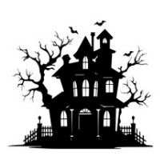  TUESDAY |   WEDNESDAY | THURSDAY | FRIDAY | SATURDAY
Movies are always available, if you would like to see a movie just ask and we can let you know what we have and put it on for you, in the T.V. room. | (DR) – Dining Room  (CR) – Community Room  (SR) – Sunroom  (W.P) – Weather Permitting  Mass, Rosary and Bible Study are in the Chapel | Diane our Hairdresser is usually here, Every Friday. Sometimes 2 days, depending on how many people we have. If you would like a hair appointment, please let Sharon at the Front desk know, or any of the staff. They will let Sharon know so that she can add you to the schedule. Thank you! | ~ All Activities are Subject to  Change ~ | 1  10:00 Apple Picking at Red Apple Farm (WP)  10:00 Game/ Yahtzee (DR)  11:15 Exercise (CR)  1:00 Bingo (CR)  2:00 Country Store Opened  2:30 Bible Study/ Pastor Bob  4:00 Cards/ Skipbo (DR) | 2 Hair Day”  10:00 LCR Dice Game (DR)  11:15 Exercise (CR)  1:00 Bingo (CR)  2:30 Entertainment with  “Dan Kirouac” (DR)  4:00 Cards/Ranter Go Round (DR) | 3  10:00 Game/ Yahtzee (DR)  11:15 Exercise (CR)  1:00 Bingo (CR)  2:15 Snack Cart  3:30 Fire Pit Gab Fest (W.P.)
4  10:00 Bingo (DR)  11:15 Exercise (CR)  1:15 United Parish Church Service (Chapel)  2:00 Nails & Tales (SR)  3:30 Fire Pit Gab Fest (W.P.) | 5 OCTOBER FEST  10:00 Rosary/ Deacon Jim  11:15 Exercise (CR)  1:00 Bingo (CR)  2:15 Snack Cart  3:30 Word Game (DR) | 6  9:45 Foliage Ride (W.P)  11:15 Exercise (CR)  1:00 Bingo (CR)  2:00 Country Store Opened  2:15 Snack Cart  3:30 Adult Coloring (CR) | 7  10:00 Catholic Mass with Father Gregory (Chapel)  11:15 Exercise (CR)  1:00 Bingo (CR)  2:30 Piano in the Foyer with  Ethan Stone  4:00 Cards/ UNO (DR) | 8  10:00 Game/ Yahtzee (DR)  11:00 Lunch Trip/Monty Tech  11:15 Exercise (CR)  1:00 Bingo (CR)  2:00 Country Store Opened  2:15 Snack Cart  3:30 Cards/ Golf (DR) | 9 “Hair Day”  10:00 Arts/ Crafts Painting Halloween Décor (CR)  11:15 Exercise (CR)  1:00 Bingo (CR)  2:30 Entertainment with  “Tim Barrett” (CR)  4:00 Cards/Ranter Go Round | 10  10:00 LCR Dice Game (DR)  11:15 Exercise (CR)  1:00 Bingo (CR)  2:15 Snack Cart  3:30 Fire Pit Gab Fest (W.P.)
11  10:00 Game (DR)  11:15 Exercise (CR)  1:00 Bingo (CR)  2:30 Nails & Tales (SR)  4:00 Fire Pit Gab Fest (W.P.) | 12  10:00 Rosary/ Deacon Jim  11:15 Exercise (CR)  1:00 Bingo (CR)  2:15 Snack Cart  3:30 Word Game (W.P.) | 13  9:45 Foliage Ride (W.P)  11:15 Exercise (CR)  1:00 Bingo (CR)  2:00 Country Store Opened  2:15 Richard Eastham/  Finding Balance (CR)  3:30 Adult Coloring (CR) | 14  10:00 LCR Dice Game (DR)  11:15 Exercise (CR)  1:00 Bingo (CR)  2:30 Smore’s at the Fire Pit (W.P)  3:30 Cards/ Rummy (DR) | 15  10:00 Bingo (CR)  11:00 Country Store Opened  11:15 Exercise (CR)  1:00 Bible Study/ Pastor Bob & Kathy  1:00 Movie (TV Room)  3:30 Cards/ Skipbo (DR) | 16 “Hair Day”  10:00 Bowling at the HUB  11:15 Exercise (CR)  1:00 Bingo (CR)  2:30 Entertainment with  “Heather Marie” (CR)  4:00 Cards/Ranter Go Round (DR) | 17  10:00 Game/ Yahtzee (DR)  11:15 Exercise (CR)  1:00 Bingo (CR)  2:15 Snack Cart  3:30 Fire Pit Gab Fest (W.P.)
18  10:00 Game (DR)  11:15 Exercise (CR)  1:00 Bingo (CR)  2:30 Nails & Tales (SR)  4:00 Fire Pit Gab Fest (W.P.) | 19  10:00 Rosary/ Deacon Jim  11:15 Exercise (CR)  1:00 Bingo (CR)  2:15 Snack Cart    3:30 Word Game (DR) | 20  9:45 Foliage Ride (W.P)  11:15 Exercise (CR)  1:00 Bingo (CR)  2:00 Country Store Opened  2:00 Veteran to Veteran Café  2:15 Snack Cart  3:30 Adult Coloring (CR) | 21  10:00 LCR Dice Game (DR)  11:15 Exercise (CR)  1:00 Bingo (CR)  2:00 Country Store Opened  2:15 Snack Cart | 22  10:00 Bingo (CR)  11:15 Exercise (CR)  1:30 Flu Clinic (CR)  2:15 Snack Cart  3:30 Cards/ UNO (DR) | 23 “Hair Day”  10:00 Arts/Crafts - Stained Glass Fall Picture (CR)  11:15 Exercise (CR)  1:00 Bingo (CR)  2:30 Entertainment with  Terry Nally” (CR)  4:00 Cards/Ranter Go Round (DR) | 24  10:00 LCR Dice Game (DR)  11:15 Exercise (CR)  1:00 Bingo (CR)  2:15 Snack Cart  3:30 Fire Pit Gab Fest (W.P.)
25  10:00 Game (DR)  11:15 Exercise (CR)  1:00 Bingo (CR)  2:30 Nails & Tales (SR)  4:00 Fire Pit Gab Fest (W.P.) | 26  10:00 Rosary/ Deacon Jim  11:15 Exercise (CR)  1:00 Bingo (CR)  2:30 Resident’s Birthday Party/ “Ron Morey” (CR)  4:00 Word Game (DR) | 27  10:00 Community Meeting (CR)  11:15 Exercise (CR)  1:00 Bingo (CR)  2:00 Country Store Opened  2:15 Snack Cart  3:30 Adult Coloring (CR) | 28  9:30 Errand Trip (W.P)  11:15 Exercise (CR)  1:00 Bingo (CR)  2:15 Snack Cart  4:00 – 5:00 RESIDENT & STAFF FAMILY  TRICK OR TREAT | 29  10:00 Game/ Sorry (DR)  11:15 Exercise (CR)  1:00 Bingo (CR)  2:00 Country Store Opened    2:30 Bible Study/ Pastor Bob & Kathy  4:00 Cards/ Skipbo (DR) | 30 “Hair Day”  10:00 Game/ Yahtzee (DR)  11:15 Exercise (CR)  1:00 Bingo (CR)  2:30 Entertainment with  “Paul & Paula” (CR)  4:00Cards/Ranter Go Round (DR) | 31 “HALLOWEEN”  10:00 LCR Dice Game (DR)  11:15 Exercise (CR)  1:00 Bingo (CR)  2:15 Snack Cart  3:30 Fire Pit Gab Fest (W.P.)  TRICK OR TREAT!
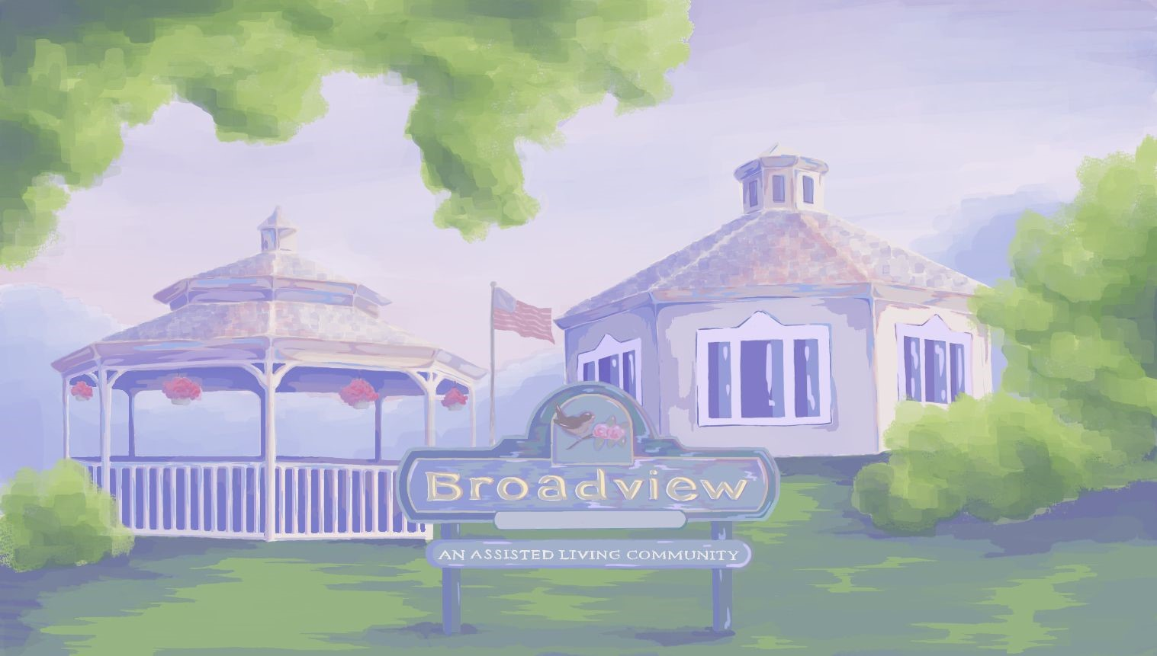
Highlights for the Month:
- Bible Study, Thursday, October 1st & 29th at 2:30. Also Thursday, October 15th at 1:00 with Pastor Bob & Kathy (Chapel)
- Entertainment Fridays, October 2nd, 9th, 16th, 23rd & 30th at 2:30.
- 4th - United Parish Church Service 1:15.
- Foliage Rides, Leaving at 9:45. Tuesdays, October 6th, 13th & 20th.
- 5th OCTOBER FEST
- 7th - Catholic Mass at 10:00 with Father Gregory. (Chapel)
- 7th Piano in the Foyer with Ethan Stone, at 2:30.
- 8th Lunch Trip, “Monty Tech. Mountain Room”
- Fire Pit Gab Fest (Weather Permitting) at 3:30 on Saturdays, 3rd, 10th, 17th, 24th& 31st.
- Fire Pit Gab Fest (Weather Permitting) at 4:00 on Sundays, 4th, 11th, 18th & 25th.
- 10th Art/Crafts – Stained Glass Picture 10:00 (CR)
- Rosary with Deacon Jim Mondays, 5th, 12th, 19th & 26th at 10:00. (Chapel)
- 13th Richard Eastham, Presentation on Finding Balance at 2:15. (Care Central)
- 14th Smore’s at the Fire Pit 2:30 (WP)
- 16th - 10:00 Bowling at the HUB
- 20th - Veteran to Veteran Café (CR)
- 22nd - 1:30-2:30 Flu Clinic (CR)
- 26th Resident Birthday Party with Ron Morey
2:30. (CR)
- 27th - Community Meeting 10:00 (CR)
- 28th - Errand trip at 9:30.
- 28th – RESIDENT & STAFF FAMILY TRICK OR TREAT 4:00- 5:00.

~ALL ACTIVITIES SUBJECT TO CHANGE ~

WELCOME NEW MEMBERS TO OUR COMMUNITY!
TRADITIONAL UNIT
Charline R.
Norma A.
Shirley L.
Raymond B.

MEMORY CARE UNIT
Mary A.
OCTOBER BIRTHDAYS
Happy Birthday!
Jeannette M. October 3rd
Don B. October 6th
Judy C. October 22nd
Norman M. October 28th ~~~~~~~~~~~~~~~~~~~~~~~~
Employee of the Month

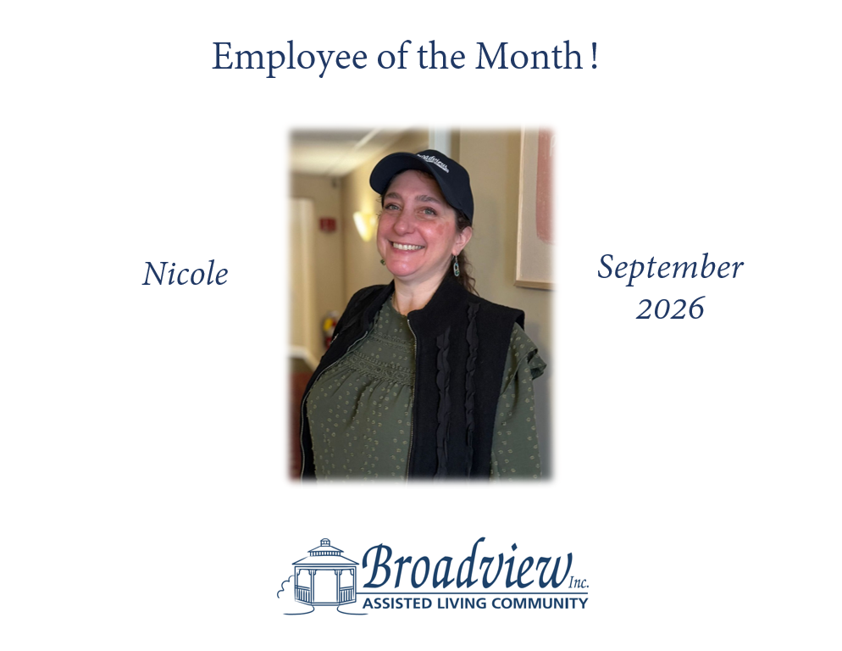 Activities Team
Welcome to
The Month of October 2026


