
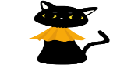
Bright Horizons Activities for October 2026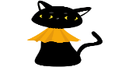
Sunday | Monday |  | Tuesday | Wednesday |  |  |  |  | Thursday | Friday | Saturday
Resident  Birthdays  Jeannette M. 10/3  Don B. 10/6  Judy C. 10/22  Norman M. 10/28  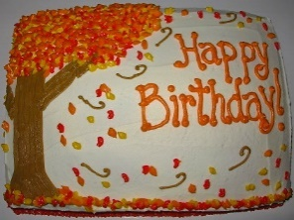  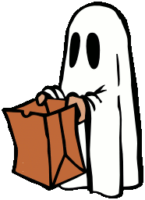 |  |  | 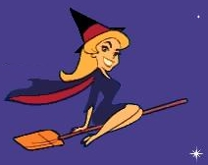  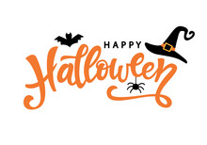 |  | 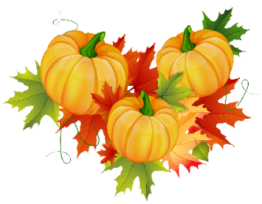  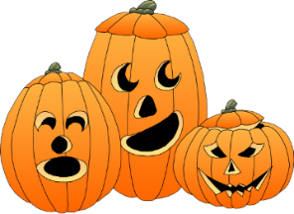 |  |  | 1  9:30 Mass on TV  10:00 Baking Muffins  11:15 Exercise  1:00 Bingo  2:30 Coffee/Hot Chocolate Social  4:00 Nails & Tales  6:00 Reminiscence 7:00 Evening Movie  8:00 Bedtime Reading |  | 2  “Hair Day”  9:30 Mass on TV  10:00 Trivia  11:15 Exercise  1:00 Bingo  2:30 Entertainment with  Dan Kirouac  2:30 Coffee/Hot Chocolate Social  4:00 LIST IT  6:00 Evening Small Talk  7:00 Evening Movie  8:00 Bedtime Reading | 3  9:30 Mass on TV  10:00 Jigsaw Puzzle  11:15 Exercise  1:00 Bingo  2:30 Coffee Social  4:00 Noodle Ball  6:00 Reminiscence  7:00 Evening Movie  8:00 Bedtime Reading
4  8:00 Mass on TV  10:00 Finish the Lyrics…  11:15 Exercise  1:00 Bingo  1:15 United Parish Church Services  2:30 Coffee/Hot Chocolate Social  4:00 Helping Around the House  6:00 Reminiscence  7:00 Evening Movie  8:00 | 5  OCTOBER FEST  9:30 Mass on TV  10:00 Trivia  11:15 Exercise  1:00 Bingo  2:30 Coffee/Hot Chocolate Social  4:00 Jigsaw Puzzle  6:00 Evening Small Talk  7:00 Evening Movie  8:00 Evening Movie |  | 6  9:30 Mass on TV  10:00 Ring Toss  11:15 Exercise  1:00 Bingo  2:30 Coffee/Hot Chocolate Social  4:00 Nails & Tales  6:00 Reminiscence  7:00 Evening Movie  8:00 Evening Movie   | 7  9:30 Mass on TV  10:00 Foliage/ Ride  (Weather Permitting)  10:00 Jigsaw Puzzles  11:15 Exercise  1:00 Bingo  2:30 Ethan Stone  Playing Piano in the Foyer  2:30 Coffee/Hot Chocolate Social  4:00 Bowling  6:00 Evening Small Talk  7:00 Evening Movie  8:00 Evening Movie |  |  |  | 8  9:30 Mass on TV  10:00 Baking Muffins  11:15 Exercise  1:00 Bingo  2:30 Coffee/Hot Chocolate Social  4:00 Nails & Tales  6:00 Reminiscence 7:00 Evening Movie  8:00 Evening Movie |  | 9  “Hair Day”  9:30 Mass on TV  10:00 Trivia  11:15 Exercise  1:00 Bingo  2:30 Entertainment with  Tim Barrett  2:30 Coffee/Hot Chocolate Social  4:00 LIST IT  6:00 Evening Small Talk  7:00 Evening Movie  8:00 Evening Movie | 10  9:30 Mass on TV  10:00 Jigsaw Puzzle  11:15 Exercise  1:00 Bingo  2:30 Coffee/Hot Chocolate Social  4:00 Noodle Ball  6:00 Reminiscence  7:00 Evening Movie  Bedtime Reading  8:00 Evening Movie  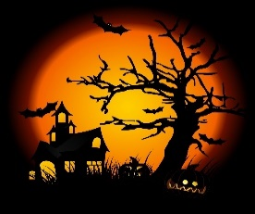
11  8:00 Mass on TV  10:00 Finish the Phrase…  11:15 Exercise  1:00 Bingo  2:30 Coffee/Hot Chocolate Social  4:00 Helping Around the House  6:00 Evening Small Talk  7:00 Evening Movie  8:00 Bedtime Reading | 12  9:30 Mass on TV  10:00 Trivia  11:15 Exercise  1:00 Bingo  2:30 Coffee/Hot Chocolate Social  4:00 Jigsaw Puzzle  6:00 Reminiscence  7:00 Evening Movie  8:00 Bedtime Reading  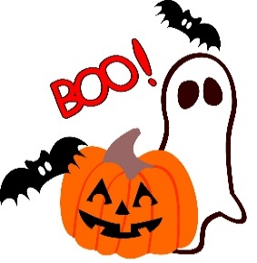 |  | 13  9:30 Mass on TV  10:00 What’s in the bag?  11:15 Exercise  1:00 Bingo  2:30 Coffee/Hot Chocolate Social  4:00 Nails & Tales  6:00 Evening Small Talk  7:00 Evening Movie  8:00 Bedtime Reading  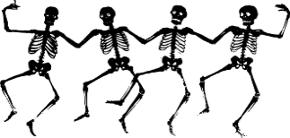 | 14  9:30 Mass on TV  10:00 Foliage/ Ride  (Weather Permitting)  11:15 Exercise  1:00 Bingo  2:30 Coffee/Hot Chocolate Social  4:00 Bowling  6:00 Reminiscence  7:00 Evening Movie  8:00 Bedtime Reading |  |  |  | 15  9:30 Mass on TV  10:00 Baking Muffins  11:15 Exercise  1:00 Bingo  2:30 Coffee/Hot Chocolate Social  4:00 Nails & Tales  6:00 Evening Small Talk  7:00 Evening Movie  8:00 Bedtime Reading |  | 16  “Hair Day”  9:30 Mass on TV  10:00 Trivia  10:00 Bowling at the HUB in Winchendon  11:15 Exercise  1:00 Bingo  2:30 Entertainment  With  Heather Marie  2:30 Coffee/Hot Chocolate Social  4:00 LIST IT  6:00 Reminiscence  7:00 Evening Movie  8:00 Bedtime Reading | 17  9:30 Mass on TV  10:00 Jigsaw Puzzle  11:15 Exercise  1:00 Bingo  2:30 Coffee/Hot Chocolate Social  4:00 Noodle Ball  6:00 Evening Small Talk  7:00 Evening Movie  8:00 Bedtime Reading
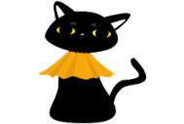Bright Horizons Activities for October 2026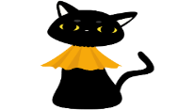
Sunday |  | Monday | Tuesday |  |  | Wednesday |  |  | Thursday | Friday |  | Saturday
18  9:30 Mass on TV  10:00 Trivia  11:15 Exercise  1:00 Bingo  2:30 Coffee/Hot Chocolate Social  4:00 Jigsaw Puzzle  6:00 Evening Small Talk  7:00 Evening Movie  8:00 Bedtime Reading |  | 19  9:30 Mass on TV  10:00 Ring Toss  11:15 Exercise  1:00 Bingo  2:30 Coffee/Hot Chocolate Social  4:00 Nails & Tales  6:00 Reminiscence  7:00 Evening Movie  8:00 Bedtime Reading | 20  w9:30 Mass on TV  10:00 What’s in the bag?  11:15 Exercise  1:00 Bingo  2:30 Coffee/Hot Chocolate Social  2:30 Entertainment with Jimmy Ragtag ONeil  4:00 Nails & Tales  6:00 Evening Small Talk  7:00 Evening Movie  8:00 Bedtime Reading |  |  | 21  9:30 Mass on TV  10:00 Foliage/ Ride  (Weather Permitting)  10:00 Jigsaw Puzzles  11:15 Exercise  1:00 Bingo  2:30 Coffee/Hot Chocolate Social  4:00 Bowling  6:00 Evening Small Talk  7:00 Evening Movie    8:00 Bedtime Reading |  |  | 22  9:30 Mass on TV  10:00 Baking Muffins  11:15 Exercise  1:00 Bingo  1:30 Flu Clinic  2:30 Coffee/Hot Chocolate Social  4:00 Nails & Tales  6:00 Reminiscence  7:00 Evening Movie  8:00 Bedtime Reading  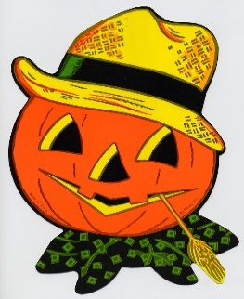 | 23  “Hair Day”  9:30 Mass on TV  10:00 Trivia  11:15 Exercise  1:00 Bingo  2:30 Entertainment  With  “Terry Nally”  2:30 Coffee/Hot Chocolate Social  4:00 LIST IT  6:00 Evening Small Talk  7:00 Evening Movie  8:00 Bedtime Reading |  | 24  9:30 Mass on TV  10:00 Jigsaw Puzzle  11:15 Exercise  1:00 Bingo  2:30 Coffee/Hot Chocolate Social  4: 00 Noodle Ball  6:00 Reminiscence  7:00 Evening Movie  8:00 Bedtime Reading  
25  8:00 Mass on TV  10:00 Ring Toss  11:15 Exercise  1:00 Bingo  2:30 Coffee/Hot Chocolate Social  4:00 Helping Around the House  6:00 Evening Small Talk  7:00 Evening Movie  8:00 Bedtime Reading |  | 26  9:30 Mass on TV  10:00 Trivia  11:15 Exercise  1:00 Bingo  2:30 Residents Birthday Party/ Entertainment with  Ron Morey  2:30 Coffee Social  4:00 Jigsaw Puzzle  6:00 Evening Small Talk  7:00 Evening Movie  8:00 Bedtime Reading | 27  9:30 Mass on TV  10:00 What’s in the bag?  11:15 Exercise  1:00 Bingo  2:30 Coffee Social  4:00 Nails & Tales  6:00 Reminiscence  7:00 Evening Movie  8:00 Bedtime Reading |  |  | 28  9:30 Mass on TV  10:00 Foliage/ Ride  (Weather Permitting)  10:00 Jigsaw Puzzles  11:15 Exercise  1:00 Bingo  2:30 Coffee Social  4:00 Bowling  6:00 Evening Small Talk  7:00 Evening Movie  8:00 Bedtime Reading  4:00-5:00  Resident & Staff Family  Trick or Treat! |  |  | 29  9:30 Mass on TV  10:00 Baking Muffins  11:15 Exercise  1:00 Bingo  2:30 Coffee Social  4:00 Nails & Tales  6:00 Reminiscence  7:00 Evening Movie  8:00 Bedtime Reading | 30  “Hair Day”  9:30 Mass on TV  10:00 Trivia  11:15 Exercise  1:00 Bingo  2:30 Entertainment with  Paul & Paula  2:30 Coffee/Hot Chocolate Social  4:00 LIST IT  6:00 Evening Small Talk  7:00 Evening Movie  8:00 Evening Movie |  | 31  Halloween  9:30 Mass on TV  10:00 Jigsaw Puzzle  11:15 Exercise  1:00 Bingo  2:30 Coffee/Hot Chocolate Social  4: 00 Noodle Ball  6:00 Reminiscence  7:00 Evening Movie  8:00 Bedtime Reading  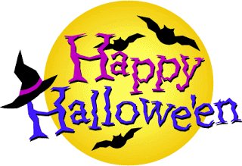  Trick or Treating  5:30-7:30
 |  | 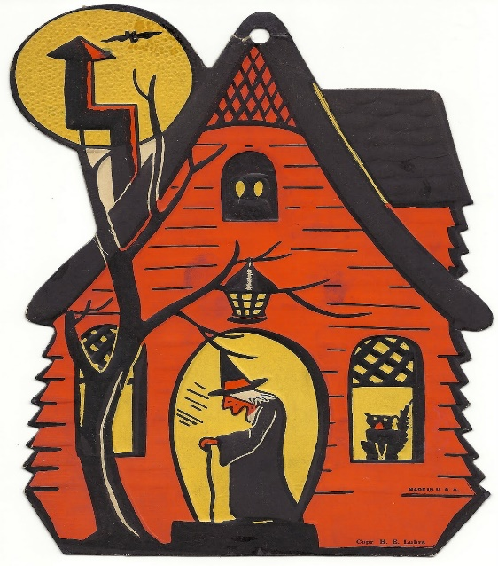 |  |  |  |  | 