SUNDAY | MONDAY | TUESDAY | WEDNESDAY | THURSDAY | FRIDAY | SATURDAY
~ All Activities are Subject to  Change ~ |  | 1  10:00 Game/ Yahtzee (DR)  11:15 Exercise (CR)  1:00 Bingo (CR)  2:00 Country Store Opened  2:15 Snack Cart  3:30 Adult Coloring (CR) | 2  10:00 Mass/ Father Gregory 11:15 Exercise (CR)  1:00 Bingo (CR)  2:30 Snack Cart  3:30 Cards/ Rummy (CR) | 3  10:00 LCR Dice Game (DR)  11:15 Exercise (CR)  1:00 Bingo (CR)  2:00 Country Store Opened  2:15 Snack Cart  4:00 Cards/ Skipbo (DR) | 4 “Hair Day”  10:00 Game/ Sorry (DR)  11:15 Exercise (CR)  1:00 Bingo (CR)  2:30 Entertainment with  Sean Fullerton (CR)  4:00 Cards/ Ranter Go Round (DR) | 5  10:00 Game/ Yahtzee (DR)  11:15 Exercise (CR)  1:00 Bingo (CR)  2:15 Snack Cart  3:30 Fire Pit Gab Fest (W.P.)
6  10:00 Bingo (CR)  11:15 Exercise (CR)  1:15 United Parish Church Service  1:30 Game (DR)  3:30 Fire Pit Gab Fest 3:00 Gazebo Gab Fest (W.P.) | 7  10:00 Bingo (CR)  11:15 Exercise (CR)  12:00 Labor Day BBQ Entertainment with “Dan Kirouac”  2:15 Snack Cart  3:30 Word Game (DR) | 8  10:00 Game/ Yahtzee (DR)  11:15 Exercise (CR)  1:00 Bingo (CR)  2:00 Country Store Opened  2:15 Snack Cart  3:30 Adult Coloring (CR) | 9  10:00 Game/ LCR Dice Game (DR)  11:15 Exercise (CR)  1:00 Bingo (CR)  2:15 Snack Cart  3:30 Cards/ Rummy (DR) | 10  10:00 Game/ Yahtzee (DR)  11:00 Lunch Trip 99 Restaurant  11:15 Exercise (CR)  1:00 Bingo (CR)  2:00 Country Store Opened  2:15 Snack Cart  2:30 Bible Study (Chapel)  4:00 Cards/ Golf (DR) | 11 “Hair Day”  10:00 Moment of Silence (DR)  11:15 Exercise (CR)  12:00 Lobster Rolls  1:00 Bingo (CR)  2:30 Entertainment with  “John Morello” (CR)  4:00 Cards/ Ranter Go Round (DR) | 12  10:00 LCR Dice Game (DR)  11:15 Exercise (CR)  1:00 Bingo (CR)  2:15 Snack Cart  3:30 Fire Pit Gab Fest (W.P.)
13  10:00 Animal Craze  11:00 Tie Dye, Popcorn, Face Painting & Games  11:15 Exercise (CR)  12:00 Hotdogs  1:00 Entertainment/To Be Determined  3:00 Gazebo Gab Fest (W.P.) | 14  10:00 Rosary/ Deacon Jim  11:15 Exercise (CR)  12:00 Lobster Rolls  1:00 Bingo (CR)  2:30 Painting with Lisa (CR) | 15  10:00 Make your own Pizza (DR) Will be served at Lunch  11:15 Exercise (CR)  1:00 Bingo (CR)  2:00 Country Store Opened  2:30 Hubbardston Senior Singers (CR)  4:00 Adult Coloring (CR) | 16  10:00 Coffee Social with the  Winchendon Police & Fire Depts.  11:15 Exercise (CR)  1:00 Bingo (CR)  2:30 Piano in the Foyer with  Gary Landgren  4:00 Cards/ UNO (DR) | 17  10:00 Bingo (CR)  11:15 Exercise (CR)  12:00 ~ 50’s Cruisin’ Diner  Car Show  2:30 Milkshakes (DR)  3:30 Cards/ Skipbo (DR) | 18 “Hair Day”  10:00 Bowling at the HUB  11:15 Exercise (CR)  12:00 Tailgate lunch  1:00 Bingo (CR)  2:30 Entertainment with Reid & Hector Williams (CR)  4:00 Cards/  Ranter Go Round (DR) | 19  10:00 Game/ Yahtzee (DR)  11:15 Exercise (CR)  1:00 Bingo (CR)  2:15 Snack Cart  3:30 Fire Pit Gab Fest (W.P.)
20  10:00 Game (DR)  11:15 Exercise (CR)  1:00 Bingo (CR)  2:30 Gazebo Gab Fest (W.P.)  4:00 Cards/ Rummy (d | 21  10:00 Rosary/ Deacon Jim  11:15 Exercise (CR)  1:00 Bingo (CR)  2:30 Make your own Banana Split (DR)  4:00 Word Game (DR) | 22  10:00 Game/ Yahtzee (DR)  11:15 Exercise (CR)  1:00 Bingo (CR)  2:00 Country Store Opened  2:30 Ukelele Players  4:00 Adult Coloring (CR) | 23  9:30 Apple Picking at Red Apple Farm (W. P.)  11:15 Exercise (CR)  1:00 Bingo (CR)  2:15 Snack Cart  3:30 Cards/ UNO (CR) | 24  10:00 Bingo (CR)  11:00 Country Store Opened  11:15 Exercise (CR)  1:00 Bible Study (Chapel)  1:00 Independent Gazebo Gab Fest (W.P)  3:00 Nails & Tales (SR)  4:00 Cards/ Skipbo (DR) | 25 “Hair Day”  10:00 Game/ Yahtzee (DR)  11:15 Exercise (CR)  1:00 Bingo (CR)  2:30 Entertainment with  Gary Girouard (CR)  4:00 Cards/  Ranter Go Round (DR) | 26  10:00 LCR Dice Game (DR)  11:15 Exercise (CR)  1:00 Bingo (CR)  2:15 Snack Cart  Fire Pit Gab Fest (W.P.)
27  10:00 Game (DR)  11:15 Exercise (CR)  1:00 Bingo (CR)  2:30 Nails & Tales  3:30 Gazebo Gab Fest (W.P.) | 28  10:00 Rosary/ Deacon Jim  11:15 Exercise (CR)  1:00 Bingo (CR)  2:30 Resident’s Birthday Party/ Bob Jordan (CR)  4:00 Word Game (DR) | 29  10:00 Community Meeting (CR)  11:15 Exercise (CR)  1:00 Bingo (CR)  2:00 Country Store Opened  2:15 Richard Eastham  “Fall Prevention” (CR)  3:30 Cards/ Golf (DR) | 30  9:30 Errand Trip (WP)  11:15 Exercise (CR)  1:00 Bingo (CR)  2:30 S'mores at the Fire Pit  4:00 Cards/ Rummy (DR) | Diane our Hairdresser is usually here, Every Thursday and Friday. Sometimes just one day, depending on how many people we have. If you would like a hair appointment, please let Sharon at the Front desk know, or any of the staff. They will let Sharon know so that she can add you to the schedule. Thank you! | Movies are always available, if you would like to see a movie just ask and we can let you know what we have and put it on for you, in the T.V. room. | (DR) – Dining Room  (CR) – Community Room  (SR) – Sunroom  (W.P) – Weather Permitting  All Spiritual Activities – Chapel
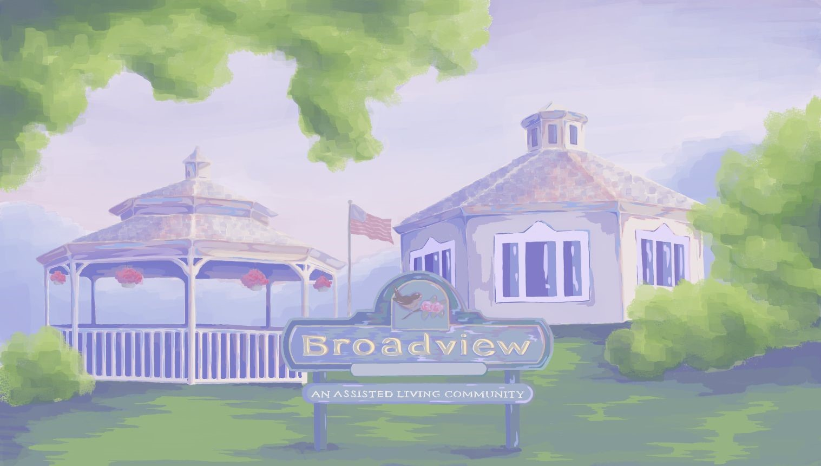
Highlights for the Month:
- 2nd - Catholic Mass with Father Gregory 10:00.
- Entertainment every Friday at 2:30.
- United Parish Church Service, September 6th at 1:15 in the Chapel
- 7th Labor Day, BBQ with the Dan Kirouac 12:00.
- Lunch Trip to the 99 Restaurant, Thursday, September 10th at 11:00 (W.P)
- Bible Study, Thursday, September 10th at 2:30 with Pastor Bob & Kathy (Chapel) 1:00 on 24th
- National Assisted Living Week
- Fun Day Sunday, 13th 10:00 - 2:00 Animal Craze/ Entertainment & More…
- Rosary with Deacon Jim Mondays, September 14th, 21st & 28th at 10:00
- 14th Painting with Lisa at 2:30 (CR)
- 15th Make your own Pizza at 10:00. (DR)
- 15th Hubbardston Senior Singers at 2:30
- 16th Coffee Social with the Winchendon Fire & Police Departments at 10:00. (CR)
- 16th Piano in the Foyer with Gary Landgren, at 2:30.
- 17th Cruisin’ Diner/ Car Show 12:00 (W.P)
- 17th Milkshakes 2:30 (DR)
- 18th Bowling at the HUB 10:00
- 18th Spirit Day, Tailgate Lunch 12:00
- 21st Make your own Banana Split at 2:30.
- 22nd Ukelele Players 2:30 (CR)
- 23rd - Apple picking, Leaving at 9:30.
(Red Apple Farm)
- 28th Resident Birthday Party with Bob Jordan (CR)
- 29th Community Meeting (CR)
- 2:15 Richard Eastham Fall Prevention” (CR)
- 30th Errand trip on Thursday at 9:30.
- 30th - 2:30 S'mores at the Fire Pit
~All Activities Subject to Change ~
Welcome to
The Month of September 2026

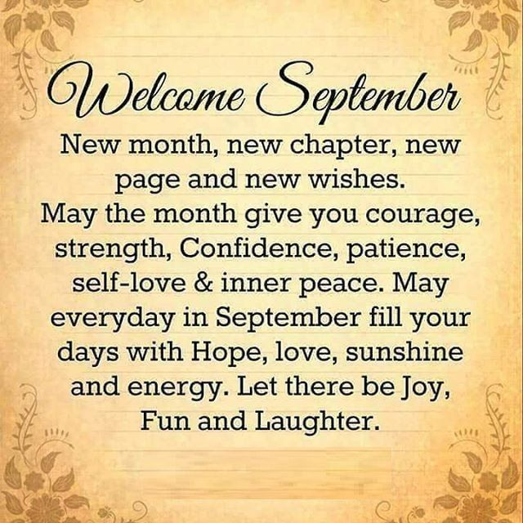

WELCOME NEW MEMBERS TO OUR COMMUNITY!
TRADITIONAL UNIT
Paul M.
MEMORY CARE UNIT
Lois F.
Maria C.
SEPTEMBER BIRTHDAYS
Happy Birthday!
Harold D. September 12th
Pat G. September 16th
Connie B. September 29th
Lois F. September 30th
~~~~~~~~~~~~~~~~~~~~~~~~~~
Wishing Dick & May Burgess!
“A Very Happy 77th Anniversary!”
September 24th 2026
