Bright Horizon’s Activities for September 2026
Sunday | Monday |  | Tuesday |  | Wednesday |  | Thursday |  | Friday |  | Saturday
All Activities Subject to Change | 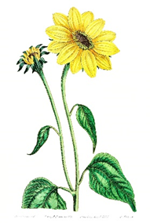 |  | 1  9:30 Mass on TV  10:00 Gardening  (Weather Permitting)  11:15 Exercise  1:00 Bingo  2:30 Coffee Social  On the Patio (Weather Permitting)  4:00 Nails & Tales  6:00 Reminiscence  7:00 Evening Movie  9:00 Bedtime Reading |  | 2  9:30 Mass on TV  10:00 What’s in the bag?  10:00 Catholic Mass with Father Gregory  11:15 Exercise  1:00 Bingo  2:30 Coffee Social  On the Patio (Weather Permitting)  4:00 Bowling  6:00 Evening Small Talk  7:00 Evening Movie  9:00 Bedtime Reading |  | 3  9:30 Mass on TV  10:00 Gardening  (Weather Permitting)  11:15 Exercise  1:00 Bingo  2:30 Coffee Social  On the Patio (Weather Permitting)  4:00 Nails & Tales  6:00 Reminiscence  7:00 Evening Movie  9:00 Bedtime Reading |  | 4  “Hair Day”  9:30 Mass on TV  10:00 Baking muffins  11:15 Exercise  1:00 Bingo  2:30 Entertainment with  Sean Fullerton  2:30 Coffee Social  On the Patio (Weather Permitting)  4:00 List It!  6:00 Reminiscence  7:00 Evening Movie  9:00 Bedtime Reading |  | 5  9:30 Mass on TV  10:00 Gardening  (Weather Permitting)  11:15 Exercise  1:00 Bingo  2:30 Coffee Social  On the Patio (Weather Permitting)  4:00 Helping Around the House  6:00 Evening Small Talk  7:00 Evening Movie  9:00 Bedtime Reading
6  8:00 Mass on TV  10:00 Trivia on the Patio  11:15 Exercise  1:00 Bingo  1:15 United Parish Church Service  2:30 Coffee Social  On the Patio (Weather Permitting)  4:00 Ring Toss  6:00 Evening Small Talk  7:00 Evening Movie  9:00 Bedtime Reading | 7  Labor Day!  9:30 Mass on TV  10:00 Trivia  11:15 Exercise  12:00 BBQ Entertainment  With  Dan Kirouac  1:00 Bingo  2:30 Coffee Social  On the Patio (Weather Permitting)  4:00 Noodle Ball  6:00 Evening Small Talk  7:00 Evening Movie  9:00 Bedtime Reading |  | 8  9:30 Mass on TV  10:00 Gardening  (Weather Permitting)  11:15 Exercise  1:00 Bingo  2:30 Coffee Social  On the Patio (Weather Permitting)  4:00 Nails & Tales  6:00 Evening Small Talk  7:00 Evening Movie  9:00 Bedtime Reading |  | 9  9:30 Mass on TV  10:00 What’s in the bag?  11:15 Exercise  1:00 Bingo  2:30 Coffee Social  On the Patio (Weather Permitting)  2:30 Piano in the Foyer with  Gary Landgren  4:00 Bowling  6:00 Evening Small Talk  7:00 Evening Movie  9:00 Bedtime Reading |  | 10  9:30 Mass on TV  10:00 Gardening  (Weather Permitting)  11:15 Exercise  1:00 Bingo  2:30 Coffee Social  On the Patio (Weather Permitting)  4:00 Nails & Tales  6:00 Reminiscence  7:00 Evening Movie  9:00 Bedtime Reading |  | 11  “Hair Day”  9/11 Remembrance  9:30 Mass on TV  10:00 Baking muffins  11:15 Exercise  1:00 Bingo  2:30 Entertainment with  John Morello  2:30 Coffee Social  On the Patio (Weather Permitting)  4:00 LIST IT  6:00 Evening Small Talk  7:00 Evening Movie  9:00 Bedtime Reading |  | 12  9:30 Mass on TV  10:00 Gardening  (Weather Permitting)  11:15 Exercise  1:00 Bingo  2:30 Coffee Social  On the Patio (Weather Permitting)  4:00 Helping Around the House  6:00 Evening Small Talk  7:00 Evening Movie  9:00 Bedtime Reading
13  8:00 Mass on TV  9:30-11:30  10:00 Animal Craze  11:00 Tie Dye Shirts, Popcorn Face Painting & Games  11:15 Exercise  12:00 Hotdogs  1:00 Bingo  1:00 Entertainment to be Determined.  2:30 Coffee Social  On the Patio (Weather Permitting)  4:00 Ring Toss  6:00 Reminiscence  7:00 Evening Movie  9:00 Bedtime Reading  National | 14  9:30 Mass on TV  10:00 Gardening  (Weather Permitting)  11:15 Exercise  12:00 Lobster Rolls for Lunch 1:00 Bingo  2:30 Coffee Social  On the Patio (Weather Permitting)  2:30 Entertainment  With  “Dick & Dawn”  “Music is Love”  4:00 Noodle Ball  6:00 Evening Small Talk  7:00 Evening Movie  9:00 Bedtime Reading  Assisted |  | 15  9:30 Mass on TV  10:00 Make your Own Pizza  11:15 Exercise  1:00 Bingo  2:30 Coffee Social  On the Patio/  (Weather Permitting)  2:30 Hubbardston Senior Singers (CR)  4:00 Nails & Tales  6:00 Reminiscence  7:00 Evening Movie  9:00 Bedtime Reading  Living |  | 16  9:30 Mass on TV  10:00 Coffee Social with the Winchendon Police and Fire Departments  10:00 What’s in the bag?  11:15 Exercise  1:00 Bingo  2:30 Coffee Social  On the Patio (Weather Permitting)  2:30 Piano in the Foyer with  Gary Landgren  4:00 Bowling  6:00 Reminiscence  7:00 Evening Movie  9:00 Bedtime Reading  Week |  | 17  9:30 Mass on TV  10:00 Gardening  (Weather Permitting)  11:15 Exercise  12:00 ~ 50’s Cruisin’ Diner  Car Show  1:00 Bingo  2:30 Coffee Social  On the Patio (Weather Permitting)  2:30 Milkshakes  4:00 Nails & Tales  6:00 Evening Small Talk  7:00 Evening Movie  9:00 Bedtime Reading  September |  | 18  “Hair Day”  9:30 Mass on TV  10:00 Bowling at the HUB  10:00 Baking muffins  11:15 Exercise  1:00 Bingo  2:30 Entertainment with  Hector & Reid Williams  2:30 Coffee Social  On the Patio (Weather Permitting)  4:00 LIST IT  6:00 Reminiscence  7:00 Evening Movie  9:00 Bedtime Reading  13-19 |  | 19  9:30 Mass on TV  10:00 Gardening  (Weather Permitting)  11:15 Exercise  1:00 Bingo  2:30 Coffee Social  On the Patio (Weather Permitting)  4:00 Helping Around the House  6:00 Reminiscence  7:00 Evening Movie  9:00 Bedtime Reading  2026

Bright Horizon’s Activities for September 2026
Sunday |  | Monday |  | Tuesday |  | Wednesday |  | Thursday |  | Friday |  | Saturday
20  8:00 Mass on TV  10:00 Patio Hour  11:15 Exercise  1:00 Bingo  2:30 Coffee Social  On the Patio (Weather Permitting)  4:00 Ring Toss  6:00 Evening Small Talk  7:00 Evening Movie  9:00 Bedtime Reading |  | 21  9:30 Mass on TV  10:00 Trivia  11:15 Exercise  1:00 Bingo  2:30 Coffee Social  On the Patio (Weather Permitting)  2:30 Make your own Banana Split 4:00 Noodle Ball  6:00 Reminiscence  7:00 Evening Movie  9:00 Bedtime Reading |  | 22  9:30 Mass on TV  10:00 Gardening  (Weather Permitting)  11:15 Exercise  1:00 Bingo  2:30 Coffee Social  On the Patio (Weather Permitting)  2:30 Ukelele Players  4:00 Nails & Tales  6:00 Evening Small Talk  7:00 Evening Movie  9:00 Bedtime Reading  First Day of Autumn   |  | 23  9:30 Mass on TV  10:00 What’s in the bag?  11:15 Exercise  1:00 Bingo  2:30 Coffee Social  On the Patio (Weather Permitting)  4:00 Bowling  6:00 Reminiscence  7:00 Evening Movie  9:00 Bedtime Reading  Johnny Appleseed Day |  | 24  9:30 Mass on TV  10:00 Gardening  (Weather Permitting)  11:15 Exercise  1:00 Bingo  2:30 Coffee Social  On the Patio (Weather Permitting)  4:00 Nails & Tales  6:00 Evening Small Talk  7:00 Evening Movie  9:00 Bedtime Reading |  | 25  Hair Day”  9:30 Mass on TV  10:00 Baking muffins  11:15 Exercise  1:00 Bingo  2:30 Entertainment with  Gary Girouard  2:30 Coffee Social  On the Patio (Weather Permitting)  4:00 LIST IT  6:00 Reminiscence  7:00 Evening Movie  9:00 Bedtime Reading |  | 26  9:30 Mass on TV  10:00 Gardening  (Weather Permitting)  11:15 Exercise  1:00 Bingo  2:30 Coffee Social  On the Patio (Weather Permitting)  4:00 Helping Around the House  6:00 Evening Small Talk  7:00 Evening Movie  9:00 Bedtime Reading
27  8:00 Mass on TV  11:15 Exercise  1:00 Bingo  2:30 Coffee Social  On the Patio (Weather Permitting)  4:00 Ring Toss  6:00 Reminiscence  7:00 Evening Movie  9:00 Bedtime Reading |  | 28  9:30 Mass on TV  10:00 Trivia  11:15 Exercise  1:00 Bingo  2:30 Residents Birthday Party/ Bob Jordan  2:30 Coffee Social  On the Patio (Weather Permitting)  4:00 Noodle Ball  6:00 Evening Small Talk  7:00 Evening Movie  9:00 Bedtime Reading |  | 29  9:30 Mass on TV  10:00 Gardening  (Weather Permitting)  11:15 Exercise  1:00 Bingo  2:30 Coffee Social  On the Patio (Weather Permitting)  4:00 Nails & Tales  6:00 Evening Small Talk  7:00 Evening Movie  9:00 Bedtime Reading |  | 30  9:30 Mass on TV  10:00 What’s in the bag?  11:15 Exercise  1:00 Bingo  2:30 Coffee Social  On the Patio (Weather Permitting)  4:00 Bowling  6:00 Reminiscence  7:00 Evening Movie  9:00 Bedtime Reading  Johnny Appleseed Day |  | 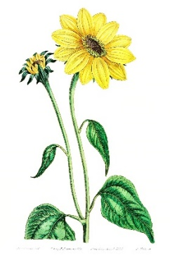 |  | 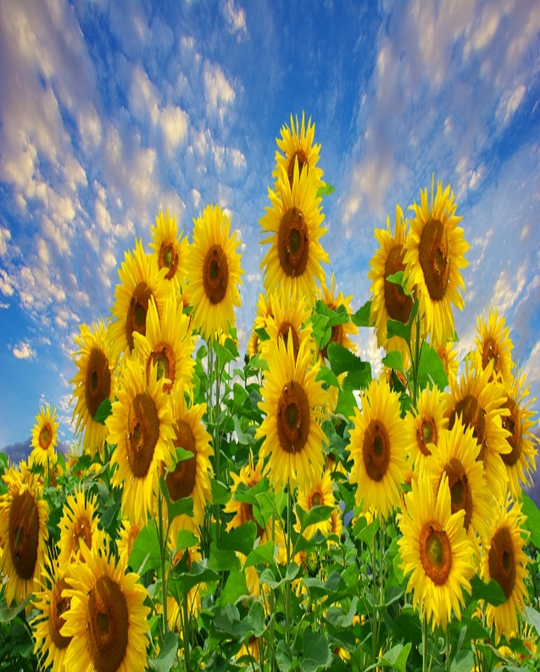
Resident  Birthdays  Harold D. 9/12  Pat G. 9/16  Connie B. 9/29  Lois F. 9/30   |  | 

