SUNDAY | MONDAY | TUESDAY | WEDNESDAY | THURSDAY | FRIDAY | SATURDAY
DR) – Dining Room  (CR) – Community Room  (SR) – Sunroom  (W.P) – Weather Permitting  All Spiritual Activities - Chapel |  | Diane our Hairdresser is usually here, Friday. If you would like a hair appointment, please let Sharon at the Front desk know, or any of the staff. They will let Sharon know so that she can add you to the schedule. Thank-you! |  |  |  | 1  10:00 Game/ Yahtzee (DR)  11:15 Exercise (CR)  1:00 Bingo (CR)  2:15 Snack Cart  3:30 Gazebo Gab Fest (W.P.)
2  10:00 Bingo (CR)    11:15 Exercise (CR)  1:15 United Parish Church Service (Chapel)  2:30 Nails & Tales (SR)  4:00 Cards/ Unlucky 7’s (DR) | 3  10:00 Rosary/ Deacon Jim  11:15 Exercise (CR)  1:00 Bingo (CR)  2:15 Snack Cart  3:30 Word Game (DR) | 4  9:30 Walking Group (W.P)  11:15 Exercise (CR)  1:00 Bingo (CR)  2:00 Country Store Opened  2:15 Snack Cart  3:30 Adult Coloring (CR) | 5 “FOOT DOCTOR”  10:00 Mass/ Father Gregory  11:15 Exercise (Chapel)  1:00 Bingo (DR)  2:30 Piano in the Foyer with  Ethan Stone  4:00 Gazebo Gab Fest (W.P.) | 6 ~ 10:00 Game/ Yahtzee  11:15 Exercise (CR)  1:00 Bingo (CR)  2:00 Country Store Opened  2:15 Snack Cart  2:30 Bible Study (Chapel)  4:00 Cards/ Skipbo (DR) | 7 “Hair Day”  10:00 Game/ Sorry (DR)  11:15 Exercise (CR)  1:00 Bingo (CR)  2:30 Entertainment with  Tim Barrett (CR)  4:00 Cards/ Golf (DR) | 8  10:00 LCR Dice Game (DR)  11:15 Exercise (CR)  1:00 Bingo (CR)  2:15 Snack Cart  3:30 Gazebo Gab Fest (W.P.)
9  10:00 Game (DR)  11:15 Exercise (CR)  1:00 Bingo (CR)  2:30 Nails & Tales (SR)  4:00 Cards/ Crazy 8’s (DR) | 10  10:00 Rosary/ Deacon Jim  11:15 Exercise (CR)  1:00 Bingo (CR)  2:15 Snack Cart  3:30 Word Game (DR) | 11  9:30 Walking Group (W. P.)  11:15 Exercise (CR)  1:00 Bingo (CR)  2:00 Country Store Opened  2:15 Care Central Presentation (CR)  3:30 Adult Coloring (CR) | 12  10:00 Game/ Sorry (DR)  11:15 Exercise (CR)  1:00 Bingo (CR)  2:30 Maddy’s Ice Cream Truck “Ice Cream Social”  4:00 Gazebo Gab Fest (W. P.) | 13  10:00 Game/ Yahtzee (DR)  11:15 Lunch Trip/Kro’s on the Common  11:15 Exercise (CR)  1:00 Bingo (CR)  2:00 Country Store Opened  2:15 Snack Cart  3:30 Cards/ Skipbo (DR) | 14 “Hair Day”  10:00 LCR Dice Game (DR)  11:15 Exercise (CR)  1:00 Bingo (CR)  2:30 Entertainment with  Ron Morey (CR)  4:00 Cards/  Ranter Go Round (DR) | 15  10:00 Game/ Yahtzee (DR)  11:15 Exercise (CR)  1:00 Bingo (CR)  2:15 Snack Cart  3:30 Gazebo Gab Fest (W.P.)
16  10:00 Game (DR)  11:15 Exercise (CR)  1:00 Bingo (CR)  2:30 Nails & Tales (SR)  4:00 Cards/ Ranter Go Round (DR) | 17  10:00 Game/ Yahtzee (DR)  11:15 Exercise (CR)  1:00 Bingo (CR)  2:15 Snack Cart  3:30 Word Game (DR) | 18  9:30 Walking Group (W.P)  11:15 Exercise (CR)  1:00 Bingo (CR)  2:00 Country Store Opened  2:30 Smores out by the Gazebo (W.P.)  4:00 Adult Coloring (CR) | 19  9:30 Errand Trip (W. P.)  11:15 Exercise (CR)  1:00 Bingo (CR)  2:15 Snack Cart  3:30 Gazebo Gab Fest (W.P.) | 20  10:00 Bingo (CR)  11:00 Country Store Opened  11:15 Exercise (CR)  3:00 Nails & Tales (SR)  4:00 Cards/ Skipbo (DR) | 21 “Hair Day”  10:00 Game/ Yahtzee (DR)  11:15 Exercise (CR)  1:00 Bingo (CR)  2:30 Entertainment with Ryan Hood (CR)  4:00 Cards/  Ranter Go Round (DR) | 22  10:00 LCR Dice Game (DR)  11:15 Exercise (CR)  1:00 Bingo (CR)  2:15 Snack Cart  3:30 Gazebo Gab Fest (W.P)
23  10:00 Game (DR)  11:15 Exercise (CR)  1:00 Bingo (CR)  2:30 Nails & Tales (SR)  4:00 Cards/ UNO (DR) | 24  10:00 Rosary/ Deacon Jim  11:15 Exercise (CR)  1:00 Bingo (CR)  2:15 Snack Cart  4:00 Word Game (DR) | 25  10:00 Resident Food & Activities Meeting (CR)  11:15 Exercise (CR)  1:00 Bingo (CR)  2:00 Country Store Opened  2:15 Snack Cart  3:30 Adult Coloring (CR) | 26  10:00 Game/Yahtzee (DR)  11:15 Exercise (CR)  1:00 Bingo (CR)  2:30 Make Your Own Sundae  3:30 Gazebo Gab Fest (W.P.) | 27  10:00 LCR Dice Game (DR)  11:15 Exercise (CR)  1:00 Bingo (CR)  2:00 Country Store Opened  2:15 Snack Cart  2:30 Bible Study (Chapel)  3:30 Cards/ Skipbo (DR) | 28 “Hair Day”  10:00 Game/ Sorry (DR)  11:15 Exercise (CR)  1:00 Bingo (CR)  2:30 Entertainment with  Dan Kirouac (CR)  4:00 Cards/ UNO (DR) | 29  10:00 Game/ Yahtzee (DR)  11:15 Exercise (CR)  1:00 Bingo (CR)  2:15 Snack Cart  3:30 Gazebo Gab Fest (W.P)
30  10:00 Game (DR)  11:15 Exercise (CR)  1:00 Bingo (CR)  2:30 Nails & Tales (SR)  4:00 Cards/ Golf (DR) | 31  10:00 Rosary/ Deacon Jim  11:15 Exercise (CR)  1:00 Bingo (CR)  2:30 Resident’s Birthday Party/ Heather Marie (CR)  4:00 Word Game (DR)

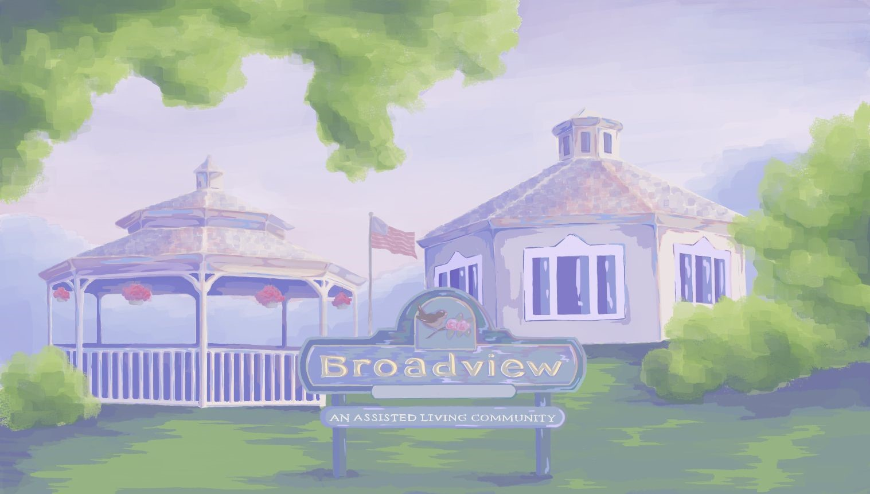
~ Highlights for the Month ~

- United Parish Church Service Sunday, August 2nd at 1:15 (Chapel)
- Rosary with Deacon Jim Monday, August 3rd, 10th, 24th & 31st at 10:00.
- Walking Group Tuesdays at the walking trail, August 4th, 11th & 18th at 9:30.
- Wednesday, August 5th Foot Doctor (Here) Salon
- Catholic Mass with Father Gregory on Wednesday, August 5th at 10:00.
- Piano in the Foyer with Ethan Stone, Wednesday, August 5th at 2:30.
- Bible Study, Thursday, August 6th & 27th at 2:30. (Chapel)
- Entertainment Every Friday at 2:30 (CR)
- Ice Cream Social, Wednesday, August 12th at 2:30. Maddy’s Ice Cream Truck
- Lunch Trip. Thursday, August 13th, 11:15 “Kro’s on the Common”
- Errand trip, Wednesday, August 19th at 9:30.
- Resident Food & Activities Council Meeting, Tuesday, August 25th at 10.
- Make your own Sundae Wednesday, August 26th at 2:30.
- Resident Birthday Party with
Heather Marie on Monday, August 31st at 2:30.

~ All Activities are Subject to Change ~

EMPLOYEE OF THE MONTH
AUGUST
Congratulations Jazmin!
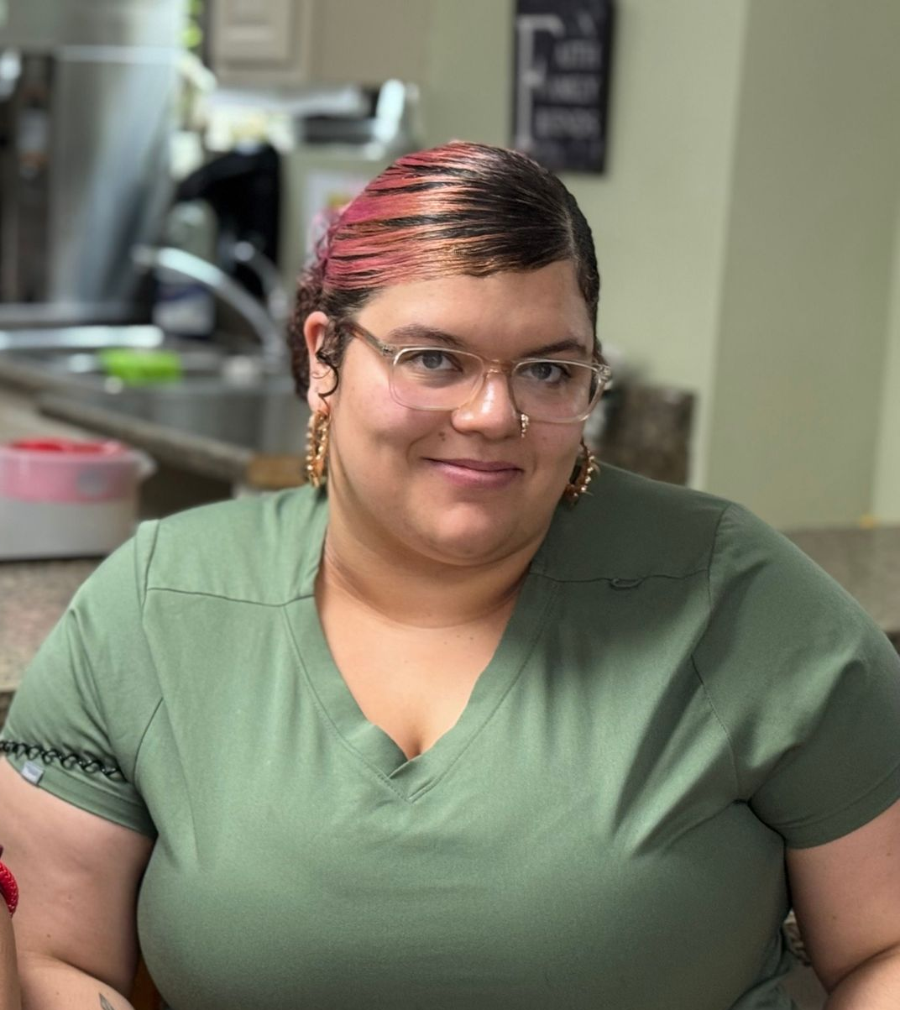

WELCOME NEW MEMBERS TO OUR COMMUNITY!
TRADITIONAL UNIT
Don B.
Jeannette M.
Paul M.
MEMORY CARE UNIT
Lois F.
Maria C.
AUGUST BIRTHDAYS
Rosee M. 10th
Sherri G. 15th
Marlene C. 24th


Hello! Welcome August!
The Month of August
