SUNDAY | MONDAY | TUESDAY | WEDNESDAY | THURSDAY | FRIDAY | SATURDAY
(DR) – Dining Room  (CR) – Community Room  (SR) – Sunroom  (W.P) – Weather Permitting  All Spiritual Activities - Chapel | Diane our Hairdresser is usually here, Friday. If you would like a hair appointment, please let Sharon at the Front desk know, or any of the staff. They will let Sharon know so that she can add you to the schedule. Thank-you! |  | 1  10:00 Mass/ Father Gregory  11:15 Exercise (CR)  1:00 Bingo (CR)  2:15 Snack Cart  3:30 Cards/ Crazy 8’s (DR)  6:00 Movie/Residents Choice | 2  10:00 Game/ Yahtzee (DR)  11:15 Exercise (CR)  1:00 Bingo (CR)  2:15 Snack Cart  2:30 Bible Study (Chapel)  4:00 Cards/ Rummy (DR)  6:00 Movie/ Residents Choice | 3 “Hair Day”  10:00 LCR Dice Game (DR)  11:15 Exercise (CR)  1:00 Bingo (CR)  2:30 Entertainment with  “Sean Fullerton” (CR)  4:00 Cards/Ranter go Round | 4 HAPPY 4TH OF JULY  10:00 Bingo (CR)  11:15 Exercise (CR)  12:00 4th of July BBQ & Entertainment with the “Cavaliers”  3:30 Word Game (DR)  6:00 Movie/ Residents Choice
5  10:00 Bingo (CR)  11:15 Exercise (CR)  1:15 United Parish Church  2:15 Nails & Tales (SR)  3:30 Gazebo Gab Fest (WP)  6:00 Movie/ Residents Choice | 6  10:00 Game/ Yahtzee (DR)  11:15 Exercise (CR)  1:00 Bingo (CR)  2:15 Snack Cart  3:30 Word Game (DR)  6:00 Movie/Residents Choice | 7  9:45 Walking Group (WP)  11:15 Exercise (CR)  1:00 Bingo (CR)  2:00 Country Store Opened  2:15 Snack Cart  3:30 Adult Coloring (CR)  6:00 Movie/Residents Choice | 8  10:00 LCR Dice Game (DR)  11:15 Exercise (CR)  1:00 Bingo (CR)  2:30 Piano in the Foyer with  “Gary Landgren”  4:00 Cards/ Rummy (DR)  6:00 Movie/Residents Choice | 9  10:00 Game/ Yahtzee (DR)  11:00 Lunch Trip to  Little Anthony’s  11:15 Exercise (CR)  1:00 Bingo (CR)  2:00 Country Store Opened 2:15 Snack Cart  3:30 Cards/ Skipbo (DR)  6:00 Movie/ Residents Choice | 10 “Hair Day”  10:00 Game/ Sorry (DR)  11:15 Exercise (CR)  1:00 Bingo (CR)  2:30 Entertainment with  “Gary Girouard” (CR)  4:00 Cards/ Ranter Go Round (DR) | 11  10:00 LCR Dice Game (DR)  11:15 Exercise (CR)  1:00 Bingo (CR)  2:15 Snack Cart  3:30 Word Game (DR)  6:00 Movie/ Residents Choice
12  10:00 Game (DR)  11:15 Exercise (CR)  1:00 Bingo (CR)  2:30 Nails & Tales (SR)  4:00 Gazebo Gab Fest (WP)  6:00 Movie/ Residents Choice | 13  10:00 Rosary (Chapel)  11:15 Exercise (CR)  1:00 Bingo (CR)  2:15 Snack Cart  3:30 Word Game (DR)  6:00 Movie/Residents Choice | 14  9:45 Walking Group (WP)  11:00 Country Store Opened  11:15 Exercise (CR)  2:15 Care Central Presentation (CR)  3:30 Adult Coloring (CR)  6:00 Movie/Residents Choice | 15  10:00 Game/ Sorry (DR)  11:15 Exercise (CR)  1:00 Bingo (CR)  2:30 Ice Cream Social Murdock Farm (DR)  3:30 Cards/ Skipbo (DR)  6:00 Movie/Residents Choice | 16  10:00 Bingo (CR)  11:00 Country Store Opened  11:15 Exercise (CR)  1:00 Bible Study (Chapel)  1:00 Movie/ Residents Choice  3:30 Cards/ Golf (DR)  6:00 Movie/ Residents Choice | 17 “Hair Day”  10:00 LCR Dice Game (DR)  11:15 Exercise (CR)  1:00 Bingo (CR)  2:30 Entertainment with  “Reid & Hector Williams”(CR)  4:00 Cards/ Ranter Go Round (DR) | 18  10:00 Game/ Yahtzee (DR)  11:15 Exercise (CR)  1:00 Bingo (CR)  2:15 Snack Cart  3:30 Word Game (DR)  6:00 Movie/Residents Choice
19  10:00 Game (DR)  11:15 Exercise (CR)  1:00 Bingo (CR)  2:30 Nails & Tales (SR)  4:00 Gazebo Gab Fest (WP)  6:00 Movie/ Residents Choice | 20  10:00 Rosary (Chapel)  11:15 Exercise (CR)  1:00 Bingo (CR)  2:15 Snack Cart  3:30 Word Game (DR)  6:00 Movie/Residents Choice | 21  9:45 Walking Group (WP)  11:15 Exercise (CR)  1:00 Bingo (CR)  2:00 Country Store Opened  3:30 Adult Coloring (CR)  6:00 Movie/Residents Choice | 22  9:30 Errand Trip (W. P.)  11:15 Exercise (CR)  1:00 Bingo (CR)  2:30 Smore’s at the Fire Pit  6:00 Movie/Residents Choice | 23  10:00 Game/ Yahtzee (DR)  11:15 Exercise (CR)  1:00 Bingo (CR)  2:00 Country Store Opened  2:15 Snack Cart  3:30 Cards/ Skipbo (DR)  6:00 Movie/ Residents Choice | 24 “Hair Day”  10:00 Bingo (CR)  11:15 Exercise (CR)  1:00 Independent Gazebo Gab Fest (WP)  2:30 Entertainment with  “Terry Nally” (CR)  4:00 Cards/ Ranter Go Round (DR) | 25  10:00 Game/ Yahtzee (DR)  11:15 Exercise (CR)  1:00 Bingo (CR)  2:15 Snack Cart  3:30 Word Game (DR)  6:00 Movie/Residents Choice
26  10:00 Game (DR)  11:15 Exercise (CR)  1:00 Bingo (CR)  2:30 Nails & Tales (SR)  4:00 Gazebo Gab Fest (WP)  6:00 Movie/ Residents Choice | 27  10:00 Game/ Yahtzee (DR)  11:15 Exercise (CR)  1:00 Bingo (CR)  2:30 Resident’s Birthday Party/ “Paul & Paula” (CR)  4:00 Word Game (DR)  6:00 Movie/Residents Choice | 28  10:00 Resident Food & Activities Council Meeting (CR)  11:15 Exercise (CR)  1:00 Bingo (CR)  2:00 Country Store Opened  2:15 Snack Cart  3:30 Adult Coloring (CR) | 29  10:00 Game/ Sorry (DR)  11:15 Exercise (CR)  1:00 Bingo (CR)  2:30 Ice Soda Social (DR)  3:30 Cards/ Skipbo (DR)  6:00 Movie/Residents Choice | 30  10:00 Game/ Yahtzee (DR)  11:15 Exercise (CR)  1:00 Bingo (CR)  2:00 Country Store Opened  2:15 Snack Cart  3:30 Cards/ Skipbo (DR)  6:00 Movie/ Residents Choice | 31  10:00 LCR Dice Game (DR)  11:15 Exercise (CR)  1:00 Bingo (CR)  2:30 Entertainment with  “Surround Sound” (CR)  4:00 Cards/ Ranter Go Round (DR) | 

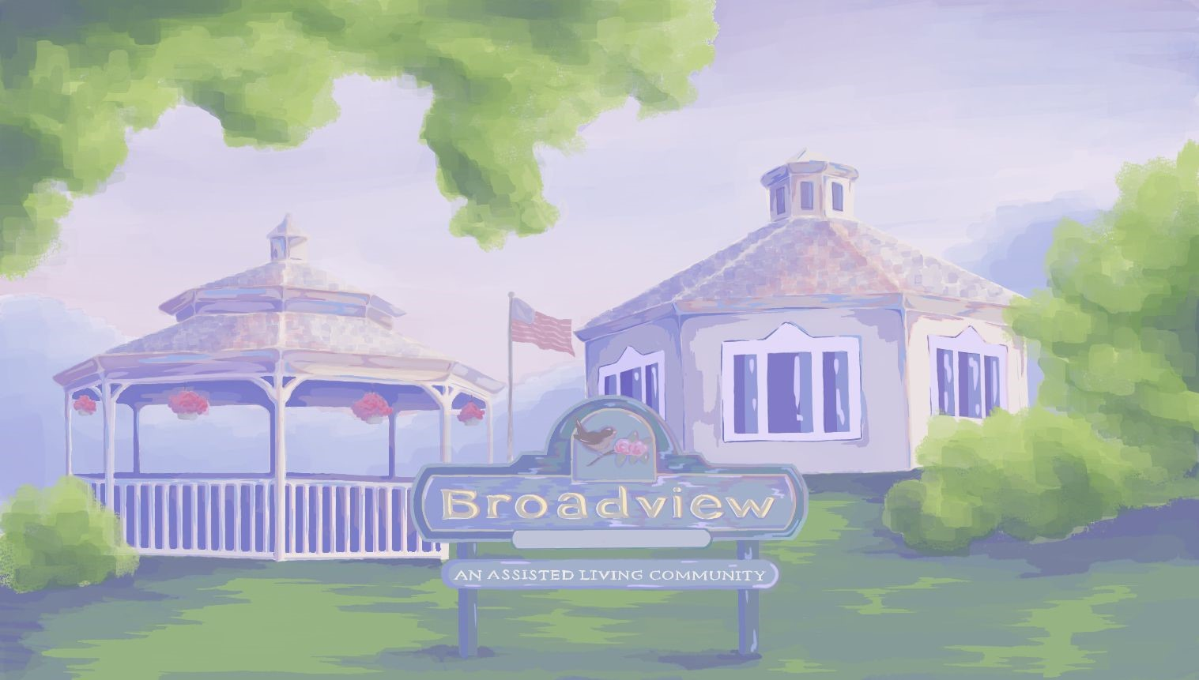
July Highlights
- Catholic Mass with Father Gregory on Wednesday, July 1st at 10:00.
- Bible Study with Pastor Bob, Thursday July 3rd at 2:30 (Chapel)
- Entertainment every Friday at 2:30.
- 12:00 Saturday July 4th - 4th of July BBQ with Entertainment by the Cavaliers. Outside Weather Permitting.
- United Parish Church service at 1:15 on July 5th.
- Adult Coloring Every Tuesday (CR)
- Walking Group at the walking Trail 9:45 On Tuesdays July 7th, 14th & 21st.
- Piano in the Foyer with Gary Landgren Wednesday July 8th at 2:30.
- Lunch Trip to Little Anthony’s Thursday, July 9th at 11:00.
- Rosary Monday July 13th, 20th & 27th at 10:00 with Deacon Jim (Chapel)
- Care Central Presentation with Richard Eastham Tuesday, July 14th at 2:15. Skin Health and What Every Older Adult Should Know.
- Ice Cream Social at 2:30 July 15th.
- Bible Study with Pastor Bob, Thursday July 16th at 1:00 (Chapel)
- Errand trip on Wednesday, July 22nd at 9:30.
- Smore’s at the Fire Pit by the Gazebo Wednesday, July 22nd at 2:30. (W.P)
- Resident Birthday Party with “Paul & Paula” on Monday, July 27th at 2:30.
- Resident Food & Activities Council Meeting Tuesday, July 28th at 10:00.
ALL ACTIVITIES SUBJECT TO CHANGE
EMPLOYEE OF THE MONTH
CONGRATULATIONS! 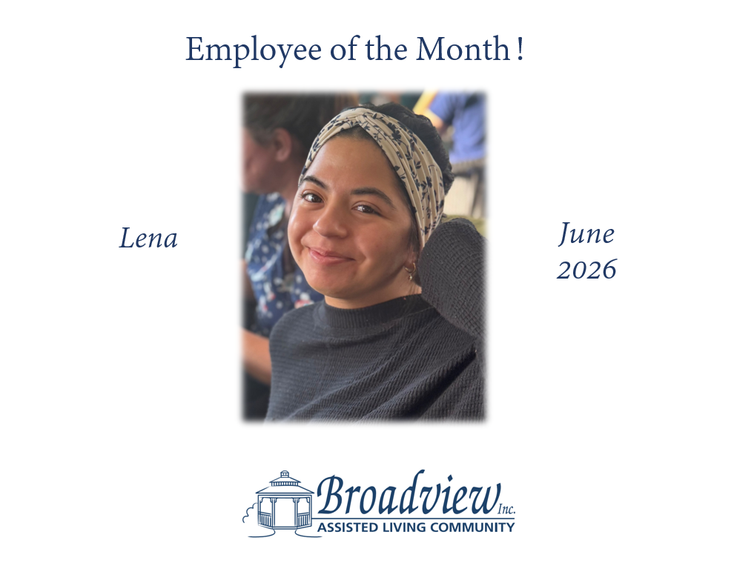
WELCOME NEW MEMBERS TO OUR COMMUNITY!
TRADITIONAL UNIT
Marlene G. (Respite)
Sally F.
~~~~~~~~~~~~~~~~~~~~~~~~~~~~~~
JULY BIRTHDAYS
Bill W. 8th
Priscilla M. 12th
Pat M. 22nd
Ruth Q. 30th




