Broadview Activities for March 2020
Sunday | Monday |  | Tuesday | Wednesday |  |  |  | Thursday | Friday | Saturday
1  7:00 Mass on TV  10:00 Bingo  11:15 Exercise  1:00 United Parish Church Service  2:00 Game/ Sorry  3:30 Unlucky 7’s  6:00 Movie/  “LeapYear”  World Compliment Day | 2  9:30 Mass on TV 10:00 Bean Bag Toss  11:15 Exercise  1:00 Bingo  2:00 Piano Music in the Lobby with Joanne  4:00 Word Game  7:00 Wheel of  Fortune  7:30 Jeopardy  Dr. Seuss Day |  | 3  9:30 Mass on TV  10:00 Arts & Crafts/ Shamrock Wreath  11:15 Exercise  1:00 Bingo  2:30 Errand Trip  3:30 Country  Store Opened  4:00 Nails & Tales  6:00 Movie/  Andre Rieu “The Flying Dutchman” |  | 4  10:00 Catholic Mass with  Father Henry  11:15 Exercise  1:00 Bingo  2:30 Entertainment with Cameron Sutphin  4:00 Penny Ante  7:00 Wheel of Fortune  7:30 Jeopardy |  | 5  9:30 Mass on TV  10:00 List it!  11:15 Exercise  1:00 Bingo  2:00 Blood Pressure Clinic  In the Country Kitchen  2:30 Cards/UNO  3:30 Country  Store Opened  4:00 Nails & Tales  6:00 Movie/  “Field of Dreams” |  | 6  “Hair Day”  9:30 Mass on TV  10:00 Penny Ante  11:15 Exercise  1:00 Bingo  2:30 Social Hour/  Tony Valley  4:00 Word Game  7:00 Wheel of Fortune  7:30 Jeopardy  Employee Appreciation Day | 7  9:30 Mass on TV  10:00 Bingo  11:15 Exercise  1:00 Cards  2:30 Finish the Phrase…  3:30 Movie/ “Speak Easily”  3:45 Catholic Mass  6:00 Saturday Night at the Movies/ Resident Choice
8  7:00 Mass on TV  10:00 Coffee Hour/ Social  11:15 Exercise  1:00 Bingo  2:30 Mystery Ride (Weather Permitting)  4:00 Unlucky 7’s  6:00 Movie/  “David Copperfield”  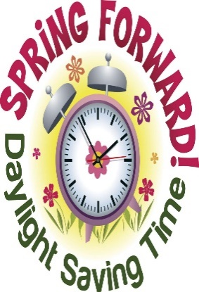 | 9  9:30 Mass on TV  9:30 Mount Wachusett Dental Hygienists  10:00 Bean Bag Toss  11:15 Exercise  1:00 Bingo  2:00 Piano Music in the Lobby with Joanne  4:00 Word Game  7:00 Wheel of  Fortune  7:30 Jeopardy |  | 10  9:30 Mass on TV  10:00 Baking/  Shamrock Cookies  11:15 Exercise  1:00 Bingo  2:30 Errand Trip  3:30 Country  Store Opened  4:00 Nails & Tales  6:00 Movie/  Andre Rieu “Live in Vienna” | 11  10:00 Catholic Mass with  Father Henry  11:15 Exercise  1:00 Bingo  3:00 LCR  Dice Game  4:00 Penny Ante  7:00 Wheel of Fortune  7:30 Jeopardy  Johnny Appleseed Day |  |  | 12  9:30 Mass on TV  10:00 List it!  11:30 Lunch Trip/  Monty Tech.  11:15 Exercise  1:00 Bingo  2:30 Cards/UNO  3:30 Country  Store Opened  4:00 Nails & Tales  6:00 Movie/  “The Fortune Cookie” |  | 13  “Hair Day”  9:30 Mass on TV  10:00 LCR Dice Game  11:15 Exercise  1:00 Bingo  2:30 Social  Hour/  Legacy Band  4:00 Word Game  7:00 Wheel of Fortune  7:30 Jeopardy | 14  9:30 Mass on TV  10:00 Bingo  11:15 Exercise  1:00 Cards  2:30 Finish the Phrase…  3:30 Movie/  “The Gauntlet”  6:00 Saturday Night at the Movies/ Resident Choice
15  7:00 Mass on TV  10:00 Bingo  11:15 Exercise  1:30 Irish American Step Dancers  &  St. Paddy’s Day Pub Party  4:00 Giant Crossword Puzzle  6:00 Movie/  “Houseboat”  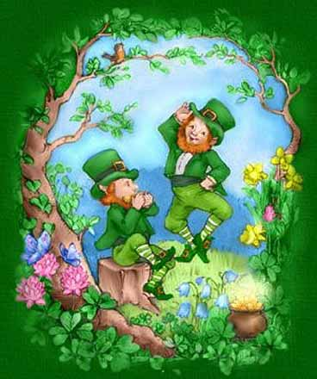 | 16  9:30 Mass on TV  10:00 Bean Bag Toss  11:15 Exercise  1:00 Bingo  2:00 Piano Music in the Lobby with Joanne  4:00 Word Search  7:00 Wheel of  Fortune  7:30 Jeopardy |  | 17  St. Patrick’s Day  9:30 Mass on TV  10:00 Arts & Crafts/ Leprechaun Puppets  11:15 Exercise  1:00 Bingo  2:30 Errand Trip  3:30 Country  Store Opened  4:00 Nails & Tales  6:00 Movie/  “Celtic Thunder” | 18  9:30 Mass on TV  10:00 Catholic Mass with  Father Henry  11:15 Exercise  1:00 Bingo  2:30 Cards/ UNO  4:00 LCR Dice Game  7:00 Wheel of  Fortune  7:30 Jeopardy |  |  | 19  9:30 Mass on TV  10:00 Bingo  11:15 Exercise  1:00 Movie/ “When Calls the Heart”  3:30 Country  Store Opened  4:00 Nails & Tales  6:00 Movie/  “The General and Steamboat  Bill Jr.” |  | 20  “Hair Day”  9:30 Mass on TV  10:00 UNO  11:15 Exercise  1:00 Bingo  2:30 Social  Hour/  Terry Nally  4:00 Word Game  7:00 Wheel of Fortune  7:30 Jeopardy  First Day of Spring | 21  9:30 Mass on TV  10:00 Bingo  11:15 Exercise  1:00 Cards  2:30 Finish the Phrase…  3:30 Movie/ “Burglar”  3:45 Catholic Mass  6:00 Saturday Night at the Movies/ Resident Choice
Broadview Activities for March 2020
Sunday |  | Monday | Tuesday |  |  | Wednesday |  | Thursday | Friday |  | Saturday
22  7:00 Mass on TV  10:00 Coffee Social Hour  11:15 Exercise  1:00 Bingo  2:30 Mystery Ride (Weather Permitting)  4:00 Game/ UNO  6:00 Movie/  “Andre Rieu “Live in Dublin” |  | 23  9:30 Mass on TV  10:00 Bean Bag Toss  11:15 Exercise  1:00 Bingo  2:00 Piano Music in the Lobby with Joanne  4:00 Crossword Puzzles  7:00 Wheel of  Fortune  7:30 Jeopardy | 24  9:30 Mass on TV  10:00 Baking/  Thin Mints  11:15 Exercise  1:00 Bingo  2:30 Errand Trip  3:30 Country  Store Opened  4:00 Nails & Tales  6:00 Movie/  “Black Beauty” |  |  | 25  10:00 Catholic Mass with  Father Henry  11:15 Exercise  1:00 Bingo  2:30 UNO/ Cards  4:00 Trivia  7:00 Wheel of  Fortune  7:30 Jeopardy |  | 26  9:30 Mass on TV  10:00 LCR Dice Game  11:15 Exercise  1:00 Bingo  2:30 Unlucky 7’s  3: 30 Country  Store Opened  6:00 Movie/  “Call of the Wild”  Purple Day | 27  “Hair Day”  9:30 Mass on TV  10:00 Penny Ante  11:15 Exercise  1:00 Bingo  2:30 Social Hour/  Cavaliers  4:00 Word Game  7:00 Wheel of  Fortune  7:30 Jeopardy |  | 28  9:30 Mass on TV  10:00 Bingo  11:15 Exercise  1:00 Cards  2:30 Finish the Phrase…  3:30 Movie/  “Driving Miss Daisy”  6:00 Saturday Night at the Movies/ Resident Choice
29  7:00 Mass on TV  10:00 Coffee  Hour/ Finish the Word…  11:15 Exercise  1:00 Bingo  2:30 Mystery Ride (Weather Permitting)  4:00 List it!  6:00 Movie/  “The Bishop’s Wife” |  | 30  9:30 Mass on TV  10:00 LCR Dice Game  11:15 Exercise  1:00 Bingo  2:30 Resident  Birthday Party/  Rich Araldi  4:00  7:00 Wheel of  Fortune  7:30 Jeopardy | 31  9:30 Mass on TV  10:00 Arts & Crafts/Tissue Paper Pom-Poms  11:15 Exercise  1:00 Bingo  2:00 Resident Food & Activity Council Meeting  3:30 Country  Store Opened  4:00 Nails & Tales  6:00 Movie/  “My Big Fat Greek Wedding” |  |  |  |  | 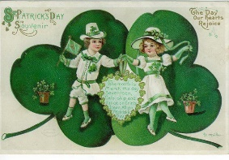
31  Resident  Birthdays  Bob P 3/9  Angie R. 3/18  Pat P. 3/18  Eleanor T. 3/19 |  | Main Events  1-1:00 United Parish Church Service 9- Mount Wachusett Dental Hygienists at 9:30 AM  2, 9, 16 & 23- 2:00 Piano Music in the Lobby with Joanne 12-11:30 Lunch Trip/Monty Tech.  3, 10, 17 & 24-2:30 Errand Trip (Weather Permitting) 13-2:30 Social Hour/ Legacy Band  4, 11, 18 & 25-10:00 Catholic Mass with Father Henry 15-1:30 Irish American Step Dancers  4- 2:30 Entertainment with Cameron Sutphin 15-St. Paddy’s Day Pub Party Following Irish Step Dancing  5-2:00 Blood Pressure Clinic 20-2:30 Social Hour/Terry Nally  6-2:30 Social Hour/ Tony Valley 27-2:30 Social Hour/The Cavaliers  7 & 21-3:45 Catholic Mass 30-2:30 Resident Birthday Party/ Rich Araldi  8, 22 & 29-2:30 Mystery Ride (Weather Permitting) 31-2:00 Resident Food & Activity Council Meeting  Country Store is open on Tuesday & Thursday - 3:30PM  Movies will be held on Tuesday & Thursday at 6:00PM, Saturday at 3:30 PM & 6:00 PM  Sunday @ 6:00 PM in the TV Room

