Bright Horizon’s Activities for December 2019
Sunday | Monday |  | Tuesday | Wednesday |  |  |  | Thursday | Friday | Saturday
1  Mass on TV  Exercise  Bingo  Helping Around the House  1:00 United  Parish Church  Service  Coffee Social  Bowling  Evening Small Talk  Bedtime Reading  Evening Movie | 2  Mass on TV  Trivia  Exercise  Bingo  2:00 Piano Music in the Lobby with Joanne While  Decorating the Christmas Tree  Nails & Tales  4:00 Tree Lighting Ceremony  Evening Small Talk  Reminiscence  Bedtime Reading  Evening Movie |  | 3  Mass on TV  10:00 Baking/  Santa Cookies Coffee Social  Exercise  Bingo  Horse Races  Nails & Tales  Evening Small Talk  Bedtime Reading  Evening Movie |  | 4  Catholic Mass with Father Carlos  Exercise  Sensory  (Tasting Test)  Bingo  2:30 Entertainment with Legacy Band  Bowling  Evening Small Talk  Bedtime Reading  Evening Movie |  | 5  Mass on TV  Exercise  What’s in the bag?  Bingo  List It!  3:30 Country  Store Opened  Afternoon Stretch  Nails & Tales  Evening Small Talk  Bedtime Reading  Evening Movie |  | 6  “Hair Day”  Mass on TV  Exercise  Bingo  2:30 Social Hour/ Walter Deery  LIST IT  Afternoon Stretch  Helping Around the House  Evening Small Talk  Bedtime Reading  Evening Movie | 7  10-2 Holiday Fair  11:00-2:00  Visits with Santa  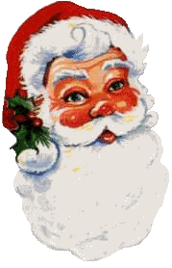  2:00 Bingo  4:00 Surround Sound Entertainment
8  Mass on TV  Exercise  Bingo  Helping Around the House  Coffee Social  Bowling  Evening Small Talk  Evening Small Talk  Bedtime Reading  Evening Movie | 9  Mass on TV  Trivia  Exercise  What’s in the bag?  Bingo  Noodle Ball  Nails & Tales  Reminiscence  Evening Small Talk  Bedtime Reading  Evening Movie |  | 10  Mass on TV  10:00 Arts & Crafts/  Beaded Wreaths  Coffee Social  Exercise  3:30 Rosary  Bingo  Horse Races  Nails & Tales  Evening Small Talk  Bedtime Reading  Evening Movie | 11  Mass on TV  Exercise  Sensory  (Tasting Test)  Bingo  Bowling  Evening Small Talk  Evening Small Talk  Bedtime Reading  Evening Movie |  |  | 12  Mass on TV  Exercise  11:00 Lunch Trip/  Emma’s Restaurant  What’s in the bag?  Bingo  List It!  3:30 Country  Store Opened  Afternoon Stretch  Nails & Tales  Evening Small Talk  Bedtime Reading  Evening Movie |  | 13  “Hair Day”  Mass on TV  Exercise  Bingo  2:30 Social Hour/  Terry Nally  LIST IT  Afternoon Stretch  Helping Around the House  Evening Small Talk  Bedtime Reading  Evening Movie | 14  Mass on TV  Bingo  Exercise  Noodle Ball  Sensory  (Touch)  3:00 United Parish Church  Cantata  Trivia  Evening Small Talk  Bedtime Reading  Evening Movie  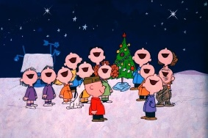
15  Mass on TV  Exercise  Bingo  2:00 Caroling & Cookies with the Winchendon Cub Scouts Pack 193 Helping Around the House  Coffee Social  Bowling  4:00 United Parish Church Christmas Caroling around the Building  Evening Small Talk  Bedtime Reading  Evening Movie  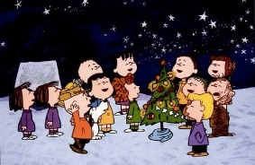 | 16  Mass on TV  Trivia  Exercise  Bingo  2:00 Piano Music in the Lobby with Joanne  Reminiscence  Evening Small Talk  Bedtime Reading  Evening Movie |  | 17  Mass on TV  10:00 Baking/  Gingerbread Houses  Exercise  Bingo  Coffee Social  Nails & Tales  Evening Small Talk  Bedtime Reading  Evening Movie | 18  Mass on TV  Exercise  Visualization  Bingo  Coffee Social  Bowling  Evening Small Talk  Bedtime Reading  Evening Movie  6:00 PM  1st Baptiste Church Choir  Christmas Carols  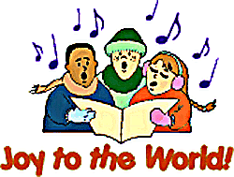 |  |  | 19  Mass on TV  Exercise  What’s in the bag?  Bingo  List It!  Coffee Social  3:30 Country  Store Opened  Afternoon Stretch  Nails & Tales  Evening Small Talk  Bedtime Reading  Evening Movie |  | 20  “Hair Day”  Mass on TV  Exercise  Bingo  2:30 Social Hour/ The Cavaliers  LIST IT  Afternoon Stretch  Helping Around the House  Evening Small Talk  Bedtime Reading  Evening Movie | 21  Mass on TV  Bingo  Exercise  Corner Stone  Church Christmas Carolers time to be announced  Noodle Ball  Sensory  (Tasting Test)  Evening Small Talk  Bedtime Reading  Evening Movie  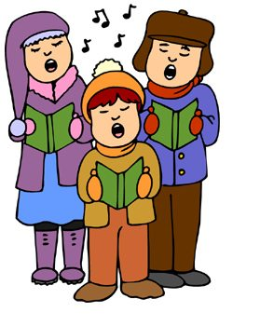
Bright Horizon’s Activities for December 2019
Sunday |  | Monday | Tuesday |  |  | Wednesday |  | Thursday | Friday |  | Saturday
22  Mass on TV  Exercise  Bingo  Helping Around the House  Coffee Social  Ring Toss  Evening Small Talk  Bedtime Reading  Evening Movie |  | 23  Mass on TV  Trivia  Exercise  Bingo  2:00 Resident Christmas Party  Sensory (Touch)  Sensory  (Tasting Test)  Reminiscence  Bedtime Reading  Evening Movie  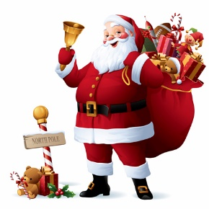 | 24  Christmas Eve  Mass on TV  10:00 Arts & Crafts/ Pipe Cleaner Beaded Snowflakes  Coffee Social  Exercise  Bingo  Evening Small Talk  Bedtime Reading  Evening Movie  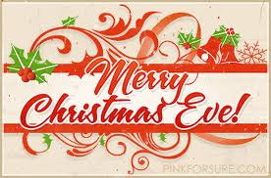 |  |  | 25  Christmas Day  Mass on TV  Exercise  Sensory  (Smelling Test)  Bingo  Bowling  Evening Small Talk  Bedtime Reading  Evening Movie |  | 26  10:00 Catholic Mass with Father Carlos  Exercise  Mini Golf  Bingo  List It!  3:30 Country  Store Opened  Afternoon Stretch  Nails & Tales  Evening Small Talk  Bedtime Reading  Evening Movie | 27  “Hair Day”  Mass on TV  Exercise  Bingo  2:30 Social Hour/ Sean Fullerton  LIST IT  Afternoon Stretch  Helping Around the House  Evening Small Talk  Bedtime Reading  Evening Movie |  | 28  Mass on TV  Bingo  Exercise  Noodle Ball  Mini Golf  Sensory  (Tasting Test)  3:45 Saturday Mass at Church  Evening Small Talk  Bedtime Reading  Evening Movie
29  Mass on TV  Exercise  Bingo  Helping Around the House  Coffee Social  Ring Toss  Evening Small Talk  Bedtime Reading  Evening Movie |  | 30  Mass on TV  Trivia  Exercise  Bingo  2:30 Resident Birthday Party  With  Tony Valley  What’s in the bag?  Evening Small Talk  Reminiscence  Bedtime Reading  Evening Movie | 31  New Year’s Eve  Mass on TV  10:00 Resident Food & Activity Council Meeting  Coffee Social  Exercise  2:30 New Year’s Eve Celebration/ Music and Snacks in the Community Room  Bingo  Trivia  Ring Toss  Evening Small Talk  Bedtime Reading  Evening Movie |  |  |  |  |  |  |  | Resident  Birthdays  Chris W. -Dec. 21  Carol M- Dec. 22  Ellen H. -Dec. 26  Cheryl S. Dec. 31
Main Events

1-United Parish Church Service at 1:00 PM | 15-2:00 Caroling & Cookies with Winchendon Cub Scouts
2 & 16-Piano music in the Lobby with Joanne at 2:00 PM | 15-4:00 United Parish Church Christmas Caroling
2- Decorating the Christmas tree in the Lobby at 2:00 | 18-6:00 PM 1st Baptiste Church Choir Christmas Carols
2-Tree Lighting Ceremony at 4:00 | 20-Social Hour with The Cavaliers at 2:30pm
4- 10:00 Mass with Father Carlos | 21-Corner Stone Church Christmas Carolers (TBA)
4-2:30 Entertainment with Legacy Band | 23-2:00 Resident Christmas Party
6-Social Hour with Walter Deery at 2:30 | 24-Christmas Eve
7-Holiday Craft Fair 10-2 | 25- Christmas Day, Merry Christmas!
7-4:00 Entertainment with Surround Sound | 26-10:00 Mass with Father Carlos
9-Lindsey’s Baby Shower | 27-2:30 Social Hour/ Sean Fullerton
10-Rosary at 3:30pm | 28-3:45 Saturday Mass at Church
12-Lunch Trip to the Emma’s Restaurant 11:30 AM | 30-Resident Birthday Party with Tony Valley at 2:30pm
13-Social Hour with Terry Nally at 2:30 | 31-10:00 Resident Food & Activity Council Meeting
14-3:00 United Parish Church Cantata | 31-New Year’s Eve Celebration at 2:30 “Happy New Year!”

Country Store is open on Tuesday & Thursday - 3:30PM
Movies will be held on Tuesday & Thursday at 6:00PM, Saturday at 3:30 PM & 6:00 PM
Sunday @ 6:00PM in the TV Room
*TBA To Be Announced

