Bright Horizon’s Activities for November 2019
Sunday | Monday |  | Tuesday | Wednesday |  |  |  | Thursday | Friday | Saturday
Resident  Birthdays  Mary S. 11:18  Joan R. 11:27  Lila D. 11/29 |  |  |  |  |  |  |  |  | 1  Mass on TV  Exercise  Bingo  2:30 Social Hour/ Tony Valley  LIST IT  Afternoon Stretch  Helping Around the House  Evening Small Talk  Bedtime Reading  Evening Movie | 2  Mass on TV  Bingo  Exercise  Thanksgiving Noodle Ball  Trivia  Evening Small Talk  Bedtime Reading  Evening Movie  Book Lovers Day  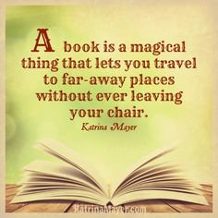
3  Mass on TV  Exercise  Bingo  Helping Around the House  1:00 United  Parish Church  Service  Coffee Social  Bowling  Evening Small Talk  Bedtime Reading  Evening Movie | 4  Mass on TV  Trivia  Exercise  Bingo  2:00 Piano Music in the Lobby with Joanne  Nails & Tales  Reminiscence  Bedtime Reading  Evening Movie |  | 5  “Hair Day”  Mass on TV  10:00 Baking/  Easy Carmel Apple Taquitos  Guinea Pig Social  Exercise  Bingo  Horse Races  Nails & Tales  Evening Small Talk  Bedtime Reading  Evening Movie | 6  10:00 Catholic Mass with  Father Carlos  Exercise  Sensory  (Tasting Test)  Bingo  2:30 Piano Music with  Diane Ammons  Bowling  Evening Small Talk  Bedtime Reading  Evening Movie |  |  | 7  Flu Clinic  Mass on TV  Exercise  What’s in the bag?  Bingo  List It!  2:30 Flu Clinic  3:30 Country  Store Opened  Afternoon Stretch  Nails & Tales  Evening Small Talk  Bedtime Reading  Evening Movie |  | 8  Mass on TV  Exercise  Bingo  2:30 Social Hour/  Dick & Dawn  LIST IT  Afternoon Stretch  Helping Around the House  Evening Small Talk  Bedtime Reading  Evening Movie | 9  Mass on TV  Bingo  Exercise  Thanksgiving Noodle Ball  Sensory  (Touch)  3:45 Saturday Mass at Church  Trivia  Evening Small Talk  Bedtime Reading  Evening Movie
10  Forget Me Not Day  Mass on TV  Exercise  Bingo  Helping Around the House  Coffee Social  Bowling  Evening Small Talk  Bedtime Reading  Evening Movie  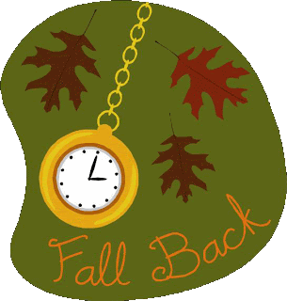  Day Light Savings Time | 11  Mass on TV  Trivia  Exercise  Bingo  1:00 Veterans Day Presentation with Legion Post 193 & the Chamber Singers  2:00 Piano Music in the Lobby with Joanne  Reminiscence  Bedtime Reading  Evening Movie |  | 12  “Hair Day”  Mass on TV  10:00 Arts & Crafts/Beaded Pumpkins  Guinea Pig Social  Exercise  Bingo  3:30 Rosary  Nails & Tales  Evening Small Talk  Bedtime Reading  Evening Movie | 13  10:00 Catholic Mass with  Father Carlos  Exercise  Visualization  Bingo  2:30 Animal Craze (CR)  Bowling  Evening Small Talk  Bedtime Reading  Evening Movie  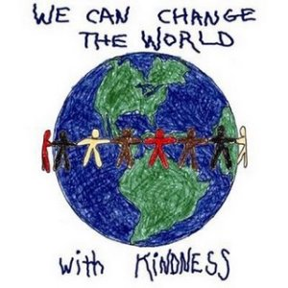 |  |  | 14  Mass on TV  11:00 Lunch Trip/  99 Restaurant  Exercise  What’s in the bag?  Bingo  List It!  3:30 Country  Store Opened  Afternoon Stretch  Nails & Tales  Evening Small Talk  Bedtime Reading  Evening Movie  Gardner Museum  November 14th-December 7th |  | 15  Mass on TV  Exercise  Bingo  2:30 Social Hour/ Heather Marie LIST IT  Afternoon Stretch  Helping Around the House  Evening Small Talk  Bedtime Reading  Evening Movie | 16  Mass on TV  Bingo  Exercise  Thanksgiving Noodle Ball  Sensory  (Tasting Test)  Evening Small Talk  Bedtime Reading  Evening Movie
Bright Horizon’s Activities for November 2019
Sunday |  | Monday | Tuesday |  |  | Wednesday |  | Thursday | Friday |  | Saturday
17  Mass on TV  Exercise  Bingo  Helping Around the House  Coffee Social  Ring Toss  Evening Small Talk  Bedtime Reading  Evening Movie  World Peace Day |  | 18  Mass on TV  Trivia  Exercise  Bingo  Sensory (Touch)  Sensory  (Tasting Test)  Reminiscence  Bedtime Reading  Evening Movie | 19  “Hair Day”  Mass on TV  10:00 Arts & Crafts/  Guinea Pig Social  Exercise  Bingo  3:30 Rosary  Evening Small Talk  Bedtime Reading  Evening Movie |  |  | 20  “Foot Doctor”  10:00 Catholic Mass with Fr. Carlos  Exercise  Sensory  (Smelling Test)  Bingo  2:00 Piano Music in the Lobby with Joanne  Bowling  Evening Small Talk  Bedtime Reading  Evening Movie |  | 21  Mass on TV  Exercise  Mini Golf  Bingo  List It!  3:30 Country  Store Opened  Afternoon Stretch  Nails & Tales  Evening Small Talk  Bedtime Reading  Evening Movie | 22  Mass on TV  Exercise  Bingo  2:30 Social Hour/ Terry Nally  LIST IT  Afternoon Stretch  Helping Around the House  Evening Small Talk  Bedtime Reading  Evening Movie |  | 23  Mass on TV  Bingo  Exercise  Thanksgiving Noodle Ball  Mini Golf  Sensory  (Tasting Test)  3:45 Saturday Mass at Church  Evening Small Talk  Bedtime Reading  Evening Movie
24  Mass on TV  Exercise  Bingo  Helping Around the House  Coffee Social  Ring Toss  Evening Small Talk  Bedtime Reading  Evening Movie |  | 25  Mass on TV  Trivia  Exercise  Bingo  2:30 Resident Birthday Party  With  The Cavaliers  Reminiscence  Bedtime Reading  Evening Movie  National Parfait Day | 26  “Hair Day”  Mass on TV  10:00 Arts & Crafts/ Beaded Indian Corn  Guinea Pig Social  Exercise  Bingo  2:00 Resident Food & Activity Council Meeting  Trivia  Ring Toss  Bedtime Reading  Evening Movie |  |  | 27  10:00 Catholic Mass with Fr. Carlos  Exercise  Bingo  Visualization  2:30 Resident Show & Tell  Bowling  Evening Small Talk  Bedtime Reading  Evening Movie |  | 28  Mass on TV  Exercise  What’s in the bag?  Bingo  List It!  3:30 Country  Store Opened  Afternoon Stretch  Nails & Tales  Evening Small Talk  Bedtime Reading  Evening Movie  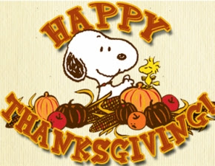 | 29  Mass on TV  Exercise  Bingo  2:30 Social Hour/ Dan Kirouac  Ring Toss  Afternoon Stretch  Helping Around the House  Evening Small Talk  Bedtime Reading  Evening Movie |  | 30  Mass on TV  Bingo  Exercise  Thanksgiving Noodle Ball  Trivia  Sensory  (Smelling Test)  Evening Small Talk  Bedtime Reading  Evening Movie
Main Events

1- Social Hour with Tony Valley at 2:30 PM | 13- Animal Craze at 2:30 PM
3-United Parish Church Service at 1:00 PM | 14-Lunch Trip to 99 Restaurant 11:00 AM
4, 11 & 20-Piano music in the Lobby with Joanne at 2:00 PM | 15-Social Hour with Heather Marie at 2:30pm
6, 13, 20 & 27-10:00 Mass with Father Carlos | 20- Foot Doctor
6- Piano Music with Diane Ammons | 22-Social Hour with Terry Nally at 2:30pm
7-Flu Clinic at 2:00 | 25-Resident Birthday Party with The Cavaliers at 2:30pm
8-Social Hour with Dick & Dawn | 26-2:00 Resident Food & Activity Council Meeting
9 & 23-Saturday Mass at Church at 3:45 PM | 28-THANKSGIVING
11-Veterans Day Presentation, with Legion Post 193 and Chamber Singers 1:00 | 29-Social Hour with Dan Kirouac at 2:30pm
12 & 26-Rosary at 3:30pm

Country Store is open on Tuesday & Thursday - 3:30PM
Movies will be held on Tuesday & Thursday at 6:00PM, Saturday at 3:30 PM & 6:00 PM
Sunday @ 6:00PM in the TV Room

