Broadview Activities for November 2019
Sunday | Monday |  | Tuesday | Wednesday |  |  |  | Thursday | Friday | Saturday
Resident  Birthdays  Mary S. 11:18  Joan R. 11:27  Lila D. 11/29 |  |  |  |  | 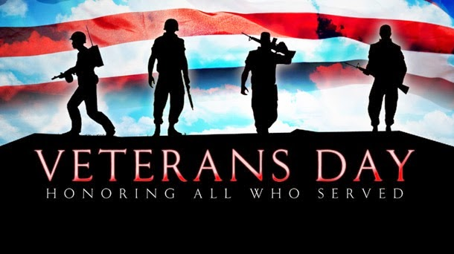 |  |  |  | 1  9:30 Mass on TV  10:00 Penny Ante  11:15 Exercise  1:00 Bingo  2:30 Social Hour/  Tony Valley  4:00 Word Game  7:00 Wheel of Fortune  7:30 Jeopardy | 2  9:30 Mass on TV  10:00 Bingo  11:15 Exercise  1:00 Cards  2:30 Finish the Phrase…  3:30 Movie/  “Driving Miss Daisy”  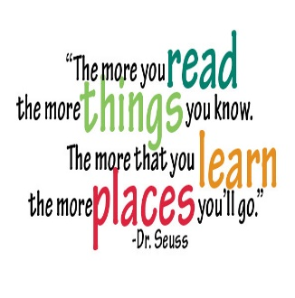  6:00 Saturday Night at the Movies/ Resident Choice  Book Lovers Day
3  Daylight Savings Time  7:00 Mass on TV  10:00 Bingo  11:15 Exercise  1:00 United Parish Church Service  1:30 Game/ Apples to Apples  3:00 Giant Crossword Puzzles  4:00 Game/ Sorry  6:00 Movie/  “The Fortune Cookie”  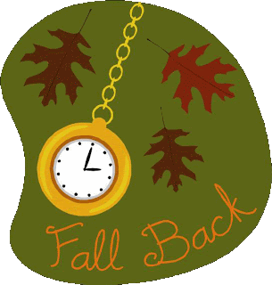 | 4  9:30 Mass on TV 10:00 Trivia  11:15 Exercise  1:00 Bingo  2:00 Piano Music in the Lobby with Joanne  4:00 Word Game  7:00 Wheel of  Fortune  7:30 Jeopardy |  | 5  “Hair Day”  9:30 Mass on TV  10:00 Baking/Easy Carmel Apple Taquitos  11:15 Exercise  1:00 Bingo  2:30 Errand Trip  (Weather Permitting)  3:30 Country  Store Opened  4:00 Nails & Tales  6:00 Movie/  “Sense and Sensibility” | 6  10:00 Catholic Mass with  Father Carlos  11:15 Exercise  1:00 Bingo  2:30 Piano Music with  Diane Ammons  4:00 Penny Ante  7:00 Wheel of Fortune  7:30 Jeopardy |  |  | 7  Flu Clinic  9:30 Mass on TV  10:00 Game/ Apples to Apples  11:15 Exercise  1:00 Bingo  2:00 Flu Clinic  2:00 Crocheting with Lorraine  2:30 Arts & Crafts/ Christmas Decoupage Balls  3:30 Country  Store Opened  4:00 Nails & Tales  6:00 Movie/  “Air Force One” |  | 8  9:30 Mass on TV  10:00 LCR Dice Game  11:15 Exercise  1:00 Bingo  2:30 Social  Hour/  Dick & Dawn  4:00 Word Game  7:00 Wheel of Fortune  7:30 Jeopardy | 9  9:30 Mass on TV  10:00 Bingo  11:15 Exercise  1:00 Cards  2:30 Finish the Phrase…  3:30 Movie/  “Bucket List”  3:45 Catholic Mass  6:00 Saturday Night at the Movies/ Resident Choice
10  Forget Me Not Day  7:00 Mass on TV  10:00 Coffee Hour/  Current Events  11:15 Exercise  1:00 Bingo  2:30 Foliage Ride  (Weather Permitting)  4:00 Cards/ Penny Ante  6:00 Movie/  “Hello Dolly”  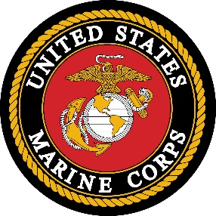  USMC Day | 11  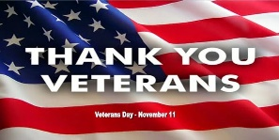  9:30 Mass on TV  10:00 Bingo  11:15 Exercise  1:00 Veterans Day Presentation with Legion Post 193 & the Chamber Singers  2:00 Piano Music in the Lobby with Joanne  4:00 Cards/ UNO  7:00 Wheel of  Fortune  7:30 Jeopardy  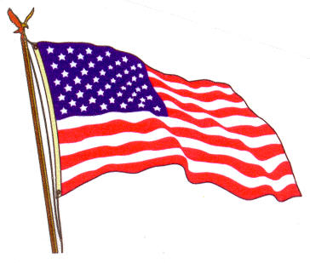 |  | 12  “Hair Day”  9:30 Mass on TV  10:00 Arts & Crafts/ Beaded Pumpkins  11:15 Exercise  1:00 Bingo  2:30 Errand Trip  (Weather Permitting)  3:30 Rosary  3:30 Country  Store Opened  4:00 Nails & Tales  6:00 Movie/  “Breakfast at Tiffany’s”  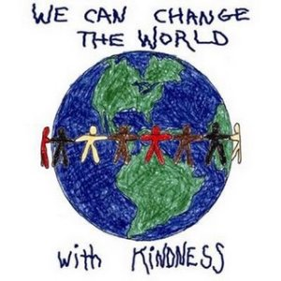 | 13  10:00 Catholic Mass with  Father Carlos  11:15 Exercise  1:00 Bingo  2:30 Animal Craze  4:00 LCR Dice Game  7:00 Wheel of  Fortune  7:30 Jeopardy |  |  | 14  9:30 Mass on TV  11:15 Exercise  11:00 Lunch Trip/  99 Restaurant  (Weather Permitting)  1:00 Bingo  2:00 Crocheting with Lorraine  2:30 Game/  Apples to Apples  3:30 Country  Store Opened  4:00 Nails & Tales  6:00 Movie/  “Life with Father”  Gardner Museum  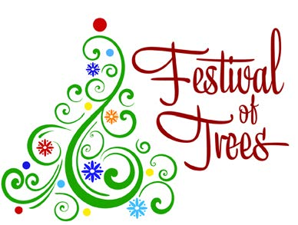  November 14th-December 7th |  | 15  9:30 Mass on TV  10:00 Cards/ UNO  11:15 Exercise  1:00 Bingo  2:30 Social  Hour/ Heather Marie  4:00 Word Game  7:00 Wheel of Fortune  7:30 Jeopardy | 16  9:30 Mass on TV  10:00 Bingo  11:15 Exercise  1:00 Cards  2:30 Finish the Phrase…  3:30 Movie/  “Father’s Little Dividend”  6:00 Saturday Night at the Movies/ Resident Choice
Broadview Activities for November 2019
Sunday |  | Monday | Tuesday |  |  | Wednesday |  | Thursday | Friday |  | Saturday
17  7:00 Mass on TV  10:00 Coffee  Hour/ Social Hour  11:15 Exercise  1:00 Bingo  2:30 Mystery Ride (Weather Permitting)  4:00 Penny Ante  6:00 Movie/  “Winn Dixie”  World Peace Day |  | 18  9:30 Mass on TV  10:00 Game/ Sorry  11:15 Exercise  1:00 Bingo  2:30 Arts & Crafts/ Christmas Decoupage Balls  4:00 LCR Dice Game  7:00 Wheel of  Fortune  7:30 Jeopardy | 19  “Hair Day”  9:30 Mass on TV  10:00 Baking/  Pumpkin Spice Pretzels  11:15 Exercise  1:00 Bingo  2:30 Errand Trip  (Weather Permitting)  3:30 Country  Store Opened  4:00 Nails & Tales  6:00 Movie/  “The Whole Nine Yards” |  |  | 20  “Foot Doctor”  10:00 Catholic Mass with  Father Carlos  11:15Exercise  1:00 Bingo  2:00 Piano Music in the Lobby with Joanne  4:00 Music Trivia  7:00 Wheel of  Fortune  7:30 Jeopardy |  | 21  9:30 Mass on TV  10:00 Bingo  11:15 Exercise  1:30 Movie/  “Anne of Avonlea”  Volume 1  2:00 Crocheting with Lorraine  3:30 Country  Store Opened  4:00 Nails & Tales  6:00 Movie/  “Anne of Avonlea”  Volume 2 | 22  9:30 Mass on TV  10:00 Game/ Penny Ante  11:15 Exercise  1:00 Bingo  2:30 Social Hour/  Terry Nally  4:00 Word Game  7:00 Wheel of  Fortune  7:30 Jeopardy |  | 23  9:30 Mass on TV  10:00 Bingo  11:15 Exercise  1:00 Cards  2:30 Finish the Phrase…  3:30 Movie/  “Bus Stop”  With  Marilyn Monroe  3:45 Catholic Mass  6:00 Saturday Night at the Movies/ Resident Choice
24  7:00 Mass on TV  10:00 Coffee  Hour/ Finish the Phrase…  11:15 Exercise  1:00 Bingo  2:30 Mystery Ride (Weather Permitting)  4:00 LCR Dice Game  6:00 Movie/  “Joshua” |  | 25  9:30 Mass on TV  10:00 Game/ Penny Ante  11:15 Exercise  1:00 Bingo  2:30 Resident  Birthday Party/  The Cavaliers  4:00 Coupons to Troops  7:00 Wheel of  Fortune  7:30 Jeopardy  National Parfait Day | 26  “Hair Day”  9:30 Mass on TV  10:00 Arts & Crafts/ Beaded Indian Corn  11:15 Exercise  1:00 Bingo  2:00 Resident Food & Activity Council Meeting  3:30 Rosary  3:30 Country  Store Opened  4:00 Nails & Tales  6:00 Movie/  “The 39 Steps”  Alfred Hitchcock |  |  | 27  10:00 Catholic Mass with  Father Carlos  11:15 Exercise  1:00 Bingo  2:30 Resident Show & Tell  4:00 Trivia  7:00 Wheel of  Fortune  7:30 Jeopardy |  | 28  Thanksgiving Day!  9:30 Mass on TV  10:00 LCR Dice Game  11:15 Exercise  1:00 Bingo  2:30 Cards/  Unlucky 7  3:30 Country  Store Opened  Coupons to troops/ Crossword Puzzles or Word Search  6:00 Movie/  “Pale Rider”  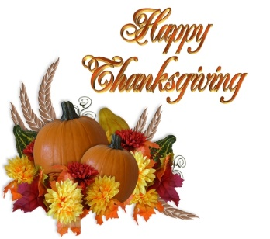 | 29  9:30 Mass on TV  10:00 Penny Ante  11:15 Exercise  1:00 Bingo  2:30 Social Hour/  Dan Kirouac  4:00 Word Game  7:00 Wheel of  Fortune  7:30 Jeopardy |  | 30  9:30 Mass on TV  10:00 Bingo  11:15 Exercise  1:00 Cards  2:30 Finish the Phrase…  3:30 Movie/  “County Fair”  Lawrence Welk  6:00 Saturday Night at the Movies/ Resident Choice
Main Events

1- Social Hour with Tony Valley at 2:30 PM | 11-Veterans Day Presentation, with Legion Post 193 and Chamber Singers 1:00
3-United Parish Church Service at 1:00 PM | 12 & 26-Rosary at 3:30pm
4, 11 & 20-Piano music in the Lobby with Joanne at 2:00 PM | 13- Animal Craze at 2:30 PM
5, 12 & 19-Errand Trip Weather Permitting | 14-Lunch Trip to 99 Restaurant 11:00 AM
6, 13, 20 & 27-10:00 Mass with Father Carlos | 15-Social Hour with Heather Marie at 2:30pm
6- Piano Music with Diane Ammons | 20- Foot Doctor
7-Flu Clinic at 2:00 | 22-Social Hour with Terry Nally at 2:30pm
7, 14 & 21- Crocheting with Lorraine at 2:00 PM | 25-Resident Birthday Party with The Cavaliers at 2:30pm
8-Social Hour with Dick & Dawn | 26-2:00 Resident Food & Activity Council Meeting
9 & 23-Saturday Mass at Church at 3:45 PM | 28-THANKSGIVING
10, 17 & 24-Mystery Ride Weather Permitting | 29-Social Hour with Dan Kirouac at 2:30pm

*There Must be at least 3 Residents signed up for the Errand Trip

Country Store is open on Tuesday & Thursday - 3:30PM
Movies will be held on Tuesday & Thursday at 6:00PM, Saturday at 3:30 PM & 6:00 PM
Sunday @ 6:00 PM in the TV Room

