Broadview Activities for July 2019
Sunday | Monday |  | Tuesday | Wednesday |  |  | Thursday | Friday | Saturday
Resident  Birthdays  Lyle N. 5th  Helen N 28th | 1  9:30 Mass on TV 10:00 Walking Group or Trivia in the Gazebo  11:15 Exercise  1:00 Bingo  2:00 Piano Music in the Lobby with Joanne  4:00 Word Game  7:00 Wheel of  Fortune  7:30 Jeopardy  Canada Day! |  | 2  “Hair Day”  9:30 Mass on TV  10:00 Baking/  Red, White and Blue Trifle Cups  11:15 Exercise  1:00 Bingo  2:30 Cards/Crazy 8  3:30 Country Store Opened  6:00 Movie/  “Finding Lucy”  Made in U.S.A. Day! |  | 3  10:00 Catholic Mass with  Father Carlos  11:15 Exercise  1:00 Bingo  2:30 Sorry  4:00 List It!  7:00 Wheel of Fortune  7:30 Jeopardy |  | 4  4th of July  9:30 Mass on TV  10:00 SkipBo  11:15 Exercise  12:00 4th of July Cookout with the Cavaliers  1:30 Bingo  2:30 Cards/  LCR Dice Game  3:30 Country Store Opened  4:00 Nails & Tales  6:00 Movie/  “1776” | 5  9:30 Mass on TV  10:00 Penny Ante  11:15 Exercise  1:00 Bingo  2:30 Social Hour/  Heather Marie  4:00 Word Game  7:00 Wheel of Fortune  7:30 Jeopardy | 6  9:30 Mass on TV  10:00 Bingo  11:15 Exercise  1:00 Cards  2:30 Finish the Phrase…  3:45 Catholic Mass  3:30 Movie/  “An Ideal Husband”  6:00 Saturday Night at the Movies/ Resident Choice
7  7:00 Mass on TV  10:00 Coffee  Hour in the Gazebo/ Gardening  11:15 Exercise  1:00 United Parish Church Service  2:00 Bingo  3:30 Cards/ UNO  6:00 Movie/  “Lincoln”  Chocolate Day! | 8  9:30 Mass on TV 10:00 Walking Group or Family Feud in the Gazebo  11:15 Exercise  1:00 Bingo  2:00 Piano Music in the Lobby with Joanne  4:00 Word Game  7:00 Wheel of  Fortune  7:30 Jeopardy |  | 9  “Hair Day”  9:30 Mass on TV  10:00 Arts & Crafts/ Painting Fireworks  11:15 Exercise  1:00 Bingo  2:30 Errand Trip  3:30 Rosary  3:30 Country  Store Opened  4:00 Nails & Tales  6:00 Movie/  “The Confession” | 10  10:00 Walking Group or Trivia in the Gazebo  11:15 Exercise  1:00 Bingo  2:30 Yoga (CR)  4:00 Penny Ante  7:00 Wheel of Fortune  7:30 Jeopardy  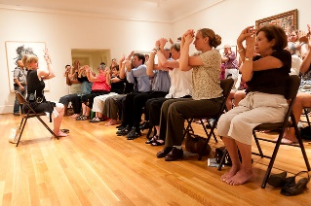 |  |  | 11  9:30 Mass on TV  10:00 List It!  11:15 Exercise  11:30 Lunch Trip/Kimball’s  1:00 Bingo  2:30 Cards/UNO  Or  Crocheting with Lorraine  3:30 Country  Store Opened  4:00 Nails & Tales  6:00 Movie/  “Minority Report” | 12  9:30 Mass on TV  10:00 LCR Dice Game  11:15 Exercise  1:00 Bingo  2:30 Social  Hour/  Terry Nally  4:00 Word Game  7:00 Wheel of Fortune  7:30 Jeopardy  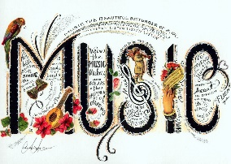 | 13  9:30 Mass on TV  10:00 Bingo  11:15 Exercise  1:00 Cards  2:30 Finish the Phrase…  3:30 Movie/  “The Patriot”  6:00 Saturday Night at the Movies/ Resident Choice
14  7:00 Mass on TV  10:00 Coffee  Hour in the Gazebo/ Gardening  11:15 Exercise  1:00 Bingo  2:30 Mystery Ride (Weather Permitting)  3:30 Monopoly  6:00 Movie/  “Murder by Numbers” | 15  9:30 Mass on TV  10:00 Walking Group or Trivia in the Gazebo  11:15 Exercise  1:00 Bingo  2:00 Piano Music in the Lobby with Joanne  4:00 Cards/ UNO  7:00 Wheel of  Fortune  7:30 Jeopardy |  | 16  “Hair Day”  9:30 Mass on TV  10:00 Baking/ Red, White and Blue Chex Mix  11:15 Exercise  1:00 Bingo  2:30 Errand Trip  3:30 Country  Store Opened  4:00 Nails & Tales  6:00 Movie/  “Miss Congeniality” | 17  10:00 Walking Group or Finish the Lyric… in the Gazebo  11:15 Exercise  1:00 Bingo  2:30 Ice Cream Float Social  4:00 LCR Dice Game  7:00 Wheel of  Fortune  7:30 Jeopardy |  |  | 18  9:30 Mass on TV  10:00 LCR Dice Game  11:15 Exercise  1:30 Movie/  “Miss Congeniality 2”  2:30 Crocheting with Lorraine  3:30 Country  Store Opened  4:00 Nails & Tales  6:00 Movie/  “Pale Rider” | 19  9:30 Mass on TV  10:00 UNO  11:15 Exercise  1:00 Bingo  2:30 Social  Hour/  Tony Valley  4:00 Word Game  7:00 Wheel of Fortune  7:30 Jeopardy | 20  9:30 Mass on TV  10:00 Bingo  11:15 Exercise  1:00 Cards  2:30 Finish the Phrase…  3:45 Catholic Mass  3:30 Movie/ “The Normandy Invasion, The Victory”  6:00 Saturday Night at the Movies/ Resident Choice
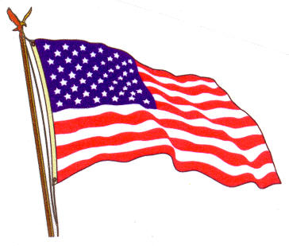Broadview Activities for July 2019
Sunday |  | Monday | Tuesday |  |  | Wednesday | Thursday | Friday |  | Saturday
21  7:00 Mass on TV  10:00 Coffee  Hour in the Gazebo/ Gardening  11:15 Exercise  1:00 Bingo  2:30 Mystery Ride (Weather Permitting)  3:30 Penny Ante  6:00 Movie/  “The Whole Nine Yards”  National Ice Cream Day! |  | 22  9:30 Mass on TV  10:00 Walking Group or Family Feud in the Gazebo  11:15 Exercise  1:00 Bingo  2:00 Piano Music in the Lobby with Joanne  4:00 LCR Dice Game  7:00 Wheel of  Fortune  7:30 Jeopardy | 23  “Hair Day”  9:30 Mass on TV  10:00 Arts and Crafts/ Patriotic Wind Catcher  11:15 Exercise  1:00 Bingo  2:00 Resident Food & Activity Council Meeting  3:30 Rosary  3:30 Country  Store Opened  4:00 Nails & Tales  6:00 Movie/  “Nights in Rodanthe” |  |  | 24  10:00 Catholic Mass with  Father Carlos  11:15 Exercise  1:00 Bingo  2:30 Yoga (CR)  4:00 Trivia in the Gazebo  7:00 Wheel of  Fortune  7:30 Jeopardy  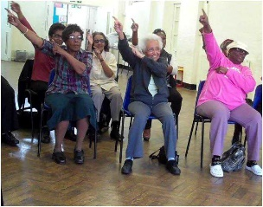 | 25  9:30 Mass on TV  10:00 Walking Group or Coffee Hour in the Gazebo  11:15 Exercise  11:30 Picnic Lunch at the Cathedral of the Pines  1:00 Bingo  2:30 Game/ Sorry  Or  Crocheting with Lorraine  3:30 Country  Store Opened  4:00 Nails & Tales  6:00 Movie/  “Message in a Bottle” | 26  9:30 Mass on TV  10:00 Penny Ante  11:15 Exercise  1:00 Bingo  2:30 Social Hour/  Dick & Dawn  4:00 Word Game  7:00 Wheel of  Fortune  7:30 Jeopardy |  | 27  9:30 Mass on TV  10:00 Bingo  11:15 Exercise  1:00 Cards/ SkipBo  2:30 Finish the Phrase…  3:30 Movie/  “A Walk to Remember”  6:00 Saturday Night at the Movies/ Resident Choice
28  7:00 Mass on TV  10:00 Coffee  Hour in the Gazebo/ Gardening  11:15 Exercise  1:00 Bingo  2:30 Mystery Ride (Weather Permitting)  4:00 LCR Dice Game  6:00 Movie/  Robin Williams in “RV” |  | 29  9:30 Mass on TV  10:00 Trivia in the Gazebo  11:15 Exercise  1:00 Bingo  2:30 Resident  Birthday Party/  Lou & Jan  4:00 Unlucky 7’s  7:00 Wheel of  Fortune  7:30 Jeopardy | 30  “Hair Day”  9:30 Mass on TV  10:00 Baking/  Strawberry Shortcake Lasagna  11:15 Exercise  1:00 Bingo  2:30 Errand Trip  3:30 Country  Store Opened  4:00 Nails & Tales  6:00 Movie/  “The NoteBook”  International Day of Friendship! |  |  | 31  10:00 Catholic Mass with  Father Carlos  11:15 Exercise  1:00 Bingo  2:30 Animal Craze  4:00 Family Feud in the Gazebo  7:00 Wheel of  Fortune  7:30 Jeopardy  National Avocado Day!  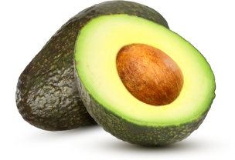 |  | 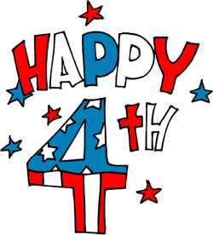
Main Events
1, 8, 15 & 22-Piano music in the Lobby with Joanne at 2:00 PM | 11-Lunch Trip to Kimball’s at 11:30 AM
3, 24 & 31-10:00 Catholic Mass with Father Carlos | 12-Social Hour with Terry Nally at 2:30pm
4th of July Cookout with the Cavaliers at 12:00 PM | 14, 21 & 28 at 1:30 PM Mystery Ride (weather permitting)
5-Social Hour with Heather Marie at 2:30 PM | 17- Ice Cream Float Social at 2:30
6 & 20 at 3:45 PM Saturday Mass at Church | 19-Social Hour with Tony Valley at 2:30pm
7-United Parish Church Service at 1:00 PM | 25- Pic-Nic Lunch at the Cathedral of the Pines at 11:30
9 & 23-Rosary at 3:30pm | 26- Social Hour with Dick & Dawn at 2:30pm
9, 16 & 30- Errand Trip | 29-Resident Birthday Party with Lou & Jan at 2:30pm
10 & 24- Yoga at 2:30 PM | 31- Animal Craze 2:30 Back Parking Lot Weather Permitting

Country Store is open on Tuesday & Thursday - 3:30PM
Movies will be held on Tuesday & Thursday at 6:00PM, Saturday at 3:30 PM & 6:00 PM
Sunday @ 6:00 PM in the TV Room

