Bright Horizon’s Activities for July 2019
Sunday | Monday |  | Tuesday | Wednesday |  |  | Thursday |  | Friday | Saturday
Resident  Birthdays  Lyle N. 5th  Helen N 28th | 1  Mass on TV  Trivia  Exercise  Bingo  2:00 Piano Music in the Lobby with Joanne  Walking Group  Outside  (Weather Permitting)  Gardening  Reminiscence  Evening Movie  Canada Day! |  | 2  “Hair Day”  Mass on TV  10:00 Baking/  Red, White & Blue Trifle Cups  Guinea Pig Social  Exercise  3:30 Country  Store Opened  Gardening  Bingo  Evening Small Talk  6:00 Game Night  Made in U.S.A. Day! |  | 3  10:00 Catholic Mass with  Father Carlos  Ring Toss on the Patio  Exercise  Sensory  (Tasting Test)  Bingo  Gardening  Bowling on the Patio  Nails & Tales  Evening Small Talk  Evening Movie |  |  | 4  4th of July  Mass on TV  Exercise  What’s in the bag?  12:00 4th of July Cookout with the Cavaliers (Outside, Weather Permitting)  Bingo  Gardening  3:30 Country  Store Opened  List It!  Evening Small Talk  Evening Movie | 5  Mass on TV  Exercise  Bingo  2:30 Social Hour/  Heather Marie  LIST IT  Gardening  Afternoon Stretch  Helping Around the House  Evening Small Talk  Evening Movie | 6  Mass on TV  10:00 Mini Golf  Bingo  Exercise  Gardening  Noodle Ball  3:45 Saturday Mass at Church  Trivia on the Patio  Evening Small Talk  6:00 Game Night
7  Mass on TV  Exercise  Bingo  Helping Around the House  1:00 United  Parish Church  Service  Coffee Social  Gardening  Bowling on the Patio  Nails & Tales  Evening Small Talk  Evening Movie  Chocolate Day!  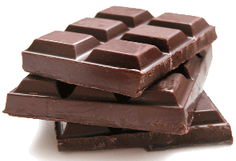 | 8  Mass on TV  Games outside on the Patio  Trivia  Exercise  Bingo  2:00 Piano Music in the Lobby with Joanne  Walking Group  Outside  (Weather Permitting)  Gardening  Reminiscence  Evening Movie |  | 9  “Hair Day”  Mass on TV  10:00 Arts & Crafts/  Painting Fireworks  Guinea Pig Social  Exercise  Bingo  Gardening  3:30 Rosary  3:30 Country  Store Opened  Walking Group  Outside  (Weather Permitting)  Evening Small Talk  6:00 Game Night | 10  Mass on TV  Exercise  Gardening  1:45 Mystery Ride (Weather Permitting)  2:30 Yoga  Bingo  Bowling on the Patio  Nails & Tales  Evening Small Talk  Evening Movie  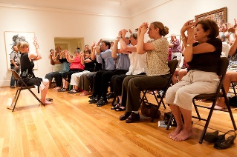 |  |  |  | 11  Mass on TV  Exercise  11:30 Lunch Trip/ Kimball’s  What’s in the bag?  Gardening  Bingo  3:30 Country  Store Opened  List It!  Evening Small Talk  Evening Movie | 12  Mass on TV  Exercise  Bingo  2:30 Social  Hour/  Terry Nally  Gardening  LIST IT  Nails & Tales  Afternoon Stretch  Helping Around the House  Evening Small Talk  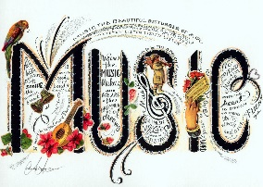 | 13  Mass on TV  10:00 Mini Golf  Bingo  Exercise  Gardening  Lemonade & Cookie Social on the Patio  Noodle Ball  Evening Small Talk  6:00 Game Night
14  Mass on TV  Exercise  Bingo  Helping Around the House  Gardening  Coffee Social  Ring Toss on the Patio  Evening Small Talk  Evening Movie | 15  9:00 Mystery Ride  (weather permitting)  Mass on TV  Trivia  Exercise  Bingo  2:00 Piano Music in the Lobby with Joanne  Walking Group  Outside  (Weather Permitting)  Gardening  Reminiscence  Evening Movie |  | 16  “Hair Day”  Mass on TV  10:00 Baking/  Red, White & Blue Chex Mix  Guinea Pig Social  Exercise  3:30 Country  Store Opened  Gardening  Bingo  Nails & Tales  Evening Small Talk  6:00 Game Night | 17  Mass on TV  Exercise  Sensory  (Smelling Test)  Bingo  2:30 Ice Cream Float Social  Gardening  Bowling  Evening Small Talk  Evening Movie  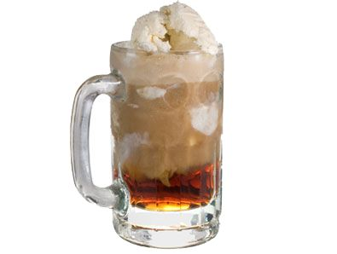 |  |  |  | 18  Mass on TV  Gardening  Exercise  What’s in the bag?  Bingo  3:30 Country  Store Opened  List It!  Evening Small Talk  Evening Movie | 19  Mass on TV  Exercise  Bingo  2:30 Social Hour/  Tony Valley  Gardening  LIST IT  Afternoon Stretch  Helping Around the House  Evening Small Talk | 20  Mass on TV  10:00 Mini Golf  Bingo  Exercise  Gardening  3:45 Saturday Mass at Church  Noodle Ball  Nails & Tales  Evening Small Talk  6:00 Game Night
Bright Horizon’s Activities for July 2019
Sunday |  | Monday | Tuesday |  |  | Wednesday | Thursday |  | Friday |  | Saturday
21  Mass on TV  Exercise  Bingo  Helping Around the House  Gardening  Coffee Social  Bowling on the Patio  Evening Small Talk  Evening Movie  National Ice Cream Day! |  | 22  Mass on TV  Bowling on the Patio  Trivia  Exercise  Bingo  2:00 Piano Music in the Lobby with Joanne  Walking Group  Outside  (Weather Permitting)  Gardening  Reminiscence  Evening Movie | 23  “Hair Day”  Mass on TV  10:00 Arts & Crafts/  Patriotic Wind Catcher  10:00 Mini Golf  Guinea Pig Social  Exercise  Bingo  Gardening  3:30 Rosary  3:30 Country  Store Opened  Walking Group  Outside  (Weather Permitting)  Evening Small Talk  6:00 Game Night |  |  | 24  10:00 Catholic Mass with  Father Carlos  Exercise  Gardening  2:30 Yoga  Bingo  Bowling  Nails & Tales  Evening Small Talk  Evening Movie  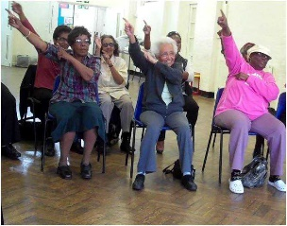 | 25  Mass on TV  Exercise  What’s in the bag?  Gardening  11:30 Picnic Lunch at the Cathedral of the Pines  Bingo  Mini Golf  3:30 Country  Store Opened  List It!  Evening Small Talk  Evening Movie  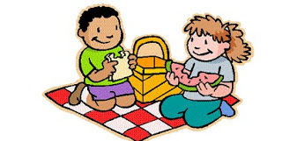 |  | 26  Mass on TV  Gardening  Trivia  Exercise  Bingo  2:30 Social Hour/  Dick & Dawn  Walking Group  Outside  (Weather Permitting)  Reminiscence  Evening Movie |  | 27  Mass on TV  10:00 Mini Golf  Bingo  Exercise  Gardening  Lemonade & Cookie Social Ring Toss on the Patio  Noodle Ball  Evening Small Talk  6:00 Game Night
28  Mass on TV  Exercise  Bingo  Helping Around the House  Gardening  Coffee Social  Ring Toss on the Patio  Nails & Tales  Evening Small Talk  Evening Movie |  | 29  Mass on TV  Trivia  Bowling on the Patio  Exercise  Bingo  2:30 Resident Birthday Party/  Entertainment with  Lou & Jan  Gardening  Walking Group  Outside  (Weather Permitting)  Reminiscence  Evening Movie | 30  “Hair Day”  Mass on TV  10:00 Baking/ Strawberry Shortcake Lasagna  Guinea Pig Social  Exercise  3:30 Country  Store Opened  Gardening  Bingo  Evening Small Talk  6:00 Game Night  International Day of Friendship! |  |  | 31  10:00 Catholic Mass with  Father Carlos  Exercise  Sensory  (Tasting Test)  Bingo  Gardening  2:30 Animal Craze  Nails & Tales  Evening Small Talk  Evening Movie  National Avocado Day!  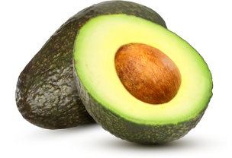
Main Events

1, 8, 15 & 22-Piano music in the Lobby with Joanne at 2:00 PM | 11-Lunch Trip to Kimball’s at 11:30 AM
3,24&31-10:00 Catholic Mass with Father Carlos | 12-Social Hour with Terry Nally at 2:30pm
4th of July Cookout with the Cavaliers at 12:00 PM | 17- Ice Cream Float Social 2:30 PM
5-Social Hour with Heather Marie at 2:30 PM | 18- Silver Sneakers 10:15 AM
10, 15M Mystery Ride (weather permitting) | 19-Social Hour with Tony Valley at 2:30pm
6 & 20 at 3:45 PM Saturday Mass at Church | 25- 11:30 Picnic Lunch at the Cathedral of the Pines
7-United Parish Church Service at 1:00 PM | 26- Social Hour with Dick & Dawn at 2:30pm
8 & 23-Rosary at 3:30pm | 29-Resident Birthday Party with Lou & Jan at 2:30pm
10 & 24- Yoga at 2:30 PM | 31-Animal Craze @ 2:30 in Back Parking Lot (Weather Permitting)

Country Store is open on Tuesday & Thursday - 3:30PM
Movies will be held on Tuesday & Thursday at 6:00 PM, Saturday at 3:30pm & 6:00pm,
Sunday @ 6:00 PM in the TV Room

