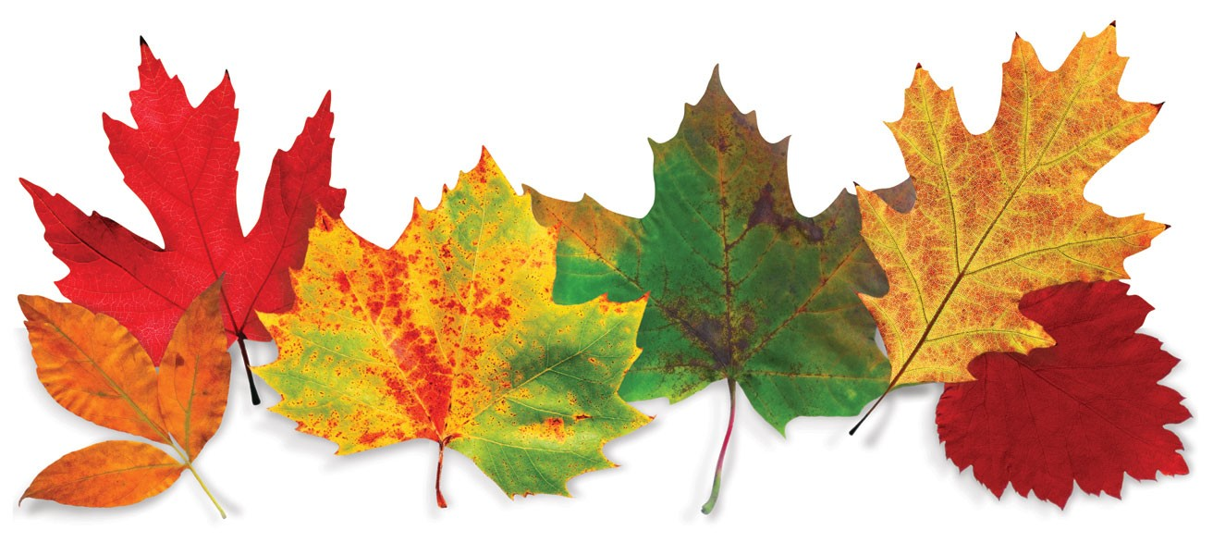

|  |  |  |  |  |  |  |  |  |  |  |
| --- | --- | --- | --- | --- | --- | --- | --- | --- | --- | --- |
| ***Broadview Activities for November 2018*** | | | | | | | | | | |
| **Sunday** | **Monday** | | **Tuesday** | | **Wednesday** | | | **Thursday** | **Friday** | **Saturday** |
| **Birthdays**  **Peter M. 11/8**  **Mary S. 11/18**  **Lila D. 11/29** |  | |  | |  | | | **1**  **10:00 Catholic Mass with Fr. Carlos**  **11:15 Exercise**  **1:00 Bingo**  **2:30 Cards/ UNO**  **3:30 Country Store Opened**  **4:00 Nails & Tales**  **6:15 Movie/**  **“Florence Nightingale”** | **2**  9:30 Mass on TV  10:00  Finish the Phrase…  **10:15 Clark**  **YMCA**  **(Silver Sneakers)**  11:15 Exercise  1:00 Bingo  **2:30 Social Hour/**  **Walter Deery**  4:00 Word Game  7:00 Wheel of  Fortune  7:30 Jeopardy  **Friday Night Dance 6:30-8:00** | **3**  **9:30 Mass on TV**  **10:00 Bingo**  **11:15 Exercise**  **1:30 Trivia**  **2:00 Cards**  **3:30 Movie/ “Daddy Day Care”**  **3:45 Saturday Mass at Church**  **6:00 Saturday Night at the Movies/ Residents Choice** |
| **4**  **7:00 Mass on TV**  **10:00 Coffee**  **Hour/**  **Current Events**  **11:15 Exercise**  **1:00 United Parish Church Service**  **2:00 Bingo**  **4:00 Word Game**  **6:00 Movie/**  **“Mrs. Doubtfire”**  **Daylight Savings Time** | **5**  **9:30 Mass on TV**  **10:00 LCR Dice Game**  **11:15 Exercise**  **1:00 Bingo**  **2:00 Piano Music in the Lobby**  **3:30 Monopoly**  **7:00 Wheel of**  **Fortune**  **7:30 Jeopardy**  **Play Monopoly Day** | | **6**  **“Hair Day”**  **9:30 Mass on TV**  **10:00 Arts & Crafts/ Make Items for the Craft Fair**  **11:15 Exercise**  **1:00 Bingo**  **2:30 Cards/**  **LCR Dice Game**  **3:30 Country**  **Store Opened**  **6:15 Movie/**  **“Lincoln”** | | **7**  **“Foot Doctor”**  **9:30 Mass on TV**  **10:00 Baking/**  **Ginger Snap Cookies**  **11:15 Exercise**  **1:00 Bingo**  **2:30 Liz Leal Playing Piano in the Lobby**  **3:30 YMCA Clark (Swimming)**  **4:00 Penny Ante**  **7:00 Wheel of**  **Fortune**  **7:30 Jeopardy** | | | **8**  **10:00 Penny Ante**  **11:15 Exercise**  **11:30 Lunch Trip/**  **Monty-Tech**  **1:00 Bingo**  **2:30 Cards/**  **LCR Dice Game**  **3:30 Country**  **Store Opened**  **4:00 Nails & Tales**  **6:15 Movie/**  **“Little Rascals” Volume 1** | **9**  **10:00 Game**  **10:15 Clark**  **YMCA**  **(Silver Sneakers)**  **11:15 Exercise**  **1:00 Bingo**  **2:30 Social Hour/**  **Dave Andrews**  **4:00 Word Game**  **7:00 Wheel of**  **Fortune**  **7:30 Jeopardy** | **10**  **10:00 Bingo**  **11:15 Exercise**  **1:30 Finish the Lyric…**  **2:00 Cards**  **3:30 Movie/ “The Adventures of the Wilderness Family”**  **3:45 Saturday Mass at Church**  **6:00 Saturday Night at the Movies/ Residents Choice**  **Happy Birthday**  **Marine Corps.** |
| **11**  **7:00 Mass on TV**  **10:00 Coffee**  **Hour Social/ Trivia**  **11:15 Exercise**  **1:00 Bingo**  **2:30 Veterans Day Presentation**  **4:00 Word Game**  **6:00 Movie/ “The King & I”**  **Veterans Day** | **12**  **9:30 Mass on TV**  **10:00 LCR Dice Game**  **11:15 Exercise**  **1:00 Bingo**  **2:00 Piano Music in the Lobby**  **3:30 Monopoly**  **7:00 Wheel of**  **Fortune**  **7:30 Jeopardy** | | **13**  **“Hair Day”**  **9:30 Mass on TV**  **10:00 Arts & Crafts/ Make Items for Craft Fair**  **11:15 Exercise**  **1:00 Bingo**  **2:30 Animal Craze**  **3:30 Country Store**  **Opened**  **3:30 Rosary**  **4:00 Nails & Tales**  **6:15 Movie/**  **“You’ve Got Mail”** | | **14**  **9:30 Mass on TV**  **10:00 Baking/**  **Banana Bread**  **11:15 Exercise**  **1:00 Bingo**  **2:30 Yoga**  **3:30 YMCA**  **Clark (Swimming)**  **4:00 List It!**  **7:00 Wheel of**  **Fortune**  **7:30 Jeopardy** | | | **15**  **10:00 Catholic Mass with Fr. Carlos**  **11:15 Exercise**  **1:30 Movie/**  **“Road to Bali”**  **3:30 Country**  **Store Opened**  **4:00 Nails & Tales**  **6:15 Movie/**  **“Road to Rio”** | **16**  **9:30 Mass on TV**  **10:00 Penny Ante**  **10:15 Clark**  **YMCA**  **(Silver Sneakers)**  **11:15 Exercise**  **1:00 Bingo**  **2:30 Social Hour/**  **Terry Nally**  **4:00 Word Game**  **7:00 Wheel of**  **Fortune**  **7:30 Jeopardy** | **17**  **9:30 Mass on TV**  **10:00 Bingo**  **11:15 Exercise**  **1:30 Trivia**  **2:00 Cards**  **3:30 Movie/**  **“Last Chance Harvey”**  **…3:45 Saturday Mass at Church**  **6:00 Saturday Night at the Movies/ Residents Choice** |
| ***Broadview Activities for November 2018*** | | | | | | | | | | |
| **Sunday** | | **Monday** | | **Tuesday** | | **Wednesday** | | **Thursday** | **Friday** | **Saturday** |
| **18**  7:00 Mass on TV  **10:00 Coffee**  **Hour/ Current Events**  11:15 Exercise  **1:00 Bingo**  **2:30 Mystery Ride (Weather Permitting)**  **4:00 Word Game**  **6:00 Movie/ “Forrest Gump”** | | **19**  **9:30 Mass on TV**  **10:00 Finish the Lyric…**  **11:15 Exercise**  **1:00 Bingo**  **2:00 Piano Music in the Lobby**  **3:30 Group Crossword Puzzle**  **4:00 Trivia**  **7:00 Wheel of**  **Fortune**  **7:30 Jeopardy**  **American Made Matters Day** | | **20**  **“Hair Day”**  **9:30 Mass on TV**  **10:00 Arts & Crafts/**  **Make Items for Craft Fair**  **11:15 Exercise**  **1:00 Bingo**  **2:30 Errand**  **Trip**  **3:30 Country**  **Store Opened**  **4:00 Nails & Tales**  **6:15 Movie/**  **“Jerry Maguire”** | | | **21**  **9:30 Mass on TV**  **10:00 Baking/**  **Baked Apples**  **11:15 Exercise**  **1:00 Bingo**  **2:30 Penny Ante**  **3:30 YMCA**  **Clark (Swimming)**  **4:00 Word Game**  **7:00 Wheel of**  **Fortune**  **7:30 Jeopardy** | **22**  **10:00 Catholic Mass with Fr. Carlos**  **11:15 Exercise**  **1:00 Bingo**  **2:30 LCR Dice Game**  **3:30 Country**  **Store Opened**  **4:00 Nails & Tales**  **6:15 Movie/**  **“Pure Country”**  **Happy Thanksgiving** | **23**  **9:30 Mass on TV**  **10:00 Unlucky 7’s**  **10:15 Clark**  **YMCA**  **(Silver Sneakers)**  **11:15 Exercise**  **1:00 Bingo**  **2:30 Social Hour/**  **Tim Barrett**  **4:00 Word Game**  **7:00 Wheel of**  **Fortune**  **7:30 Jeopardy** | **24**  **9:30 Mass on TV**  **10:00 Bingo**  **11:15 Exercise**  **1:30 Finish the Phrase…**  **2:00 Cards**  **3:30 Movie/**  **“Jack Frost”**  **3:45 Saturday Mass at Church**  **6:00 Saturday Night**  **at the Movies/ Residents Choice** |
| **26**  **7:00 Mass on TV**  **10:00 Coffee**  **Hour/**  **Finish the Phrase…**  **11:15 Exercise**  **1:00 Bingo**  **2:30 Mystery Ride (Weather Permitting)**  **4:00 Word Game**  **6:00 Movie/**  **“The Money Pit”** | | **26**  **9:30 Mass on TV**  **10:00 Craft Fair Preparations**  **11:15 Exercise**  **1:00 Bingo**  **2:30 Resident Birthday Party/**  **The Cavaliers**  **4:00 Word Game**  **7:00 Wheel of**  **Fortune**  **7:30 Jeopardy** | | **27**  **“Hair Day”**  **9:30 Mass on TV**  **10:00 Craft Fair Preparations**  **11:15 Exercise**  **1:00 Bingo**  **2:00 Resident**  **Food &**  **Activity Council Meeting**  **3:30 Country**  **Store Opened**  **3:30 Rosary**  **4:00Nails & Tales**  **6:15 Movie/**  **“Falling in Love”** | | | **28**  **9:30 Mass on TV**  **10:00 Baking/**  **Cranberry Bread for Fair**  **11:15 Exercise**  **1:00 Bingo**  **2:30 Yoga**  **3:30 YMCA**  **Clark (Swimming)**  **4:00 List It!**  **7:00 Wheel of**  **Fortune**  **7:30 Jeopardy** | **29**  **10:00 Catholic Mass with Fr. Carlos**  **11:15 Exercise**  **1:00 Bingo**  **2:30 Decorate Christmas Tree in Lobby**  **3:30 Country**  **Store Opened**  **4:00 Nails & Tales**  **6:15 Movie/**  **“Michael”** | **30**  **9:30 Mass on TV**  **10:00 Penny Ante**  **10:15 Clark**  **YMCA**  **(Silver Sneakers)**  **11:15 Exercise**  **1:00 Bingo**  **2:30 Social Hour/**  **Peter Sargent**  **4:00 List It!**  **7:00 Wheel of Fortune**  **7:30 Jeopardy** | **Saturday**  **December**  **1st**  **10:00 -2:00**  **Holiday Craft**  **Fair**  **&**  **Tree Lighting Ceremony**  **4:00-5:00** |
| **Festival of**  **Trees at the**  **Gardner**  **Museum**  **Nov. 8th -**  **Dec.1st** | | **Festival of Trees**  **Hours:**  **Wed.-Thurs. 1-4**  **Friday 1-7**  **Sat. & Sun. 10-4**  **Special:**  **Holiday Coffee**  **10-12**  **Wednesday, November 14th** | | **Main Events**   |  |  | | --- | --- | | **1, 15, 22 & 29 - Catholic Mass at 10:00am** | **13th & 27th Rosary at 3:30** | | **2, 6, 16, 23 &30-10:15 Clark YMCA (Silver Sneakers)** | **14th & 28th - Yoga at 2:30** | | **2nd -Social Hour with Walter Deery at 2:30pm** | **16th -2:30 Social Hour/ Terry Nally** | | **2nd - Masquerade Dance 6:30-8:00** | **18, 26-2:30 Mystery Ride (Weather Permitting)** | | **3, 10, 17 & 24 -3:45 Saturday Mass at Church** | **20 - 2:30 Errand Trip** | | **4th -United Parish Church Service at 1:00pm** | **23rd -2:30 Social Hour/ Tim Barrett** | | **5, 12, & 19 - 2:00 Piano Music in the Lobby** | **26th -Resident Birthday Party /The Cavaliers2:30** | | **7th - Foot Doctor** | **29th -2:30 Decorate Christmas Tree in Lobby** | | **7th - 2:30 Liz Leal Playing Piano in the Lobby** | **30th - 2:30 Social Hour/** **Peter Sargent** | | **7, 14, 21 & 28- 3:30 YMCA Clark (Swimming)** |  | | **8th -11:30 Lunch Trip/ Monty Tech** | | **9th -2:30 Social Hour/ Dave Andrews** | | **11th - 2:30 Veterans Day Presentation** | | **13th - 2:30 Animal Craze** |  |   **Country Store is open on Tuesday & Thursday - 3:30 to 4:30 PM**  **Movies will be held on Tuesday & Thursday at 6:15PM, Saturday at 3:30 & 6:00 PM &**  **Sunday at 6:00 PM in the 2nd Floor TV Room** | | | | | | |

