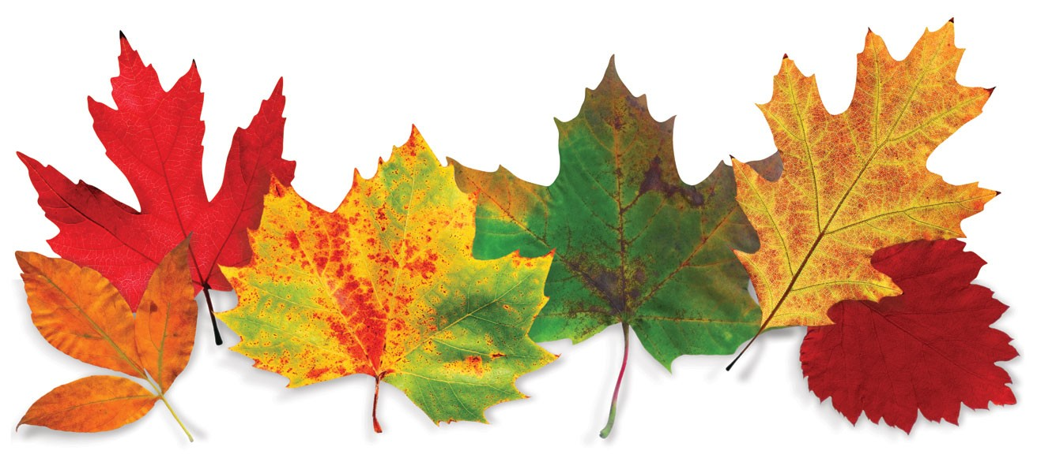
Bright Horizon’s Activities for November 2018
Sunday | Monday |  |  | Tuesday | Wednesday | Thursday |  | Friday |  | Saturday
Resident Birthdays  Peter M. 11/8  Mary S. 11/18  Lila D. 11/29 |  | 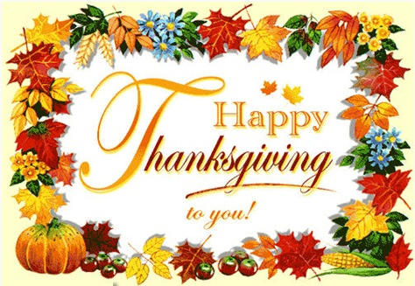 |  |  |  | 1  Personal Care  10:00 Catholic Mass with Fr. Carlos  Exercise  What’s in the bag?  Bingo  List It!  3:30 Country  Store Opened  Afternoon Stretch  Personal Care  Evening Small Talk  Wii SPORTS  Bedtime Reading | 2  Personal Care  Exercise  10:15 Clark YMCA (Silver Sneakers)  Bingo  2:30 Social Hour/ Walter Deery  LIST IT  Afternoon Stretch  Helping Around the House  Personal Care  Evening Small Talk  Bedtime Reading  Friday Night Dance 6:30-8:00  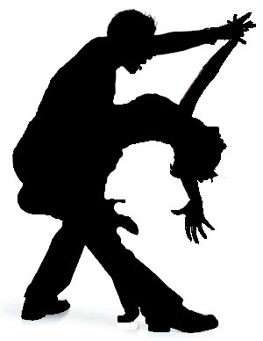 |  |  | 3  Personal Care  Mass on TV  Bingo  Exercise  1:30 Mystery Ride (weather permitting)  Thanksgiving Noodle Ball  3:45 Saturday Mass at Church  Trivia  Personal Care  Evening Small Talk  Bedtime Reading
4  Personal Care  Mass on TV  Exercise  Bingo  Helping Around the House  1:00 United  Parish Church  Service  Coffee Social  Bowling  Personal Care  Evening Small Talk  Bedtime Reading  Wii Sports  Day Light Savings  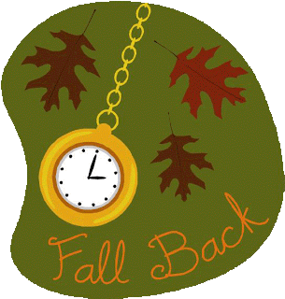 | 5  Personal Care  Mass on TV  Trivia  Exercise  Bingo  2:00 Piano Music in the Lobby with Joann  Wii Sports  Walking Group  Personal Care  Reminiscence  Bedtime Reading |  |  | 6  “Hair Day”  Personal Care  Mass on TV  Walking Group  10:00 Arts & Crafts/ Make Items for the Craft Fair  Guinea Pig Social  Exercise  Bingo  Horse Races  Nails & Tales  Personal Care  Evening Small Talk  Bedtime Reading | 7  “Foot Doctor”  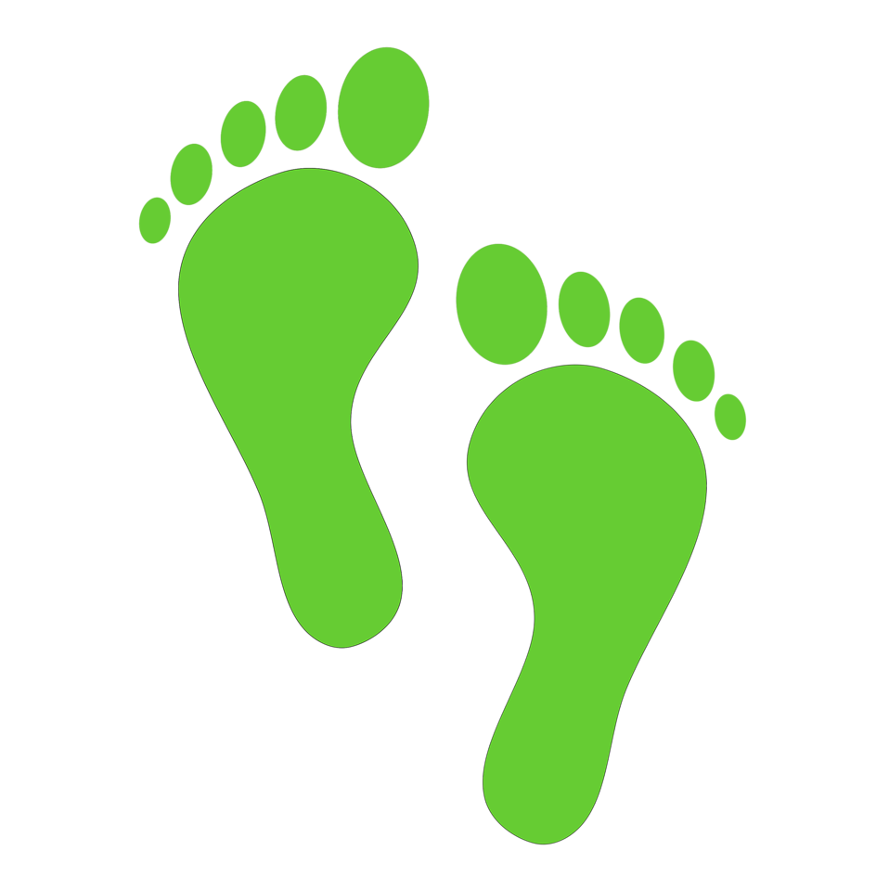  Personal Care  Mass on TV  10:00 Baking/ Ginger Snap Cookies  Exercise  3:30 YMCA Clark (Swimming)  Visualization  Bingo  Bowling  Personal Care  Evening Small Talk  Bedtime Reading | 8  Personal Care  Exercise  What’s in the bag?  11:30 Lunch Trip/ Monty Tech.  Bingo  List It!  3:30 Country  Store Opened  Afternoon Stretch  Personal Care  Evening Small Talk  Wii SPORTS  Bedtime Reading |  |  | 9  Personal Care  Exercise  10:15 Clark YMCA (Silver Sneakers)  Bingo  2:30 Social Hour/ Dave Andrews  LIST IT  Afternoon Stretch  Helping Around the House  Personal Care  Evening Small Talk  Bedtime Reading | 10  Personal Care  Mass on TV  Bingo  Exercise  1:30 Mystery Ride (weather permitting)  Thanksgiving Noodle Ball  3:45 Saturday Mass at Church  Trivia  Personal Care  Evening Small Talk  Bedtime Reading  Happy Birthday  Marine Corps.  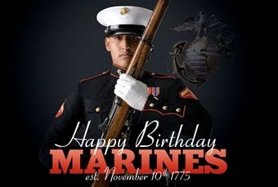
11  Personal Care  Mass on TV  Exercise  Bingo  Helping Around the House  2:30 Veterans Day  Presentation  Coffee Social  Bowling  Personal Care  Evening Small Talk  Bedtime Reading  Wii Sports  Veteran’s Day | 12  Personal Care  Mass on TV  Trivia  Exercise  Bingo  2:00 Piano Music in the Lobby with Joann  Wii Sports  Walking Group  Personal Care  Reminiscence  Bedtime Reading |  |  | 13  “Hair Day”  Personal Care  Mass on TV  10:00 Arts & Crafts/ Make Items for the Craft Fair  Guinea Pig Social  Exercise  2:30 Animal Craze  Bingo  3:30 Rosary  Wii Sports  Personal Care  Evening Small Talk  Bedtime Reading  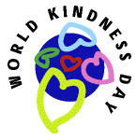 | 14  Personal Care  Mass on TV  10:00 Baking/  Banana Bread  Exercise  2:30 Yoga  3:30 YMCA Clark (Swimming)  Visualization  Bingo  Bowling  Personal Care  Evening Small Talk  Bedtime Reading  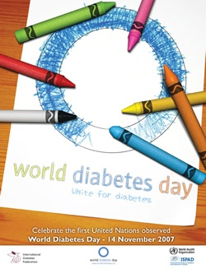 | 15  Personal Care  10:00 Catholic Mass with Fr. Carlos  Exercise  What’s in the bag?  Bingo  List It!  3:30 Country  Store Opened  Afternoon Stretch  Personal Care  Evening Small Talk  Wii SPORTS  Bedtime Reading  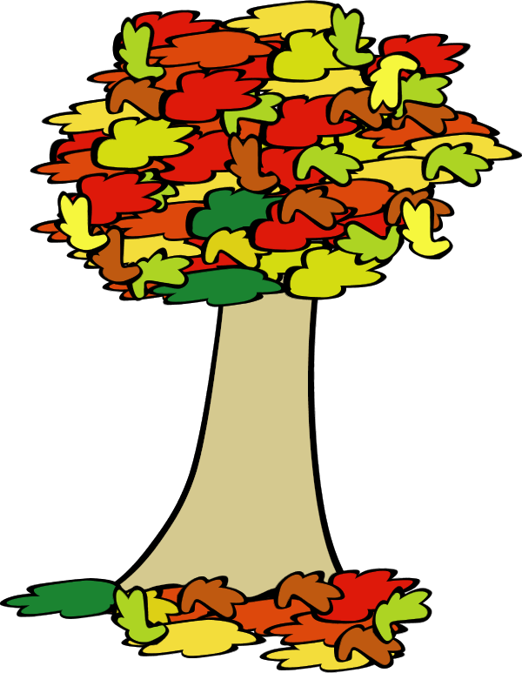 |  |  | 16  Personal Care  Exercise  10:15 Clark YMCA  (Silver Sneakers)  Bingo  2:30 Social Hour/ Terry Nally  LIST IT  Afternoon Stretch  Helping Around the House  Personal Care  Evening Small Talk  Bedtime Reading | 17  Personal Care  Mass on TV  Bingo  Exercise  1:30 Mystery Ride (weather permitting)  Thanksgiving Noodle Ball  3:45 Saturday Mass at Church  Personal Care  Evening Small Talk  Bedtime Reading  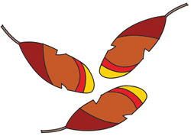
Bright Horizon’s Activities for November 2018
Sunday |  |  | Monday | Tuesday | Wednesday | Thursday |  |  | Friday |  | Saturday
18  Personal Care  Mass on TV  Exercise  Bingo  Helping Around the House  Coffee Social  Ring Toss  Personal Care  Evening Small Talk  Bedtime Reading  Wii Sports |  |  | 19  Personal Care  Mass on TV  Trivia  Exercise  Bingo  2:00 Piano Music in the Lobby with Joann  Wii Sports  Walking Group  Personal Care  Reminiscence  Bedtime Reading  American Made Matters Day | 20  “Hair Day”  Personal Care  Mass on TV  10:00 Arts & Crafts/ Make Items for the Craft Fair  Guinea Pig Social  Exercise  2:30 Errand  Trip  Bingo  Wii Sports  Walking Group  Personal Care  Evening Small Talk  Bedtime Reading | 21  Personal Care  Mass on TV  10:00 Baking/  Baked Apples  Exercise  3:30 YMCA Clark (Swimming)  Visualization  Bingo  Bowling  Personal Care  Evening Small Talk  Bedtime Reading | 22  Personal Care  10:00 Catholic Mass with Fr. Carlos  Exercise  What’s in the bag?  Bingo  List It!  3:30 Country  Store Opened  Afternoon Stretch  Personal Care  Evening Small Talk  Wii SPORTS  Bedtime Reading  Thanksgiving Day  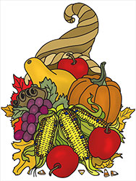 |  |  | 23  Personal Care  Exercise  10:15 Clark YMCA  (Silver Sneakers)  Bingo  2:30 Social Hour/ Tim Barrett  LIST IT  Afternoon Stretch  Helping Around the House  Personal Care  Evening Small Talk  Bedtime Reading |  | 24  Personal Care  Mass on TV  Bingo  Exercise  1:30 Mystery Ride (weather permitting)  Noodle Ball  3:45 Saturday Mass at Church  Personal Care  Evening Small Talk  Bedtime Reading
25  Personal Care  Mass on TV  Exercise  Bingo  Helping Around the House  Coffee Social  Ring Toss  Personal Care  Evening Small Talk  Bedtime Reading  Wii Sports |  |  | 26  Personal Care  Mass on TV  Trivia  Exercise  Bingo  2:30 Resident Birthday Party  With  The Cavaliers  Wii Sports  Walking Group  Personal Care  Reminiscence  Bedtime Reading | 27  “Hair Day”  Personal Care  Mass on TV  10:00 Arts & Crafts/ Make Items for the Craft Fair  Guinea Pig Social  Exercise  Bingo  3:30 Rosary  Wii Sports  Walking Group  Personal Care  Bedtime Reading | 28  Personal Care  Mass on TV  10:00 Baking/  Cranberry Bread for Fair  Exercise  2:30 Yoga  Bingo  3:30 YMCA Clark (Swimming)  Visualization  Bowling  Personal Care  Evening Small Talk  Bedtime Reading | 29  Personal Care  10:00 Catholic Mass with Fr. Carlos  Exercise  What’s in the bag?  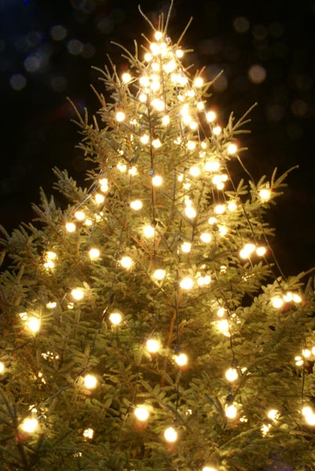2:30 Decorate Christmas Tree in Lobby  Bingo  List It!  3:30 Country  Store Opened  Afternoon Stretch  Personal Care  Evening Small Talk  Wii SPORTS  Bedtime Reading |  | 30  Personal Care  Mass on TV  10:15 Clark YMCA  (Silver Sneakers)  Exercise  2:30 Social Hour/ Peter Sargent  Bingo  Visualization  Bowling  Personal Care  Evening Small Talk  Bedtime Reading |  |  | Saturday  December  ^{1st}  Holiday  Craft  Fair  10:00-2:00  SANTA VISIT  11:30-2:00  &  Tree  Lighting  Ceremony  4:00-5:00
Festival of  Trees at the  Gardner  Museum  Nov. 8th -  Dec. 1st. |  |  | Festival of Trees  Hours:  Wed.-Thurs. 1-4  Friday 1-7  Sat. & Sun. 10-4  Special:  Holiday Coffee  10-12  Wednesday, November 14th  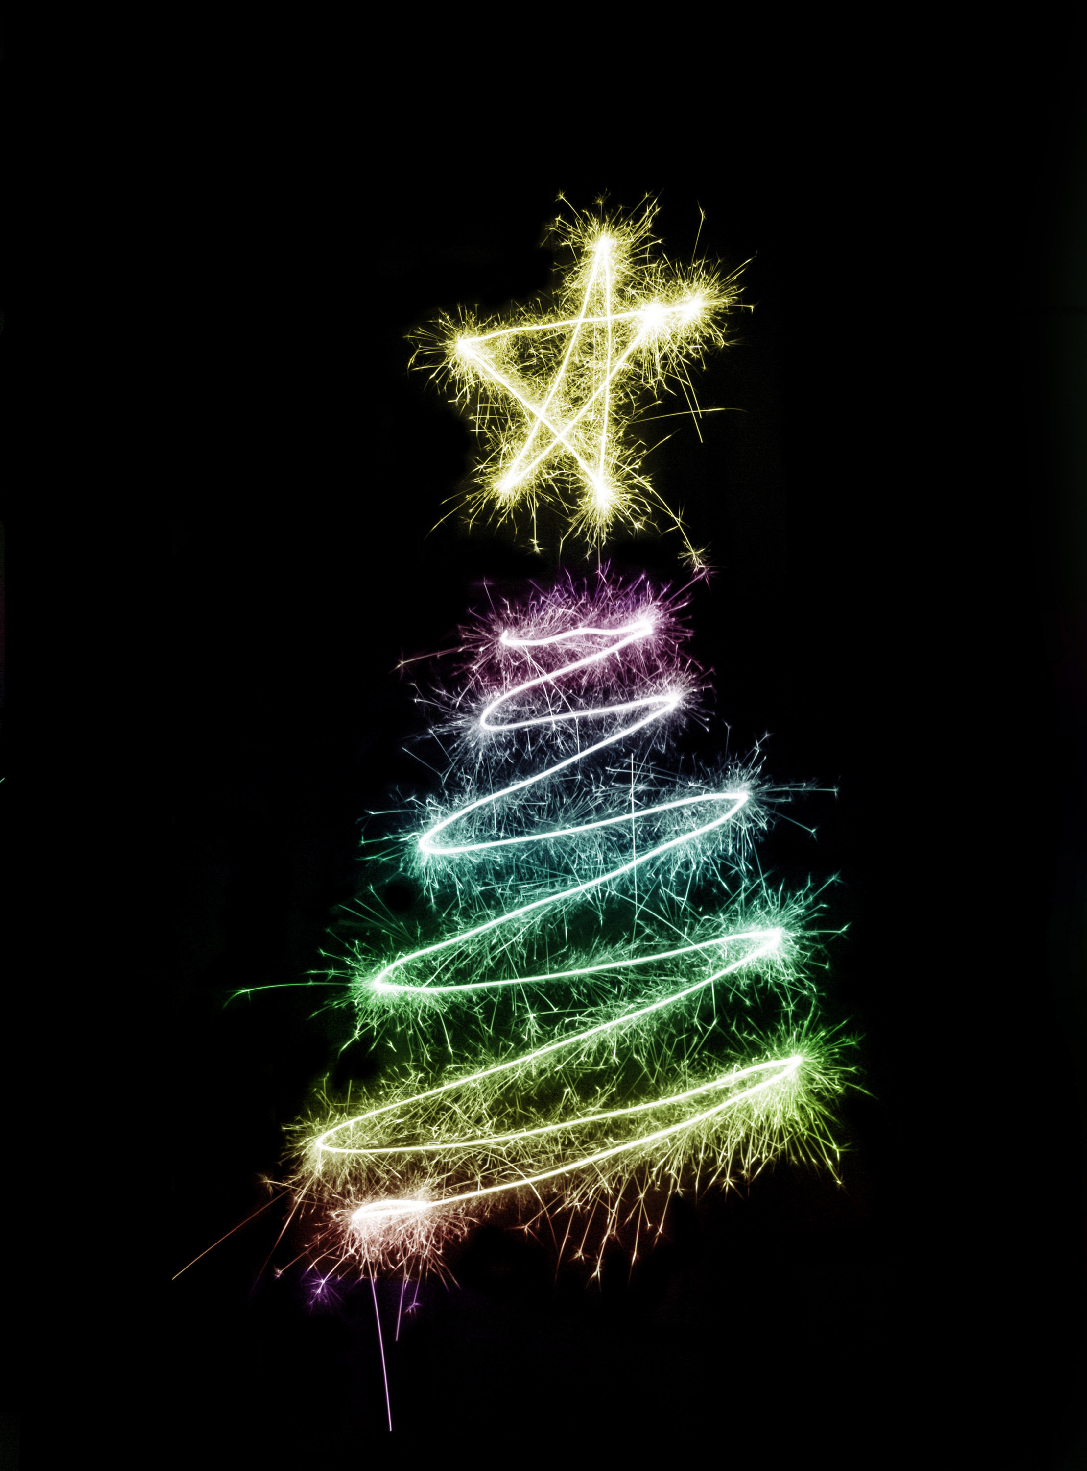 | Main Events  1, 15, 22 & 29- Catholic Mass at 10:00am 13th & 27th Rosary at 3:30  2nd -10:15 Clark YMCA (Silver Sneakers) 14 & 28 - Yoga at2:30  2nd -Social Hour with Walter Deery at 2:30pm 16th -2:30 Social Hour/ Terry Nally  2nd – Masquerade Dance 6:30-8:00 20 - 2:30 Errand Trip  3, 10, 17 & 24 -2:30 Mystery Ride (Weather Permitting) 23rd -2:30 Social Hour/ Tim Barrett  3, 10, 17 & 24 - 3:45 Saturday Mass at Church 26th -Resident Birthday Party 2:30/ The Cavaliers  4th -United Parish Church Service at 1:00pm 29th -2:30 Decorate Christmas Tree in Lobby  5, 12, & 19 - 2:00 Piano Music in the Lobby 30th - 2:30 Social Hour/ Peter Sargent  7th - Foot Doctor  7th - 2:30 Liz Leal Playing Piano in the Lobby  7, 14, 21 & 28-3:30 YMCA Clark (Swimming)  8th -11:30 Lunch Trip/ Monty Tech  9th -2:30 Social Hour/ Dave Andrews  11th – 2:30 Veterans Day Presentation  13th Animal Craze at 2:30  Country Store is open on Tuesday & Thursday - 3:30 to 4:30 PM  Movies will be held on Tuesday & Thursday at 6:15PM, Saturday at 3:30 & 6:00 PM &  Sunday at 6:00 PM in the 2nd Floor TV Room

