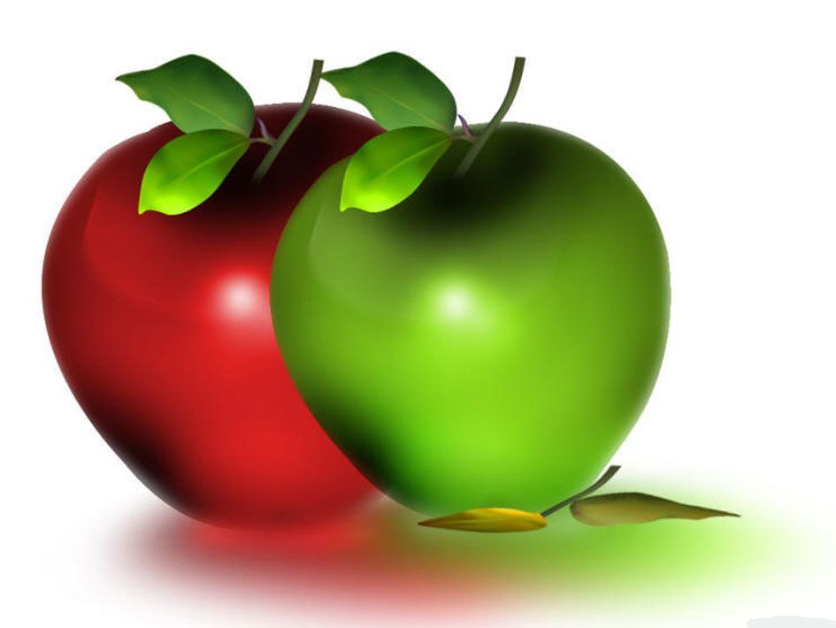Broadview Menu Calendar for September 2018
Sunday | Monday | Tuesday |  | Wednesday |  | Thursday | Friday | Saturday
  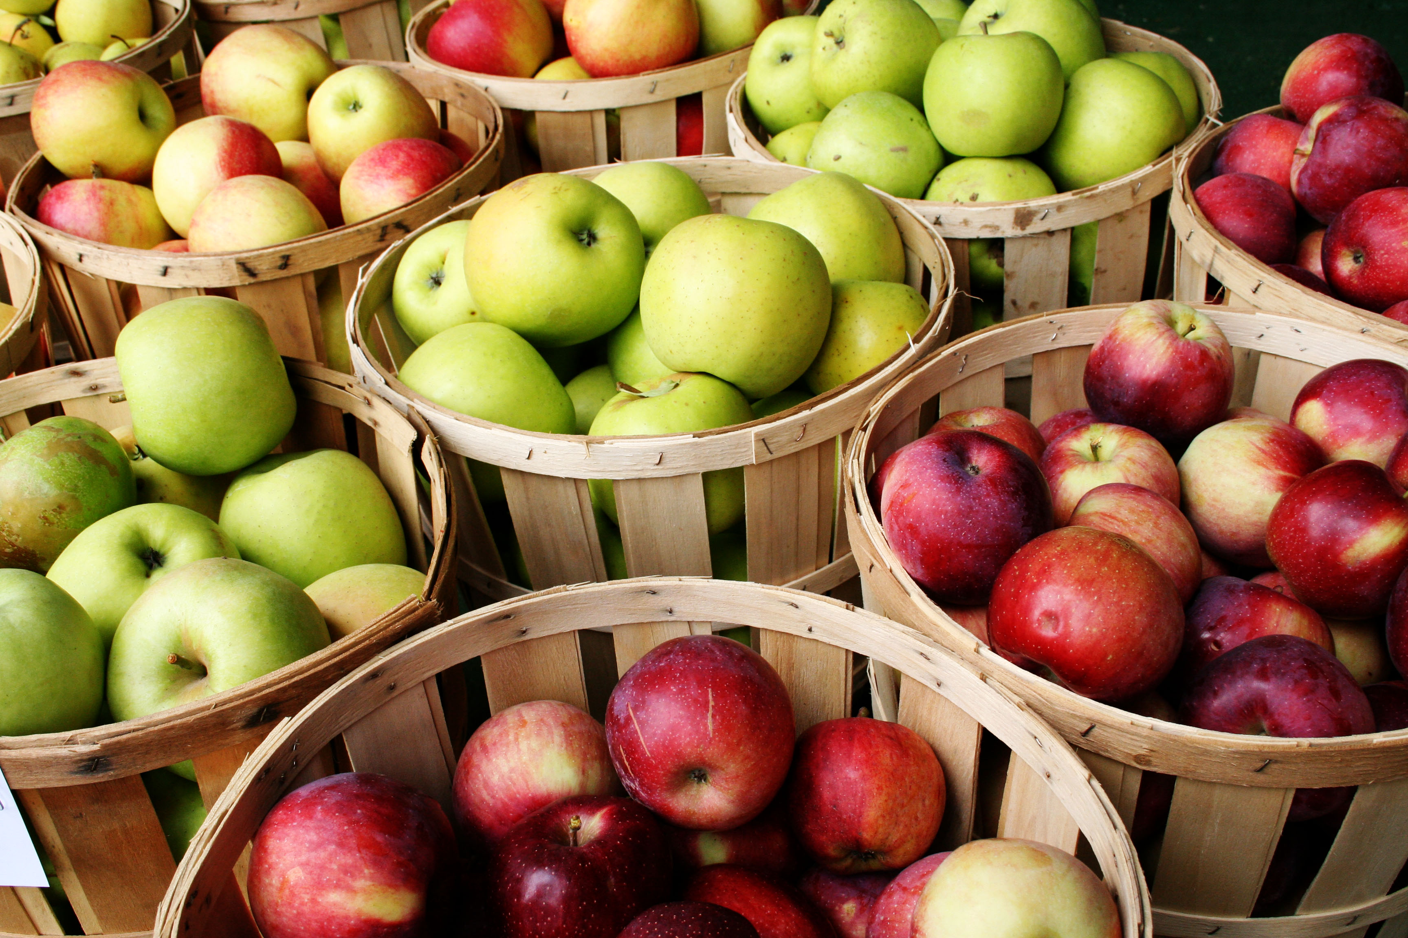  All American Breakfast Month  Eat Chicken Month  National Bacon Day 1st  National Banana Day 8th  International Eat an Apple Day 15th  National Monte Cristo Day 17th  National Ice Cream Cone Day 22nd  National Biscotti Day 29th |  |  |  |  |  |  | National  Assisted  Living  Week  September  9-15  2018 | 1  Breakfast  Yogurt  Muffin  Banana  Lunch  BBQ Ribs  Side Salad  Or  House Salad with Grilled Chicken Strips  Roll  Ice Cream  Dinner  Hot Dog on a Bun  Baked Beans  with Bacon  Coleslaw  Or  Turkey Noodle Soup  Roll  Vanilla Custard
2  Breakfast  Scrambled Eggs  Cinnamon Roll  Fruit Medley  Lunch  Boiled Dinner  Ham, Potatoes, Carrots, & Onions  Biscuit  Or  Turkey  Mashed Potatoes  Carrots  Strawberry Jell-O Pie  Dinner  Chicken Nuggets  French Fries  Green Beans  Or  Broccoli Cheddar Soup  Roll  Chocolate chip Cookie | 3  Labor Day  Breakfast  Waffles  Bacon  Pears  Lunch  Hotdogs & Hamburgers  Macaroni Salad  Corn on the Cob  Chips, Pickles  Tomato Mozzarella Salad  Novelty Ice Cream  or  Watermelon  Dinner  Ham & Cheese Quiche  Squash Medley  Or  Hamburger Soup  Roll  Tapioca Pudding | 4  Breakfast  Country Skillet  English Muffin  Mandarin Oranges  Lunch  Liver, Bacon & Onion  Or  Roasted Chicken  Baked Sweet Potato  Corn  Brownie Sundae  Dinner  Fish Sandwich  Seasonal Salad  Or  Minestrone Soup  Sourdough Bread  Fruited Jell-O |  | 5  Breakfast  French Toast  Sausage  Apple Sauce  Lunch  Turkey Tetrazzini  Or  Italian Sausage with Peppers & Onion  Rice  Zucchini  Strawberry Shortcake  Dinner  Chicken Noodle Soup  Cheddar & Corn Muffin  Or  Seafood Salad on a Roll  Tomato Salad  Rice Pudding |  | 6  Breakfast  Fried Eggs  Toast  Peaches  Lunch  Roast Pork with Gravy  Mashed Potatoes  Carrots  Or  Beef Stew with Dumplings  Pumpkin Bread  Dinner  Beef Barley Soup  Sliced Buttered Bread  Or  Egg Salad Sandwich  Chips & Pickle  Ice Cream | 7  Breakfast  Pancakes  Bacon  Banana  Lunch  Herbed Baked Haddock  Twice Baked Potato  Steamed Spinach Or  Homemade Mac &  Cheese  Blueberry Lemon Cake  Dinner  Tomato Soup  &  ½ or Whole  Grilled Cheese  Sandwich  Waldorf Salad  Oatmeal Cookie | 8  Breakfast  Eggs Benedict  English Muffin  Fruit Cocktail  Lunch  Shepherd’s Pie  Or  Baked Stuffed Chicken  Rice  Beets  Ice Cream  Dinner  Hot Dog on a Bun  Baked Beans  Cucumber Sour Cream Salad  Or  Turkey Chili  Corn Muffin  Banana Pudding with Topping
9  Breakfast  Fried Eggs  Toast  Home Fries  Peaches  Lunch  Baked Ham  Or  Roast Beef  Sweet Potatoes  Cauliflower  Lemon Bars  Dinner  Pea Soup  Biscuit  Or  Beef Macaroni Skillet  Greek Salad  Rice Pudding | 10  Breakfast  Donuts/Bagels/Muffins  Yogurt Cup  Pears  Lunch  Lobster Roll  Or  Chunky Chicken Salad Sandwich  Vegetable Slaw  Chips & Pickles  Oatmeal Hermit  Dinner  BLT Sandwich  Salad  Or  Beef Noodle Soup  Roll | 11  Breakfast  Plain  or  Blueberry Pancakes  Sausage  Banana  Lunch  Baked Chicken or  Make Your Own Pizza  Rice  Peas  Zucchini Bread  Dinner  Tuna Salad Sandwich  Cucumber  Salad  Or  Baked Onion Soup  Cheese Bread  Fruit Parfait |  | 12  Breakfast  Cheese Omelet  Homemade Muffin  Pineapple  Lunch  Baked Cod  Au Gratin Potato  Green Beans  Or  Spaghetti with  Meatballs  Italian Bread  Cool & Easy Pie  Dinner  Roast Beef & Provolone  Sandwich  Corn & Bean  Salad  Or  Zuppa Toscana  Roll  Bread Pudding |  | 13  Breakfast  French Toast  Bacon  Melon  Lunch  Steak Tips with Peppers & Onions  Or  Chicken Divan Noodles  Mixed Vegetable  Banana Cream Pie  Dinner  Cream of Mushroom Soup  Or  Ham & Swiss  Sandwich on Rye  Carrots  Ice Cream | 14  Breakfast  Baked Tomato & Cheese Omelet  English Muffin  Mandarin Oranges  Lunch  Seafood Casserole  Or  Meatloaf  Baked Potato  Summer Squash  Fruit Crisp  Dinner  Chicken Nuggets  Vegetable Macaroni Salad  Carrots  Or  Fish Chowder  Roll  Peanut Butter Cookie | 15  Breakfast  Waffles  Sausage  Fruit Cocktail  Lunch  Chicken-Shepherd’s Pie  Or  Vegetable Lasagna  Side Salad  Cheesecake  Dinner  Hamburger  Or  Hotdog on a Bun  Baked Beans  Potato Salad  Coleslaw  Blueberry Cobbler
Broadview Menu Calendar for September 2018
Sunday | Monday |  | Tuesday |  | Wednesday | Thursday | Friday |  | Saturday
16  Breakfast  Scrambled Eggs  English Muffin  Mandarin Oranges  Lunch  Baked American Chop Suey  Or  Pork Roast  Mashed Potatoes  Beets  Fruit Pie  Dinner  Seafood Chowder  Roll  Or  Grilled Cheese & Tomato Sandwich  Butterscotch Pudding | 17  Breakfast  French Toast  Sausage  Mixed Fruit  Lunch  Roasted Turkey  Or  Swedish Meatballs  Egg Noodles  Mixed Vegetables  Brownie Pudding  Dinner  Monte Cristo Sandwich  Or  Broccoli Cheddar Soup  Crackers  Side Salad  Ice Cream |  | 18  Breakfast  Cheese Omelet  Cranberry Orange Muffin  Banana  Lunch  Baked Cod  Or  BBQ Ribs  Sweet Potatoes  Corn  Fruit Cup  Dinner  Turkey Salad Sandwich  Lettuce & Tomato  Cranberry Sauce  Or  Potato Leek Soup  Corn Bread  Chocolate Chip Cookie |  | 19  Breakfast  Waffles  Canadian Bacon  Peaches  Lunch  Lasagna  Garlic Bread  Or  Chicken Pot Pie  Side Salad  Apple Cake  Dinner  Corn Chowder  Roll  Or  Italian Sandwich  Pickled Beets  Chips & Pickle  Chocolate Mousse | 20  Breakfast  Boiled Eggs  Bran Muffin  Fresh Fruit  Lunch  Pot Roast  Or  Baked Ham  Potatoes & Carrots  Bread Pudding  Dinner  C&S Pizza  Side Salad  Or  BLT Sandwich with Fries  Peanut Butter Cookie | 21  Breakfast  Pancakes  Bacon  Pears  Lunch  Crab Cake  Or  Italian Sausage with Peppers & Onion  Mashed Potatoes  Green Beans  Mocha Chocolate Cake  Dinner  Beef Stew  Biscuit  Or  Ham Salad Sandwich  Sliced Cucumbers  Tapioca Pudding |  | 22  Breakfast  Yogurt  Muffin  Strawberries  Lunch  Chicken Cacciatore  Noodles  Or  Homemade Mac & Cheese  Mixed Vegetable  Ice cream Cones  Dinner  Hot Dog on a Bun  Baked Beans  Coleslaw  Or  Chicken Noodle Soup  Roll  Lemon Pie
23  Breakfast  Scrambled Eggs  Cinnamon Roll  Fruit  Lunch  Roast Beef w\ Gravy  Or  Pork Tenderloin  Mashed Sweet Potato  Peas  Oatmeal Cookie  Dinner  Chicken, Tomato & Rice Soup  Roll  Or  Tuna Salad Sandwich  Fries  Salad  Strawberry Parfait | 24  Breakfast  French Toast  Sausage  Grapes  Lunch  Pulled Pork  Red Mashed Potato  Green Beans  Or  Linguine with Shrimp & Vegetable Garlic Sauce  Carrot Cake  Dinner  Sloppy Joe on a Bun  Side Salad  Or  Tortellini Soup  Roll  Ice Cream |  | 25  Breakfast  Poached Eggs  Wheat Toast  Mandarin Oranges  Lunch  Baked Chicken  Or  Cod Nuggets  Potato Salad  Roasted Vegetables  Banana Cake  Dinner  Tomato Soup  Roll  Or  Grilled Cheese Sandwich  Raisin Carrot Salad  Rice Pudding |  | 26  Breakfast  Pancakes  Bacon  Banana  Lunch  Stuffed Shells  Or  Beef Stroganoff  Egg Noodles  Side Salad  Chocolate Cream Pie  Dinner  Turkey Bacon Ranch Sandwich  Seasoned French Fries  Or  Clam Chowder  Roll  Fruit Sorbet | 27  Breakfast  Fried Eggs  Sausage  Toast  Pears  Lunch  Baked Ham  Or  Turkey in Gravy  Mashed Potato  Beets  Pineapple  Upside Down Cake  Dinner  Pilgrim Sandwich  Sliced Tomatoes  Or  Chef Salad  Garlic Bread  Jell-O | 28  Breakfast  Yogurt  Apple Muffin  Melon  Lunch  Bruschetta Topped Haddock  Rice  Broccoli & Cauliflower  Or  American Chop Suey  Bread Pudding  Dinner  French Toast  Home Fries  Sausage  Or  Minestrone Soup  Dinner Roll  Yogurt Parfait |  | 29  Breakfast  Breakfast Quiche  Croissant  Apricots  Lunch  Meatloaf with Gravy  Or  Oven Fried Chicken  Baked Potato  Green Beans  Apple Crisp  Dinner  Hotdogs  Beans  Brown Bread  Coleslaw  Or  Corn Chowder  Roll  Fresh Pineapple
30  Breakfast  French Toast  Sausage  Mandarin Oranges  Lunch  Roast Beef  Or  Herb Crusted Cod  Mashed Potatoes  Peas & Onions  Pie Cart  Dinner  Grilled Rueben  Side Salad  Or  Pasta Faggioli Soup  ½ Grilled Rueben  Molasses Spice Cookie | Broadview Assisted Living  Menu Choices Always Available
  Breakfast | Fruit | Lunch & Dinner
  Cold Cereal: | (Seasonal Fruit Ask Your Server) | Sandwiches:
  Corn Flakes, Rice Krispies | Oranges, Mandarin Oranges, Peaches | Ham, Roast Beef, Peanut Butter & Jelly,
  Raisin Bran, Cheerios, | Pears, Apple Sauce, Apples, Banana's | Tuna, Egg Salad
  Honey Nut Cheerios | Pineapple, Fruit Cocktail
   |  | Soups:
  Hot Cereal: | Beverages: All Meals | Chicken Noodle, Soup Du Jour
  Oatmeal, Cream of Wheat | Iced Coffee, Iced Tea, Lemonade
   | Coffee, Tea (Regular & Decaf.) | Salad:
  Eggs to Order | Milk, Hot Chocolate, Lactaid Milk, | Tossed Salad with Dressing
  Breads: | Juices: | Dessert:
  White, Wheat, Rye, Raisin, English Muffins | Tomato/V8, Apple, Cranberry, Orange, Prune | Fruited Yogurt
   |  | Assorted Desserts, Ask your Server
   | Soda:
   | MENU SUBJECT TO CHANGE

