Broadview Activities for July 2018
Sunday | Monday |  |  |  | Tuesday |  |  | Wednesday |  |  | Thursday | Friday |  | Saturday
1  9:30 Rosary on TV  10:00 Mass on TV  10:00 Coffee  Hour/  Monthly Gazette  Or  Room Visits  11:15 Exercise  1:00 United  Parish Church  Service  2:00 Bingo  3:30 Movie/  “Breakfast at Tiffanies”  8:05 RED SOX  Canada Day  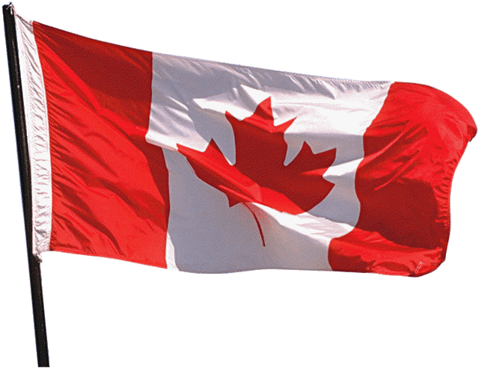 |  | 2  9:30 Mass on TV  10:00 Walking Group (Weather Permitting)  11:15 Exercise  1:00 Bingo  2:00 Piano Music in the Lobby with Joann  4:00 Trivia  7:00 Wheel of  Fortune  7:05 RED SOX  7:30 Jeopardy |  |  |  | 3  9:30 Mass on TV  10:00 Arts &  Crafts/ Festive 4th Hats  11:15 Exercise  1:00 Bingo  2:30 Errand  Trip  3:30 Nails & Tales  3:30 Country Store  Opened  4:00 Finish the Lyrics…  6:05 RED SOX  6:15 Movie/  “Forrest Gump” |  |  | 4  9:30 Mass on TV  10:00 Baking/  Peanut Butter Fudge  11:15 Exercise  12:00 July 4th BBQ & The Cavaliers  1:30 Bingo  2:30 Word Game  4:00 Gazebo Gab Fest  7:00 Wheel of  Fortune  7:30 Jeopardy  11:05 RED SOX  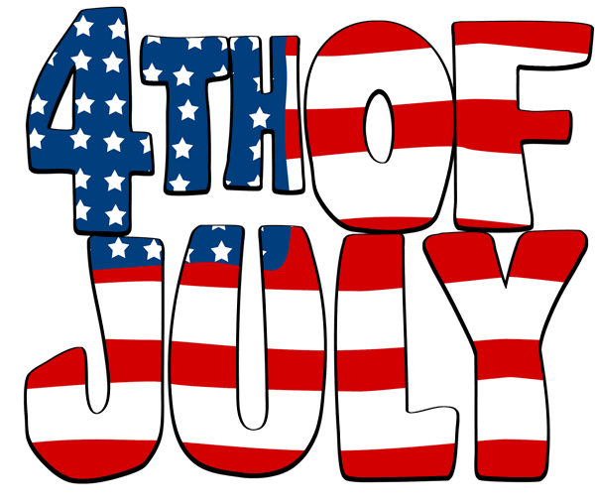 |  | 5  9:30 Mass on TV  10:00 Trivia/Cards  10:30 YMCA Clark (Pool)  11:15 Exercise  1:00 Bingo  2:30 Ice cream trip to Murdock  3:30 Country  Store Opened  4:00 Nails & Tales  6:15 Movie/  “The Legend of Bagger Vance”  National Apple Turnover Day | 6  “Hair Day”  10:00 Walking Group & Gazebo Gab Fest  10:15 Clark YMCA  (Silver Sneakers)  11:15 Exercise  1:00 Bingo  2:30 Social Hour/  Dave Andrews  4:00 Word Game  7:00 Wheel of Fortune  7:30 Jeopardy  8:15 RED SOX |  | 7  9:30 Catholic Mass on TV  10:00 Bingo  11:15 Exercise  1:00 Cards  2:30 Finish the Phrase…  3:30 Movie/  “The King & I”  6:00 Saturday Night at the Movies/ Residents Choice  7:15 RED SOX  National Strawberry Sundae Day
8  9:30 Mass on TV  10:00 Coffee Hour/  Current Events  Or  Room Visits  11:15 Exercise  1:00 Bingo  2:15 RED SOX  2:30Yahtzee/  Cards  3:30 Movie/  “The Road to Bali”  National Chocolate with Almonds Day | 9  9:30 Mass on TV  10:00 Walking Group  (Weather Permitting)  11:15 Exercise  1:00 Bingo  2:00 Piano Music in the Lobby with Joann  4:00 Trivia  7:00 Wheel of  Fortune  7:10 RED SOX  7:30 Jeopardy |  |  |  | 10  9:30 Mass on TV  10:00 Arts &Crafts/ Paper Mache Cacti  11:15 Exercise  1:00 Bingo  2:30 Nails & Tales  3:30 Rosary  3:30 Country  Store Opened  6:15 Movie/  “Men of Honor”  7:10 RED SOX  National Pick Blueberries Day |  |  | 11  “Hair Day”  9:30 Mass on TV  10:00 Baking/ Pimento Cheese Finger Sandwiches  11:15 Exercise  1:00 Bingo  2:30 Ice Cream Social  3:30 Walking Group  7:00 Wheel of  Fortune  7:10 RED SOX  7:30 Jeopardy  National Blueberry Muffin Day |  |  | 12  9:30 Mass on TV  10:00 Catholic Mass with Fr. Mike  10:30 YMCA Clark (Pool)  11:15 Exercise  11:30 Lunch Trip/  Kay’s Dairy Bar  1:00 Bingo  2:30 Cards/  Unlucky 7's  3:30 Country  Store Opened  4:00 Nails & Tales  6:15 Movie/  “Mr. Holland’s Opus”  7:10 RED SOX |  | 13  “Hair Day”  10:00 Walking  Group  10:15 Clark YMCA  (Silver Sneakers)  11:15 Exercise  1:00 Bingo  2:30 Social Hour/Walter Deery  4:00 Word Game  7:00 Wheel of Fortune  7:10 RED SOX  7:30 Jeopardy  National French Fry Day  Barber Shop Music Appreciation Day | 14  9:30 Catholic Mass on TV  10:00 Bingo  11:15 Exercise  1:00 Finish the Line…  1:05 RED SOX  2:30 Cards  3:30 Movie/  “The Fortune Cookies”  6:00 Saturday Night at the Movies/ Residents Choice
15  9:30 Rosary on TV  10:00 Mass on TV  10:00 Coffee  Hour/  Spelling Bee  Or  Room Visits  11:15 Exercise  1:00 Bingo  1:05 RED SOX  2:30 Mystery Ride (Weather Permitting)  4:00 Movie/  “Houseboat”  National Ice Cream Day | 16  9:30 Mass on TV  10:00 Walking Group  (Weather Permitting)  11:15 Exercise  1:00 Bingo  2:00 Piano Music in the Lobby with Joann  4:00 Word Game  7:00 Wheel of  Fortune  7:30 Jeopardy  8:00 RED SOX |  |  |  | 17  9:30 Mass on TV  10:00 Arts & Crafts/Homemade Bird Feeders  11:15 Exercise  1:00 Bingo  2:30 Animal Craze  3:30 Country  Store Opened  4:00 Gazebo Gab  Fest  6:15 Movie/  “The Best of John Wayne”  8:00 RED SOX |  |  | 18  “Hair Day”  9:30 Mass on TV  10:00 Baking/  Jam Filled Butter Cookies  11:15 Exercise  1:00 Bingo  2:30 Yoga Class  3:30 Walking Group  7:00 Wheel of  Fortune  7:30 Jeopardy |  |  | 19  9:30 Mass on TV  10:00 Catholic Mass with Fr. Mike  10:30 YMCA Clark (Pool)  11:15 Exercise  1:30 Movie/  “Residents Choice”  3:30 Country  Store Opened  4:00 Nails & Tales  6:15 Movie/  “The Best of Jack Benny”  10:10 RED SOX |  | 20  “Hair Day”  10:00 Walking  Group or Blueberry Picking  10:15 Clark YMCA  (Silver Sneakers)  11:15 Exercise  1:00 Bingo  2:30 Social  Hour/ Dan Kirouac  4:00 Word Game  7:00 Wheel of Fortune  7:10 RED SOX  7:30 Jeopardy  National Ice Cream Soda Day | 21  9:30 Mass on TV  10:00 Bingo  11:15 Exercise  1:00 Finish the Proverb…  2:30 Cards  3:30 Movie/  “Sweet Nothing in My Ear”  6:00 Saturday Night at the Movies/ Residents Choice  8:15 RED SOX
Broadview Activities for July 2018
Sunday |  |  | Monday | Tuesday |  |  | Wednesday |  |  | Thursday |  |  | Friday |  | Saturday
22  9:30 Rosary on TV  10:00 Mass on TV  10:00 Coffee  Hour/  Current Events  Or  Room Visits  11:15 Exercise  1:00 Bingo  1:10 RED SOX  2:30 Word Game  3:30 Movie/  “Annie Get Your Gun” |  |  | 23  9:30 Mass on TV  10:00 Walking Group or Blueberry Picking  11:15 Exercise  1:00 Bingo  2:00 Piano Music in the Lobby with Joann  4:00 Cards/ Unlucky 7’s  7:00 Wheel of  Fortune  7:05 RED SOX  7:30 Jeopardy | 24  9:30 Mass on TV  10:00 Arts &  Crafts/ Eatable Aquarium  11:15 Exercise  1:00 Bingo  2:00 Activity,  Resident &  Food Council Meeting  3:30 Rosary  Nails & Tales  3:30 Country  Store Opened  6:15 Movie/  “The Carol Burnett Show”  7:05 RED SOX  Amelia Earhart Day |  |  | 25  “Hair Day”  9:30 Mass on TV  10:00 Baking/  Ants on a Log  11:15 Exercise  11:30 Picnic Lunch to Mt. Wachusett  1:00 Bingo  2:30 Word Game  4:00 Coupons to Troops  7:00 Wheel of  Fortune  7:05 RED SOX  7:30 Jeopardy  Culinarians Day |  |  | 26  9:30 Mass on TV  10:00 Catholic Mass with Fr. Mike  10:45 Fishing trip/ Dunn’s Park  11:15 Exercise  1:00 Bingo  3:30 Country  Store Opened  4:00 Nails & Tales  6:15 Movie/  “Hotel for Dogs”  7:10 RED SOX |  |  | 27  “Hair Day”  10:00 Blueberry Picking or  Penny Ante  10:15 Clark YMCA (Silver Sneakers)  11:15 Exercise  1:00 Bingo  2:30 Social  Hour/  Tony Valley  4:00 Word Game  7:00 Wheel of Fortune  7:30 Jeopardy  7:10 RED SOX |  | 28  9:30 Mass on TV  10:00 Bingo  11:15 Exercise  1:00 Finish the Lyric…  2:30 Cards  3:30 Movie/  “Sabrina”  6:00 Saturday Night at the Movies/ Residents Choice  7:10 RED SOX
29  9:30 Mass on TV  10:00 Coffee  Hour/ Finish  the Phrase…  11:15 Exercise  1:00 Bingo  2:30 Penny Ante  3:30 Movie/  “I Dream of Jeanie” |  |  | 30  9:30 Mass on TV  10:00 Blueberry Picking or  Word Game  11:15 Exercise  1:00 Bingo  2:30 Resident Birthday Party/Richard Erickson  4:00 Cards/ UNO  7:00 Wheel of  Fortune  7:10 RED SOX  7:30 Jeopardy  International Day of Friendship | 31  9:30 Mass on TV  10:00 Arts & Crafts/ Picking Blueberries  11:15 Exercise  1:00 Bingo  2:30 Errand  Trip  2:30 Nails & Tales  3:30 Country  Store Opened  4:00 Walking Group  6:15 Movie/  “The Legend of Zorro”  7:10 RED SOX |  |  | National Blueberry Month  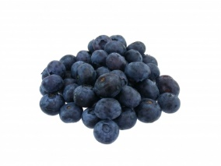  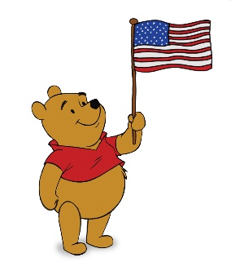 |  |  | Birthdays  Lyle N. 7/5  Helen N. 7/28
Main Events
Country Store is open on Tuesday & Thursday - 3:30 PM and by Request.
Movies will be held on Tuesday & Thursday at 6:15 PM,
Saturday at 3:30 PM & 6:00 PM, Sunday at 6:00 PM in the 2nd Floor TV Room
1-1:00 United Parish Church Service | 12-11:30 Lunch Trip/Kay’s Dairy Bar
2, 9, 16 & 23 -2:00 Piano Music in the Lobby with Joann | 13-2:30 Social Hour/ Walter Deery
3, 17 & 31-2:30 Errand Trip | 15-2:30 Mystery Ride (Weather Permitting)
4-12:00 July 4th BBQ & The Cavaliers | 17 – 2:30 Animal Craze
5, 12, 19 & 26 - 10:30 YMCA Clark (Pool) | 18- 2:30 Yoga Class
5- 2:30 Ice cream trip to Murdock | 20-2:30 Social Hour/ Dan Kirouac
6, 13, 20, &27- 10:15 Clark YMCA (Silver Sneakers) | 25- 11:30 Picnic Lunch to Mt. Wachusett
6- 2:30 Social Hour/ Dave Andrews | 27-2:30 Social Hour/ Tony Valley
10 & 24- 3:30 Rosary | 30-2:30 Resident Birthday Party/Richard Erickson
11-2:30 Ice Cream Social
12, 19, & 26-10:00 Catholic Mass with Fr. Mike

