Broadview Activities for October 2018
Sunday | Monday |  | Tuesday |  | Wednesday |  |  | Thursday | Friday | Saturday
BIRTHDAYS!  Jane ~ 10/1  Louise ~ 10/8  Ray G. ~ 10/16  Cecelia 10/30  Tim ~ 10/30  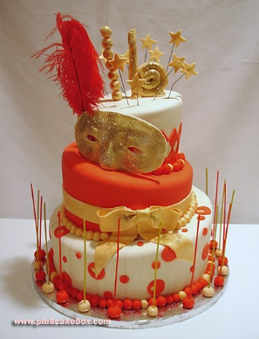 | 1  9:30 Mass on TV  10:00 Walking Group (Weather Permitting)  11:15 Exercise  1:00 Bingo  2:00 Piano Music in the Lobby with Joann  4:00 Finish the Phrase… In the Gazebo (Weather Permitting)  7:00 Wheel of  Fortune  7:30 Jeopardy |  | 2  9:30 Mass on TV  10:00 Arts &  Crafts/ Paper Spider Web  11:15 Exercise  1:00 Bingo  2:30 List It!  3:30 Rosary  3:30 Country  Store Opened  4:00 Nails & Tales  6:15 Movie/  “One Fine Day”  Peanuts Cartoon Day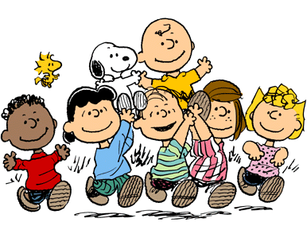 |  |  | 3  “Hair Day”  9:30 Mass on TV  10:00 Baking/ Candy Corn Mix  11:15 Exercise  1:00 Bingo  2:30 Entertainment  Ron Morey  3:30 YMCA  Clark (Swimming)  4:00 LCR  Dice Game  7:00 Wheel of  Fortune  7:30 Jeopardy |  | 4  “Flu Shot Clinic”  10:00 Catholic Mass  11:15 Exercise  1:00 Bingo  2:30 Cards/ Unlucky 7  3:30 Country  Store Opened  3:30 Please join us  in Welcoming  Leslie Cosentino RN. Back to Broadview  with Cookies and  Light refreshments  4:00 Nails & Tales  6:15 Movie/  “Sabrina”  New England Patriots 8:20 PM | 5  “Hair Day”  9:30 Mass on TV  10:00 Trivia  10:15 Clark  YMCA  (Silver Sneakers)  11:15 Exercise  1:00 Bingo  2:30 Social Hour/ Tony Valley  4:00 Word Game  7:00 Wheel of Fortune  7:30 Jeopardy  7:10 Red Sox  World Smile Day | 6  9:30 Catholic Mass on TV  10:00 Bingo  11:15 Exercise  1:30 Finish the Phrase…  2:30 Cards/UNO  3:30 Movie/  “An Ideal Husband”  3:45 Saturday Mass at Church  6:00 Saturday Night at the Movies/ Residents Choice
7  7:00 Mass on TV  10:00 Coffee  Hour Social  11:15 Exercise  1:00 United  Parish Church  Service  2:00 Bingo  3:30 LCR Dice Game  6:00 Movie/  “Speak Easily”  National Fallen Firefighters Memorial Day  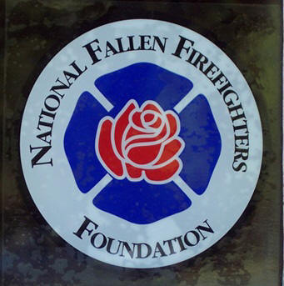 | 8  9:30 Mass on TV  10:00 Walking Group (Weather Permitting)  Or  Penny Ante  11:15 Exercise  1:00 Bingo  2:00 Piano Music in the Lobby with Joann  4:00 Coupons to Troops  7:00 Wheel of  Fortune  7:30 Jeopardy |  | 9  9:30 Mass on TV  10:00 Arts & Crafts/  Bat Book Marks  11:15 Exercise  1:00 Bingo  2:30 List It!  3:30 Country  Store Opened  4:00 Nails & Tales  6:15 Movie/  “The Private Navy of Sergeant O’Farrell” |  | 10  “Hair Day”  9:30 Mass on TV  10:00 Baking/  Spooky Cookies  11:15 Exercise  1:00 Bingo  2:30 Yoga  3:30 YMCA  Clark (Swimming)  4:00 Trivia in the Gazebo (Weather Permitting)  7:00 Wheel of  Fortune  7:30 Jeopardy |  |  | 11  10:00 Catholic Mass  11:15 Exercise  11:30 Lunch Trip/  Flipside Grille  1:00 Bingo  2:30 Cards/or Yahtzee  3:30 Country  Store Opened  4:00 Nails & Tales  6:15 Movie/  “Phantom of the Opera” | 12  “Hair Day”  9:30 Mass on TV  10:00 Cards/ UNO  10:15 Clark  YMCA  (Silver Sneakers)  11:15 Exercise  1:00 Bingo  2:30 Social Hour/  Heather Marie  4:00 Word Game  7:00 Wheel of Fortune  7:30 Jeopardy | 13  9:30 Catholic Mass on TV  10:00 Bingo  11:15 Exercise  1:30 Finish the Line…  2:30 Cards  3:30 Movie/  “The Red Skelton Show”  3:45 Saturday Mass at Church  6:00 Saturday Night at the Movies/ Residents Choice
14  7:00 Mass on TV  10:00 Coffee  Hour/ Trivia  11:15 Exercise  1:00 Bingo  2:30 Foliage Ride (Weather Permitting)  4:00 Word Game  6:00 Movie/  “The Big Street”  New England Patriots 8:20 PM | 15  9:30 Mass on TV  10:00 Walking Group (Weather Permitting)  11:15 Exercise  1:00 Bingo  2:00 Piano Music in the Lobby with Joann  4:00List It!  7:00 Wheel of  Fortune  7:30 Jeopardy  I Love Lucy Day  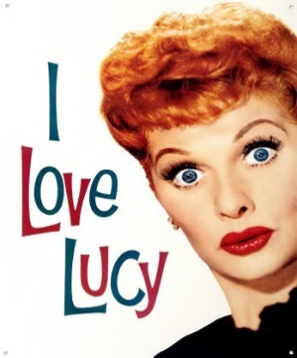 |  | 16  “Hair Day”  9:30 Mass on TV  10:00 Arts &  Crafts/ Web Door Decor  11:15 Exercise  1:00 Bingo  2:30 Errand Trip  3:30 Rosary  3:30 Country  Store Opened  4:00 Nails & Tales  6:15 Movie/  “Devine Secrets of the Ya-Ya Sisterhood” |  | 17  9:30 Mass on TV  10:00 Baking/  “Bones”  11:15 Exercise  1:00 Bingo  2:30 Word Game  3:30 YMCA  Clark (Swimming)  4:00 Penny Ante  7:00 Wheel of  Fortune  7:30 Jeopardy |  |  | 18  10:00 Catholic Mass  11:15 Exercise  1:30 Movie/  “Cleopatra Part 1”  3:30 Country  Store Opened  4:00 Nails & Tales  6:15 Movie/  “Cleopatra Part 2”  National Boss’s Day  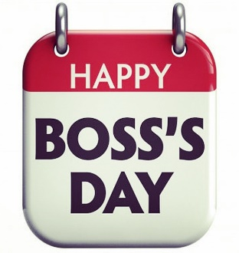 | 19  “Hair Day”  9:30 Mass on TV  10:00 Walking Group (Weather Permitting)  Or  Card Game  10:15 Clark  YMCA  (Silver Sneakers)  11:15 Exercise  1:00 Bingo  2:30 Social Hour/  Dan Kirouac  4:00 Word Game  7:00 Wheel of Fortune  7:30 Jeopardy | 20  9:30 Mass on TV  10:00 Bingo  11:15 Exercise  1:30 Finish the Proverb…  2:30 Cards  3:30 Movie/  “Ever After”  3:45 Saturday Mass at Church  6:00 Saturday Night at the Movies/ Residents Choice
Broadview Activities for October 2018
Sunday |  | Monday | Tuesday | Wednesday |  |  | Thursday |  | Friday |  | Saturday
21  7:00 Mass on TV  10:00 Coffee  Hour/  Current Events  11:15 Exercise  New England Patriots 1:00 PM  1:00 Bingo  2:30 Winchendon Historic Center Tour  4:00 Word Game  6:00 Movie/  “A Time to Reflect”  The History of Whalom Park  &  “Quartet” |  | 22  9:30 Mass on TV  10:00 List It!  11:15 Exercise  1:00 Bingo  2:00 Piano Music in the Lobby with Joann  4:00 Finish the Word  7:00 Wheel of  Fortune  7:30 Jeopardy | 23  9:30 Mass on TV  10:00 Arts & Crafts/ Halloween Decorations  11:15 Exercise  1:00 Bingo  2:30 Trivia  3:30 Country  Store Opened  4:00 Nails & Tales  6:15 Movie/  “When Calls the Heart” | 24  “Hair Day”  Country Breakfast for Men  &  Victorian Breakfast for Women  9:30 Mass on TV  10:00 Baking/  Cups of Dirt  11:15 Exercise  1:00 Bingo  2:30 Yoga  3:30 YMCA  Clark (Swimming)  4:00 Penny Ante  7:00 Wheel of  Fortune  7:30 Jeopardy |  |  | 25  10:00 Catholic Mass 11:15 Exercise  1:00 Bingo  2:30 Puppy Party  3:30 Country  Store Opened  4:00 Nails & Tales  6:15 Movie/  “Good Will Hunting” |  | 26  “Hair Day”  9:30 Mass on TV  10:00 Coffee Hour Social  10:15 Clark  YMCA  (Silver Sneakers)  11:15 Exercise  1:00 Bingo  2:30 Social  Hour/ Lou & Jan  4:00 Word Game  7:00 Wheel of Fortune  7:30 Jeopardy |  | 27  9:30 Mass on TV  10:00 Bingo  11:15 Exercise  1:30 Finish the Lyric…  2:30 Animal Craze  3:30 Movie/  “Casablanca”  3:45 Saturday Mass at Church  6:00 Saturday Night at the Movies/  Residents Choice
28  7:00 Mass on TV  10:00 Coffee  Hour/  Finish the Phrase…  11:15 Exercise  1:00 Bingo  2:30 List It!  4:00 Making Halloween Goodie Bags for Trick or Treaters  6:00 Movie/  “The Bishop’s Wife” |  | 29  9:30 Mass on TV  10:00 Penny Ante  11:15 Exercise  1:00 Bingo  2:30 Resident Birthday Party/  Peter Sargent  4:00 Making Halloween Goodie Bags for Trick or Treaters  7:00 Wheel of  Fortune  7:30 Jeopardy  New England Patriots 8:15 PM | 30  9:30 Mass on TV  10:00 Arts & Crafts/ Mason Jar  Jack-o-lantern  11:15 Exercise  1:00 Bingo  2:00 Resident  Food & Activity  Council Meeting  3:30 Rosary  3:30 Country  Store Opened  4:00 Nails & Tales  6:15 Movie/  "Overboard"  7:10 Red Sox  National Cat Day  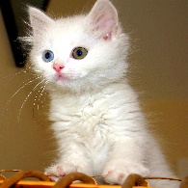 | 31  “Hair Day”  9:30 Mass on TV  10:00 Baking/  Witches Hats  11:15 Exercise  1:00 Bingo  2:30 Word Game  3:30 YMCA  Clark (Swimming)  4:00 LCR Dice Game  6:35 Red Sox  7:00 Wheel of  Fortune  7:30 Jeopardy  5:30-7:30  Trick or Treaters
 |  | 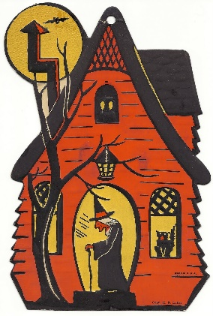 | Main Events  Country Store is open on Tuesday & Thursday - 3:30PM and by request.  Movies will be held on Tuesday & Thursday at 6:15 PM, Saturday at 3:30 PM & 6:00 PM,  Sunday at 6:00 PM in the 2nd Floor TV Room  1, 8, 15 & 22- 2:00 Piano Music in the Lobby with Joann 11- 11:30 Lunch Trip/ Flipside Grille  2,16 & 30- Rosary 11- 2:30 Social Hour/ Heather Marie  3-2:30 Entertainment Ron Morey 14- 2:30 Foliage Ride (Weather Permitting)  3, 10, 17, 24 & 31-3:30 YMCA Clark (Swimming) 16- 2:30 Errand Trip  4, 11, 18 & 25- 10:00 Catholic Mass 19- 2:30 Social Hour/ Dan Kirouac  4- “Flu Shot Clinic” 21- 2:30 Winchendon Historic Center Tour  5, 12, 19 & 26-10:15 Clark YMCA (Silver Sneakers) 24- Country Breakfast for Men & Victorian Breakfast for Women  5- 2:30 Social Hour/ Tony Valley 25- 2:30 Puppy Party  6, 13, 20 & 27- 3:45 Saturday Mass at Church 26-2:30 Social Hour/ Lou & Jan  7-1:00 United Parish Church Service 27- 2:30 Animal Craze  10 & 24- 2:30 Yoga 29- 2:30 Resident Birthday Party/ Peter Sargent  31- HALLOWEEN (5:30-7:30)

