Bright Horizons Activities for October 2018
Sunday | Monday |  |  |  | Tuesday |  | Wednesday |  |  | Thursday | Friday | Saturday
BIRTHDAYS!  Jane ~ 10/1  Louise ~ 10/8  Ray G. ~ 10/16  Cecelia 10/30  Tim ~ 10/30  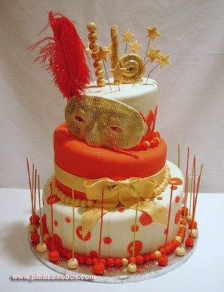 |  | 1  Personal Care  Mass on TV Gardening  Exercise  Bingo  2:00 Piano Music in the Lobby with Joann  Walking Group Ring Toss  Personal Care Evening Small Talk  Bedtime Reading |  |  |  | 2  Personal Care  Mass on TV Walking Group 10:00 Arts &  Crafts/ Paper Spider Web  Exercise  Bingo  Nails & Tales  3:30 Country Store Opened  3:30 Rosary  Personal Care  Evening Small Talk  Bedtime Reading  Peanuts Cartoon Day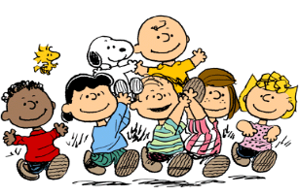 |  | 3  “Hair Day”  Personal Care Mass on TV Exercise  10:00 Baking/ Candy Corn Mix  Open Air Discussion/R&R  Bingo  2:30 Entertainment Ron Morey  3:30 Clark  YMCA (POOL)  Bowling  Personal Care  Evening Small Talk  Bedtime Reading |  | 4  “Flu Shot Clinic”  Personal Care  10:00 Catholic Mass  Exercise  Bingo  List It!  Walking Group  3:30 Country Store Opened  3:30 Please join us  in Welcoming  Leslie Cosentino RN. Back to Broadview  with Cookies and  Light refreshments  Personal Care  Evening Small Talk Bedtime Reading  New England Patriots 8:20 PM | 5  “Hair Day”  Personal Care  10:15 Clark YMCA  (Silver Sneakers)  Exercise  Walking Group Bingo  2:30 Social Hour/  Tony Valley  Word Game  Open-Air Discussion/R&R Ring Toss  Helping Around the House  Personal Care  Evening Small Talk Bedtime Reading  World Smile Day | 6  Personal Care United Parish or Mass on TV Bingo  Exercise  1:30 Foliage Ride (weather permitting) Walking Group Cards  Trivia  Personal Care Evening Small Talk  Bedtime Reading
7  Personal Care Mass on TV Exercise  Walking Group 1:00 United Parish Church Service Bingo  Helping Around the House  Coffee Hour/ (Monthly Gazette) Personal Care Evening Small Talk  Bedtime Reading  National Fallen Firefighters Memorial Day  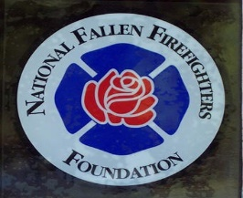 | 8  Personal Care  Mass on TV Gardening  Exercise  Bingo  2:00 Piano Music in the Lobby with Joann  Walking Group  Ring Toss  Personal Care Evening Small Talk Bedtime Reading |  |  |  | 9  Personal Care  Mass on TV Walking Group 10:00 Arts & Crafts/  Bat Book Marks  Exercise  Bingo  Nails & Tales  3:30 Country Store Opened  Personal Care  Evening Small Talk Bedtime Reading |  | 10  “Hair Day”  Personal Care  Mass on TV  10:00 Baking/  Spooky Cookies  Exercise  2:30 Yoga Class  Open Air Discussion/  R & R  3:30 Clark  YMCA (POOL)  Bingo  Bowling  Personal Care  Evening Small Talk Bedtime Reading |  |  | 11  Personal Care  10:00 Catholic Mass  Exercise  11:30 Lunch Trip/  Flip Side Grille  Bingo  List It!  Walking Group  3:30 Country Store Opened  Personal Care  Evening Small Talk Bedtime Reading | 12  “Hair Day”  Personal Care 10:15 Clark YMCA  (Silver Sneakers)  Exercise Gardening  Bingo  2:30 Social  Hour/  Heather Marie  Word Game Afternoon Stretch  Open-Air Discussion/R&R  Personal Care Evening Small Talk  Bedtime Reading | 13  Personal Care United Parish or Mass on TV Bingo  Exercise  1:30 Foliage Ride (weather permitting) Walking Group Cards  4:05 RED SOX Trivia  Personal Care Evening Small Talk Bedtime Reading
14  Personal Care Mass on TV  Exercise  Bingo  Helping Around the House  Coffee Hour/ (Reminiscence) Personal Care Evening Small Talk Bedtime Reading  New England Patriots 8:20 PM | 15  Personal Care  Mass on TV  Exercise  Bingo  2:00 Piano Music in the Lobby with Joann  Walking Group Visualization  Personal Care  Wii SPORTS  Evening Small Talk Bedtime Reading  I Love Lucy Day  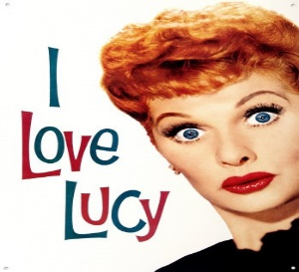 |  |  |  | 16  Personal Care  Mass on TV  10:00 Arts &  Crafts/  Web Door Decor  Exercise  Bingo  2:30 Errand Trip  Nails & Tales  3:30 Country Store Opened  3:30 Rosary  Personal Care  Evening Small Talk Bedtime Reading |  | 17  “Hair Day”  Personal Care  Mass on TV  10:00 Baking/  “Bones”  Exercise  Open Air Discussion/  R & R  Bingo  3:30 Clark  YMCA (POOL)  Noodle Ball Personal Care Evening Small Talk Bedtime Reading |  |  | 18  Personal Care  10:00 Catholic Mass  Exercise  Bingo  List It!  3:30 Country Store Opened  Afternoon Stretch Personal Care  Evening Small Talk Wii SPORTS  Bedtime Reading  National Boss’s Day  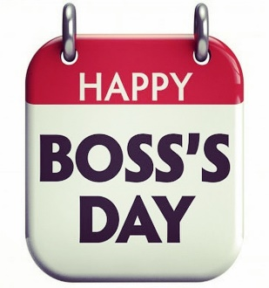 | 19  “Hair Day”  Personal Care 10:15 Clark YMCA  (Silver Sneakers)  Exercise Gardening  Bingo  2:30 Social  Hour/ Dan Kirouac  LIST IT Afternoon Stretch  Open-Air Discussion/R&R  Personal Care Evening Small Talk  Bedtime Reading | 20  Personal Care United Parish or Mass on TV  Bingo  Exercise  1:30 Foliage Ride (weather  permitting) Afternoon Stretch Cards  Trivia  Personal Care  Evening Small Talk  Bedtime Reading
Bright Horizons Activities for October 2018
Sunday |  |  | Monday | Tuesday |  |  | Wednesday |  | Thursday |  | Friday |  | Saturday
21  Personal Care  Mass on TV  Exercise  Helping Around the House  New England Patriots 1:00 PM  2:30 Winchendon Historic Center Tour  Personal Care Evening Small Talk Bedtime Reading |  |  | 22  Personal Care Mass on TV Gardening Exercise  Bingo  2:00 Piano Music in the Lobby with Joann  Walking Group Personal Care  Evening Small Talk  Bedtime Reading | 23  Personal Care  Mass on TV  10:00 Arts & Crafts/ Halloween Decorations  Exercise  Bingo  Nails & Tales  3:30 Country Store Opened  Visualization Personal Care Evening Small Talk Bedtime Reading |  |  | 24  “Hair Day”  Personal Care  Country Breakfast for Men  &  Victorian Breakfast for Women  Mass on TV  10:00 Baking/ Cups of Dirt  Exercise  2:30 Yoga Class  Open Air Discussion/  R & R  3:30 Clark  YMCA (POOL)  Bingo  Ring Toss  Personal Care Evening Small Talk Wii SPORTS Bedtime Reading |  | 25  Personal Care  10:00 Catholic Mass  Exercise  2:30 Puppy Party Bingo  List It!  3:30 Country Store Opened  Afternoon Stretch Personal Care  Evening Small Talk  Wii SPORTS  Bedtime Reading |  | 26  “Hair Day”  Personal Care  10:15 Clark YMCA  (Silver Sneakers)  Exercise  Walking Group Bingo  2:30 Social  Hour/  Lou & Jan  Patio Bowling  Open-Air Discussion/R&R Helping Around the House  Personal Care  Evening Small Talk Bedtime Reading |  | 27  Personal Care United Parish or Mass on TV Bingo  Exercise Afternoon  Stretch  1:30 Foliage Ride (weather permitting)  2:30 Animal Craze  Cards  Trivia  Personal Care Evening  Small Talk  Bedtime Reading
28  Personal Care  Mass on TV  Exercise  Gardening  Ring Toss  Helping Around  the House  Coffee Hour/ (TRIVIA)  Personal Care  Evening Small Talk Bedtime Reading |  |  | 29  Personal Care Mass on TV Exercise  2:30 Resident Birthday Party/  Peter Sargent  Gardening  Bingo  Walking Group Personal Care Evening Small Talk  Bedtime Reading  New England Patriots 8:15 PM | 30  Personal Care  Mass on TV  10:00 Arts & Crafts/ Mason Jar  Jack-o-lantern  Exercise  Bingo  Nails & Tales  3:30 Rosary  3:30 Country Store Opened  Visualization Personal Care  Evening Small Talk Bedtime Reading  National Cat Day  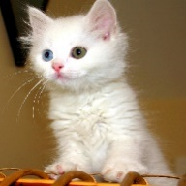 |  |  | 31  “Hair Day”  Personal Care  Mass on TV  10:00 Baking/  Witches Hats  Exercise  Open Air Discussion/  R & R  Bingo  3:30 Clark  YMCA (POOL)  Noodle Ball Personal Care Evening Small Talk Bedtime Reading |  | 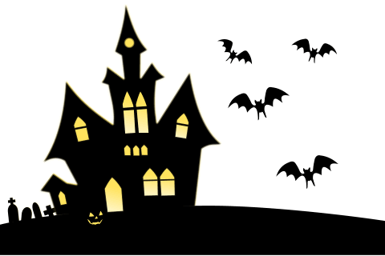 |  |  |  | 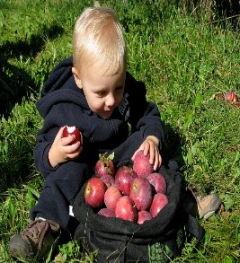
Main Events
Country Store is open on Tuesday & Thursday - 3:30 PM and by Request.
1, 8, 15 & 22 -2:00 Piano Music in the Lobby with Joann | 11- 11:30 Lunch Trip/ Flipside Grille
2, 16 & 30- 3:30 Rosary | 11- 2:30 Social Hour/ Heather Marie
3-2:30 Entertainment Ron Morey | 16- 2:30 Errand Trip
3, 10, 17, 24 & 31-3:30 YMCA Clark (Swimming) | 19- 2:30 Social Hour/ Dan Kirouac
4, 11, 18 & 25- 10:00 Catholic Mass | 21- 2:30 Winchendon Historic Center Tour
4- “Flu Shot Clinic” | 24- Country Breakfast for Men &  Victorian Breakfast for Women
5, 12, 19 & 26-10:15 Clark YMCA (Silver Sneakers) | 25- 2:30 Puppy Party
5- 2:30 Social Hour/ Tony Valley | 26-2:30 Social Hour/ Lou & Jan
6, 13, 20 & 27- 1:30 Foliage Ride (weather permitting) | 27- 2:30 Animal Craze
6, 13, 20 & 27- 3:45 Saturday Mass at Church | 29- 2:30 Resident Birthday Party/ Peter Sargent
7-1:00 United Parish Church Service | 31- HALLOWEEN (5:30-7:30)
10 & 24- 2:30 Yoga

