Broadview Activities for August 2018
Sunday | Monday |  | Tuesday |  | Wednesday |  |  | Thursday | Friday |  | Saturday
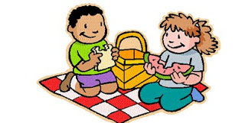 |  |  | 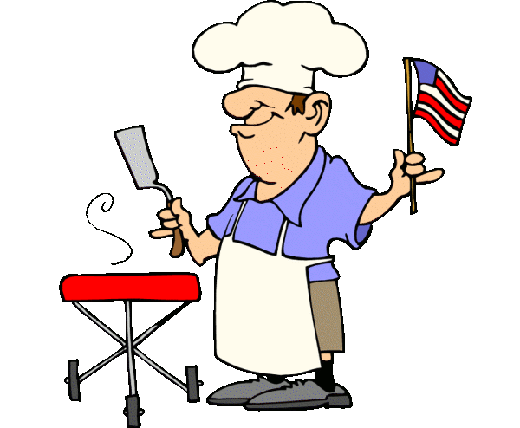 |  |  | 1  “Hair Day”  9:30 Mass on TV  10:00 Baking/ Build Your Own Smores  11:15 Exercise  1:00 Bingo  2:30 Glenn Hillard  4:00 LCR  Dice Game  7:00 Wheel of  Fortune  7:30 Jeopardy |  | 2  10:00 Catholic Mass with Fr. Mike  11:15 Exercise  1:00 Bingo  2:30 Cards/ Unlucky 7  3:30 Country  Store Opened  4:00 Nails & Tales  6:15 Movie/  “The Man in the Iron Mask”  7:10 Red Sox | 3  “Hair Day”  9:30 Mass on TV  10:00 Walking Group Or Gazebo Gab Fest (Weather Permitting)  11:15 Exercise  1:00 Bingo  2:30 Social Hour/ Tim Barrett  4:00 Word Game  7:00 Wheel of Fortune  7:30 Jeopardy  7:10 Red Sox |  | 4  9:30 Catholic Mass on TV  10:00 Bingo  11:15 Exercise  1:30 Finish the Phrase…  2:30 Cards/UNO  3:30 Movie/  “Falling in Love”  4:05 Red Sox  6:00 Saturday Night at the Movies/ Residents Choice
5  7:00 Mass on TV  10:00 Coffee  Hour Social  11:15 Exercise  1:00 United  Parish Church  Service  2:00 Bingo  3:30 LCR Dice Game  6:00 Movie/  “Gone with the Wind”  TBD Red Sox | 6  9:30 Mass on TV  10:00 Walking Group (Weather Permitting)  11:15 Exercise  1:00 Bingo  2:30 Finish the Phrase... In the Gazebo (Weather Permitting)  4:00 Coupons to Troops  7:00 Wheel of  Fortune  7:30 Jeopardy |  | 7  9:30 Mass on TV  10:00 Arts &  Crafts/ Printing with Flowers  11:15 Exercise  1:00 Bingo  2:30 List It!  3:30 Rosary  3:30 Country  Store Opened  4:00- 5:00 YMCA  Clark (Swimming)  4:00 Nails & Tales  6:15 Movie/  “One Fine Day”  7:07 Red Sox |  | 8  “Hair Day”  9:30 Mass on TV  10:00 Baking/  Mini Fruit Tarts  11:15 Exercise  1:00 Bingo  2:30 Animal Craze  4:00 Trivia in the Gazebo (Weather Permitting)  7:00 Wheel of  Fortune  7:30 Jeopardy  7:07 Red Sox |  |  | 9  10:00 Catholic Mass with Fr. Mike  11:15 Exercise  11:30 Lunch Trip/  Picnic Lunch-  Cathedral  of the Pines  1:00 Bingo  2:30 Cards/  Yahtzee  3:30 Country  Store Opened  4:00 Nails & Tales  6:15 Movie/  “Love's Enduring Promise”  7:07 Red Sox |  | 10  “Hair Day”  9:30 Mass on TV  10:00 Cards/UNO  10:15 Clark  YMCA  (Silver Sneakers)  11:15 Exercise  1:00 Bingo  2:30 Social Hour/  Heather Marie  4:00 Word Game  7:00 Wheel of Fortune  7:05 Red Sox  7:30 Jeopardy | 11  9:30 Catholic Mass on TV  10:00 Bingo  11:15 Exercise  1:30 Finish the Line…  2:30 Cards  3:30 Movie/  “The Wedding Date”  6:00 Saturday Night at the Movies/ Residents Choice  7:05 Red Sox
12  7:00 Mass on TV  10:00 Coffee  Hour/ Spelling Bee  11:15 Exercise  1:00 Bingo  1:05 Red Sox  2:30 LCR Dice Game  3:30 Word Game  6:00 Movie/  “My Best Friend's Wedding” | 13  9:30 Mass on TV  10:00 Walking Group  11:15 Exercise  1:00 Bingo  2:30 List It!  4:00 Finish the Phrase… In the Gazebo (Weather Permitting)  7:00 Wheel of  Fortune  7:30 Jeopardy |  | 14  “Hair Day”  9:30 Mass on TV  10:30 Fishing Trip to Dunn Park  11:15 Exercise  1:00 Bingo  2:30 Penny Ante  Or  2:30 Errand Trip  3:30 Trivia  3:30 Country  Store Opened  4:00- 5:00 YMCA  Clark (Swimming)  4:00 Nails & Tales  6:15 Movie/  “Pride & Prejudice”  7:05 Red Sox |  | 15  “FOOT DR.”  9:30 Mass on TV  10:00 Baking/  Canolli's  11:15 Exercise  1:00 Bingo  2:30 Yoga  4:00 List It!  7:00 Wheel of  Fortune  7:05 Red Sox  7:30 Jeopardy  9:30- 5:30  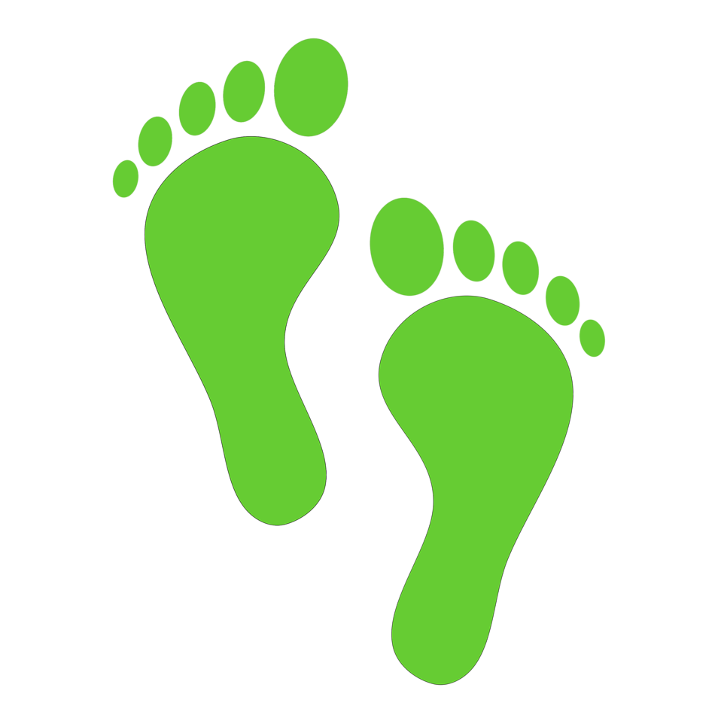 |  |  | 16  10:00 Catholic Mass with Fr. Mike  11:15 Exercise  1:30 Movie/  “Titanic”  Part One  3:30 Country  Store Opened  4:00 Nails & Tales  6:15 Movie/  “Titanic”  Part Two |  | 17  “Hair Day”  9:30 Mass on TV  10:00 Walking Group  10:15 Clark  YMCA  (Silver Sneakers)  11:15 Exercise  1:00 Bingo  2:30 Social Hour/  Lou & Jan  4:00 Word Game  7:00 Wheel of Fortune  7:10 Red Sox  7:30 Jeopardy | 18  9:30 Mass on TV  10:00 Bingo  11:15 Exercise  1:30 Finish the Proverb…  2:30 Cards  3:30 Movie/  “Presumed Innocent”  6:00 Saturday Night at the Movies/ Residents Choice  7:10 Red Sox
Broadview Activities for August 2018
Sunday |  | Monday | Tuesday | Wednesday |  |  | Thursday |  |  | Friday |  | Saturday
19  7:00 Mass on TV  10:00 Coffee  Hour/  Current Events  11:15 Exercise  1:00 Bingo  1:05 Red Sox  2:30 Mystery Ride  4:00 Word Game  6:00 Movie/  “Love's Abiding Joy” |  | 20  9:30 Mass on TV  10:00 List It!  11:15 Exercise  1:00 Bingo  2:30 Cards/  Yahtzee  4:00 Finish the Word  7:00 Wheel of  Fortune  7:30 Jeopardy  7:10 Red Sox | 21  9:30 Mass on TV  10:00 Arts &  Crafts/ Paper Beads  11:15 Exercise  1:00 Bingo  2:30 Trivia in the Gazebo  3:30 Rosary  3:30 Country  Store Opened  4:00- 5:00 YMCA  Clark (Swimming)  4:00 Nails & Tales  6:15 Movie/  “George of the Jungle”  7:10 Red Sox | 22  “Hair Day”  9:30 Mass on TV  10:00 Baking/  Hershey Kiss or  PB Cup Cookies  11:15 Exercise  1:00 Bingo  2:30 Word Game  4:00 Penny Ante  7:00 Wheel of  Fortune  7:10 Red Sox  7:30 Jeopardy |  |  | 23  10:00 Catholic Mass with Fr. Mike  11:15 Exercise  1:00 Bingo  1:05 Red Sox  2:30 Ice Cream Social  3:30 Country  Store Opened  4:00 Nails & Tales  6:15 Movie/  “Cousin Bette” |  |  | 24  “Hair Day”  9:30 Mass on TV  10:00 Coffee Hour Social in the Gazebo  10:15 Clark  YMCA  (Silver Sneakers)  11:15 Exercise  1:00 Bingo  2:30 Social  Hour/ Terry Nally  4:00 Word Game  7:00 Wheel of Fortune  7:10 Red Sox  7:30 Jeopardy |  | 25  9:30 Mass on TV  10:00 Bingo  11:15 Exercise  1:30 Finish the Lyric…  2:30 Cards  3:30 Movie/  “Hope Floats”  6:00 Saturday Night at the Movies/  Residents Choice  6:10 Red Sox
26  7:00 Mass on TV  10:00 Coffee  Hour/  Finish the Phrase…  11:15 Exercise  1:00 Bingo  1:10 Red Sox  2:30 List It!  4:00 Hang Man/ Game  6:00 Movie/  “The Holiday” |  | 27  9:30 Mass on TV  10:00 Penny Ante  11:15 Exercise  1:00 Bingo  2:30 Resident Birthday Party/  Richard Erickson  4:00 Trivia in the Gazebo (Weather Permitting)  7:00 Wheel of  Fortune  7:30 Jeopardy | 28  9:30 Mass on TV  10:00 Arts &  Crafts/Friendship Bracelets  11:15 Exercise  1:00 Bingo  2:00 Resident &  Food Council &  Activity  Council Meeting  3:30 Country  Store Opened  4:00- 5:00 YMCA  Clark (Swimming)4:00 Nails & Tales  6:15 Movie/  "Chicago"  7:10 Red Sox | 29  “Hair Day”  9:30 Mass on TV  10:00 Baking/ Coffee Can Ice Cream  11:15 Exercise  1:00 Bingo  2:30 Word Game  4:00 Penny Ante  6:35 Red Sox  7:00 Wheel of  Fortune  7:30 Jeopardy |  |  | 30  10:00 Catholic Mass with Fr. Mike  10:30 Painting with Will  11:15 Exercise  1:00 Bingo  2:30 Finish the Lyrics.... In the Gazebo (Weather Permitting)  3:30 Country  Store Opened  4:00 Nails & Tales  6:15 Movie/ The African Queen  8:10 Red Sox |  | 31  “Hair Day”  9:30 Mass on TV  10:00 Walking Group (Weather Permitting)  10:15 Clark  YMCA  (Silver Sneakers)  11:15 Exercise  1:00 Bingo  2:30 Social Hour/  Peter Sargent  4:00 Word Game  7:00 Wheel of Fortune  7:30 Jeopardy  8:10 Red Sox
Birthdays  Dot ~ 8/4  Marianne C.~8/4  Martha C. ~ 8/23  Shirley P. ~ 8/26 |  |  | Main Events  Country Store is open on Tuesday & Thursday - 3:30PM and by request.  Movies will be held on Tuesday & Thursday at 6:15 PM, Saturday at 3:30 PM & 6:00 PM,  Sunday at 6:00 PM in the 2nd Floor TV Room  1- 2:30 Glenn Hillard 14- 2:30 Errand Trip  2, 9, 16, 23 & 30- 10:00 Catholic Mass with Father Mike 15- FOOT DOCTOR (9:30-5:00)  3- 2:30 Social Hour/ Tim Barrett 15- 2:30 Yoga  5- 1:00 United Parish Church Service 17-2:30 Social Hour/ Lou & Jan  7, 14, 21 & 28- 4:00- 5:00 YMCA Clark (Swimming) 19- 2:30 Mystery Ride (Weather Permitting)  7 & 21- 3:30 Rosary 23- 2:30 Ice Cream Social  8- 2:30 Animal Craze 24- 2:30 Social Hour/ Terry Nally  9- 11:30 Lunch Trip/Picnic Lunch to Cathedral of the Pines 27- 2:30 Resident Birthday Party/ Richard Erickson  10, 17, 24 & 31- 10:15 Clark YMCA (Silver Sneakers) 30 – painting with Will  10- 2:30 Social Hour/ Heather Marie 31- 2:30 Social Hour/ Peter Sargent  14- 10:30 Fishing Trip (Dunn Park)

