Bright Horizons Activities for August 2018
Sunday | Monday |  | Tuesday |  | Wednesday |  |  | Thursday | Friday |  | Saturday
 | 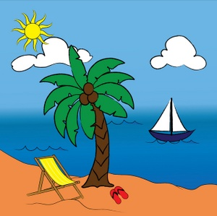 |  | 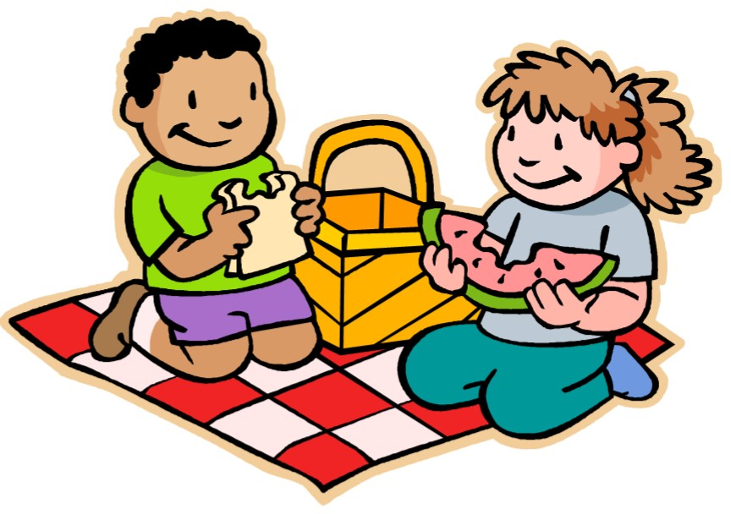 |  |  | 1  “Hair Day”  Personal Care  Mass on TV  10:00 Baking/  Build Your Own Smores  Exercise Visualization  2:30 Glenn Hillard  Bingo  Bowling  Personal Care  Word puzzles Bedtime Reading |  | 2  Personal Care  10:00 Catholic Mass with Father Mike  Exercise  What’s in the bag? Bingo  List It!  3:30 Country Store Opened  Afternoon Stretch Personal Care Evening Small Talk Wii SPORTS Bedtime Reading  7:10 Red Sox | 3  “Hair Day”  Personal Care  Gardening  Exercise  Bingo  2:30 Social Hour/ Tim Barrett  LIST IT  Afternoon Stretch Discussion/R&R Helping Around the House  Personal Care Word Puzzles Bedtime Reading  7:10 Red Sox |  | 4  Personal Care  Mass on TV  Bingo  Exercise  2:30 Iced Tea & Lemonade Social Noodle Ball  4:05 Red Sox  Trivia  Personal Care Evening Small Talk Bedtime Reading
5  Personal Care  Mass on TV Exercise  Bingo  Helping Around the House  1:00 United Parish Church Service Coffee Social Bowling  Personal Care Evening Small Talk  TBD Red Sox | 6  Personal Care  Mass on TV  Trivia  Exercise  Bingo  Gardening  Wii Sports  Personal Care Reminiscence Bedtime Reading |  | 7  Personal Care  Mass on TV  Walking Group  10:00 Arts & Crafts/  Printing with Flowers  Guinea Pig Social Exercise  Bingo  3:30 Rosary  3:30 Country Store Opened  Horse Races  4:00- 5:00 YMCA  Clark (Swimming)  Nails & Tales Personal Care Evening Small Talk 7:07 Red Sox  Bedtime Reading |  | 8  “Hair Day”  Personal Care  Mass on TV  10:00 Baking/  Mini Fruit Tarts  Exercise  2:30 Animal Craze  Visualization  Bingo  Bowling  Personal Care  Word Puzzles  7:07 Red Sox  Bedtime Reading |  |  | 9  Personal Care  10:00 Catholic Mass with Father Mike Exercise  11:30 Lunch Trip/Picnic Lunch  to Cathedral  of the Pines  What’s in the bag? Bingo  List It!  3:30 Country Store Opened  Afternoon Stretch Personal Care  7:07 Red Sox  Evening Small Talk Wii SPORTS  Bedtime Reading |  | 10  “Hair Day”  Personal Care Exercise  10:15 Clark YMCA  Bingo  2:30 Social Hour/  Heather Marie  LIST IT  Outdoor R & R Helping Around the House  Personal Care  7:05 Red Sox  Word puzzles Bedtime Reading | 11  Personal Care  Mass on TV  Bingo  Exercise  Helping Around the House  1:30 Mystery Ride 2:30 Iced Tea & Lemonade Social Noodle Ball  Trivia  Personal Care Evening Small 7:05 Red Sox  Talk Bedtime Reading
12  Personal Care  Mass on TV Exercise  Bingo  1:05 Red Sox  Helping Around the House  Coffee Social  Bowling  Personal Care Evening Small Talk Bedtime Reading Wii Sports | 13  Personal Care  Mass on TV  Trivia  Exercise  Bingo  Wii Sports Gardening  Personal Care Reminiscence Bedtime Reading |  | 14  “Hair Day”  Personal Care  Mass on TV  Walking Group  10:30 Fishing Trip to Dunn Park  Guinea Pig Social Exercise  Bingo  Visualization with Will  2:30 Errand Trip  3:30 Country Store Opened  4:00- 5:00 YMCA  Clark (Swimming)  Summer Trivia  Nails & Tales  7:05 Red Sox  Personal Care Evening Small Talk Bedtime Reading |  | 15  “FOOT DR.”  Personal Care  Mass on TV  10:00 Baking/  Canolli's  Exercise  2:30 Yoga  Gardening  Outdoor R & R Visualization  Bingo  Bowling  7:05 Red Sox  Personal Care  Word Puzzles  Bedtime Reading |  |  | 16  Personal Care  10:00 Catholic Mass with Father Mike  Exercise  What’s in the bag? Bingo  List It!  3:30 Country Store Opened  Afternoon Stretch Personal Care Evening Small Talk Wii SPORTS  Bedtime Reading |  | 17  “Hair Day”  Personal Care Exercise  10:15 Clark YMCA  Bingo  2:30 Social Hour/  Lou & Jan  LIST IT  Afternoon Stretch Discussion/R&R Helping Around the House  Personal Care  Word Puzzles Bedtime Reading  7:10 Red Sox | 18  Personal Care  Mass on TV  Bingo  Exercise  Helping Around the House  1:30 Mystery  Ride  2:30 Iced Tea & Lemonade Social  Noodle Ball  Trivia  Personal Care Evening Small Talk Bedtime Reading  7:10 Red Sox
Bright Horizons Activities for August 2018
Sunday |  | Monday | Tuesday | Wednesday |  |  | Thursday |  |  | Friday |  | Saturday
19  Personal Care  Mass on TV  Bingo  Exercise  1:05 Red Sox  Noodle Ball  Trivia  Word Game  Personal Care Evening Small Talk Bedtime Reading |  | 20  Personal Care  Mass on TV  Trivia  Exercise  Bingo  Wii Sports  Outdoor R & R Personal Care Reminiscence Bedtime Reading  7:10 Red Sox | 21  Personal Care  Mass on TV Walking Group 10:00 Arts & Crafts/  Paper Beads  Guinea Pig Social Exercise  Bingo  3:30 Rosary  3:30 Country Store Opened  Horse Races  4:00- 5:00 YMCA  Clark (Swimming)  Nails & Tales Personal Care Evening  Small Talk  Bedtime Reading  7:10 Red Sox | 22  “Hair Day”  Personal Care  Mass on TV  10:00 Baking/  Hershey Kiss or  PB Cup Cookies  Exercise  Gardening  Discussion/ R & R Visualization  Bingo  Bowling  Personal Care  Evening Small Talk Bedtime Reading  7:10 Red Sox |  |  | 23  Personal Care  10:00 Catholic Mass with Fr. Mike  Exercise  What’s in the bag? Bingo  1:05 Red Sox  List It!  2:30 Ice Cream Social  3:30 Country  Store Opened  Afternoon Stretch Personal Care  Word Puzzles  Wii SPORTS |  |  | 24  “Hair Day”  Personal Care Exercise  10:15 Clark YMCA Bingo  2:30 Social  Hour/ Terry Nally  LIST IT  Afternoon Stretch Discussion/R&R Helping Around the House  Personal Care Evening Small Talk Bedtime Reading  7:10 Red Sox |  | 25  Personal Care Mass on TV Bingo  Exercise  1:30 Mystery Ride  2:30 Iced Tea & Lemonade Social  Noodle Ball Trivia  6:10 Red Sox  Helping Around the House Personal Care Word Puzzles Bedtime Reading
26  Personal Care  Mass on TV Gardening  Exercise  1:10 Red Sox  Bingo  Helping Around the House  Coffee Social Bowling  Personal Care Evening Small Talk Bedtime Reading  Wii Sports |  | 27  Personal Care Mass on TV  Trivia  Exercise  Bingo  2:30 Resident Birthday Party/  Richard Erickson  Wii Sports Personal Care Reminiscence Bedtime Reading | 28  Personal Care  Mass on TV Walking Group 10:00 Arts & Crafts/ Friendship Bracelets  Guinea Pig Social Exercise  Bingo  3:30 Country Store Opened  Horse Races  4:00- 5:00 YMCA  Clark (Swimming)Nails & Tales Personal Care Evening Small Talk Bedtime Reading  7:10 Red Sox | 29  “Hair Day”  Personal Care  Mass on TV  10:00 Baking/  Coffee Can Ice Cream  Exercise  Gardening  Discussion/ R & R Visualization  Bingo  6:35 Red Sox  Bowling  Personal Care  Evening Small Talk Bedtime Reading |  |  | 30  Personal Care  10:00 Catholic Mass with Fr. Mike  10:30 Painting  with Will  Exercise  What’s in the bag? Bingo  List It!  3:30 Country  Store Opened  Afternoon Stretch Personal Care  Word Puzzles  Wii SPORTS  8:10 Red Sox |  | 31  “Hair Day”  Personal Care Exercise  10:15 Clark YMCA  Bingo  2:30 Social Hour/  Peter Sargent  LIST IT  Afternoon Stretch Discussion/R&R Helping Around the House  Personal Care  Word Puzzles Bedtime Reading  8:10 Red Sox
Birthdays  Dot ~ 8/4  Marianne C.~8/4  Martha C. ~ 8/23  Shirley P. ~ 8/26 |  |  | Main Events  Country Store is open on Tuesday & Thursday - 3:30PM and by request.  Movies will be held on Tuesday & Thursday at 6:15 PM, Saturday at 3:30 PM & 6:00 PM,  Sunday at 6:00 PM in the 2nd Floor TV Room  1- 2:30 Glenn Hillard 14- 10:30 Fishing Trip to Dunn's Park  2, 9, 16, 23 & 30- 10:00 Catholic Mass with Father Mike 14- 2:30 Errand Trip  3- 2:30 Social Hour/ Tim Barrett 15- FOOT DOCTOR 9:30-5:00  5- 1:00 United Parish Church Service 15- 2:30 Yoga  7, 14, 21 & 28-4:00 YMCA Clark (Swimming) 17-2:30 Social Hour/ Lou & Jan  7 & 21- 3:30 Rosary 23- 2:30 Ice Cream Social  8- 2:30 Animal Craze 24- 2:30 Social Hour/ Terry Nally  9- 11:30 Lunch Trip/Picnic Lunch to Cathedral of the Pines 27- 2:30 Resident Birthday Party/ Richard Erickson  10, 17, 24 & 31- 10:15 Clark YMCA (Silver Sneakers) 30 – Painting with Will  10- 2:30 Social Hour/ Heather Marie 31- 2:30 Social Hour/ Peter Sargent  11, 18 & 25-1:30 Mystery Ride

